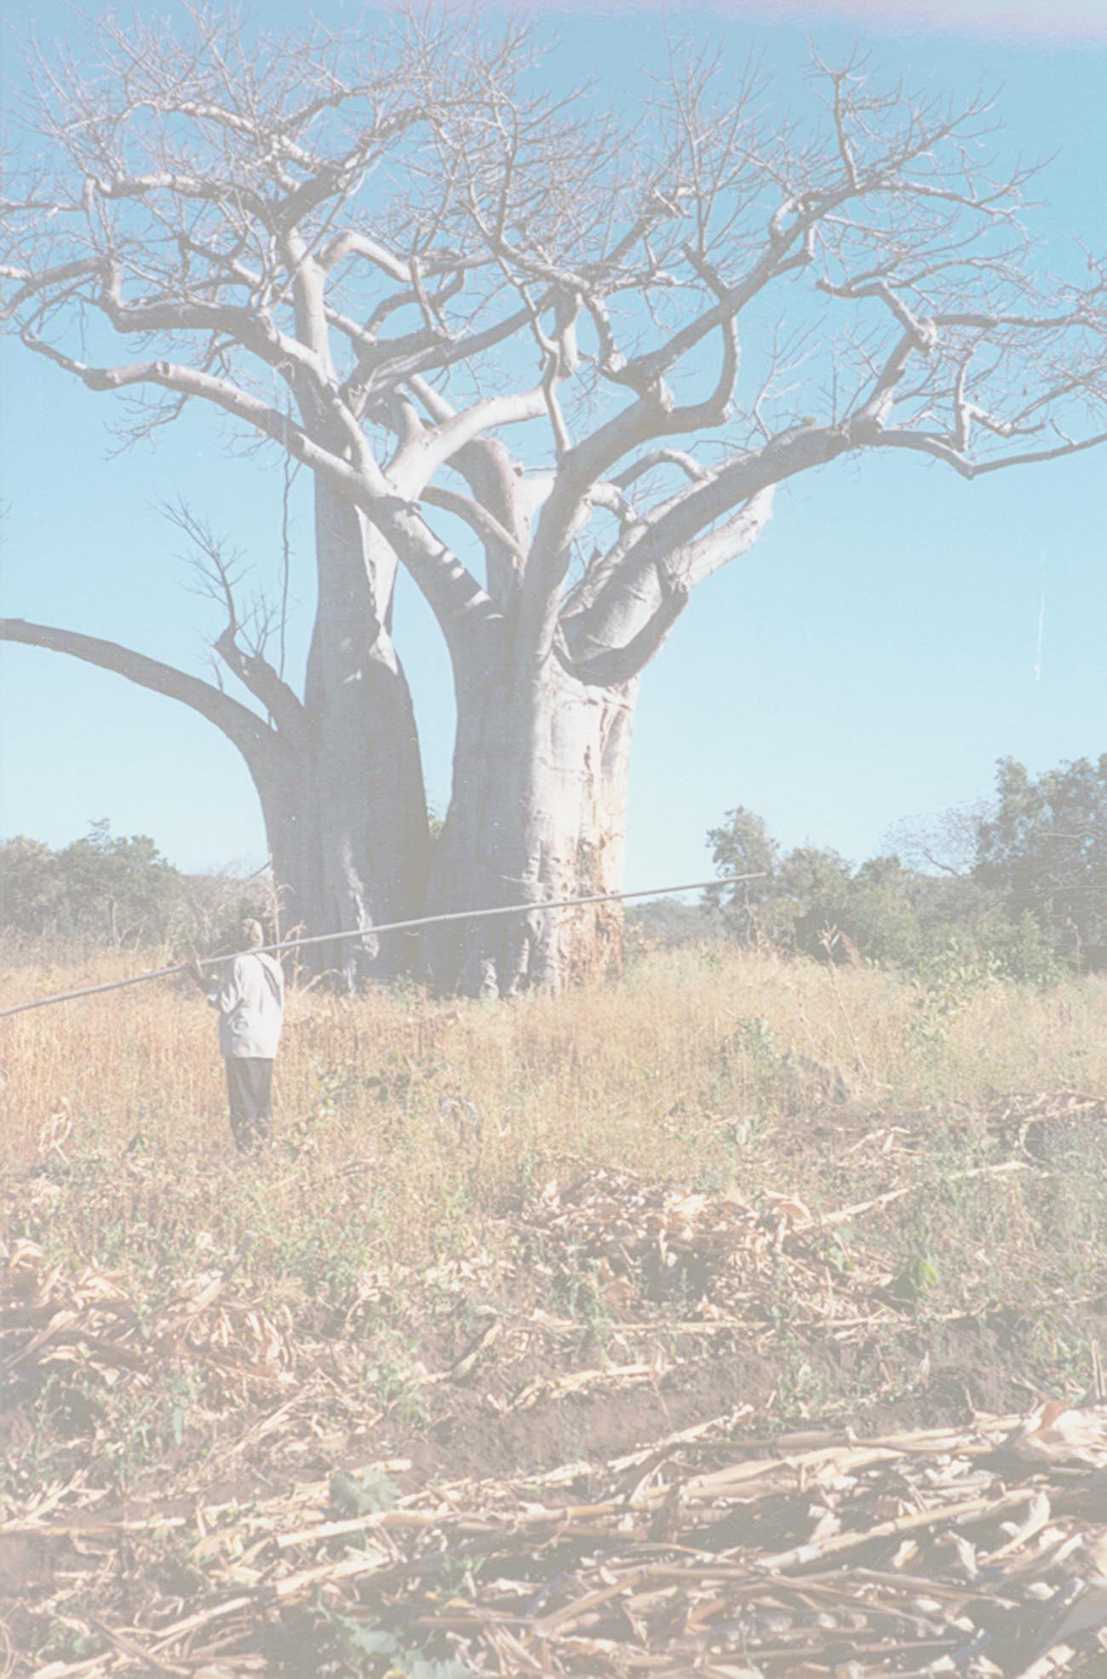

CHIULUKIRE LOCAL FOREST

JOINT FOREST MANAGEMENT PLAN

October 2001

Government of the Republic of Zambia
Ministry of Environment and Natural Resources

Department of Forestry
Joint Forest Management Steering Committee of Katete
Chiefdom of Undi
Villages around Chiulukire Local Forest,
represented by Chief Mbangombe
Cooperative League of the USA
United States Agency for International Development

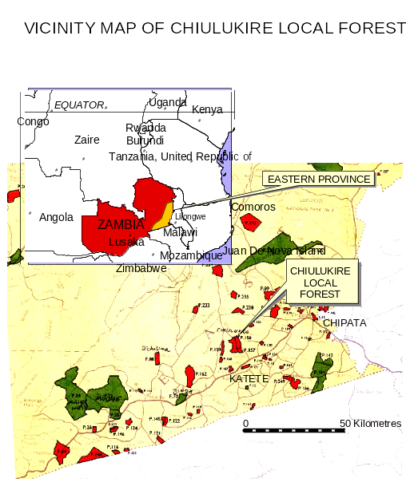
PREFACE

Overuse and degradation of forest resources and waters are threatening woodlands in Eastern Province. Increasing population pressure for agricultural land and a perception that the forest will never end are some of the main causes of the destruction of trees and soil. People look to forests for survival and yet do not realize that insurmountable damage is being done to them.

These days, thanks to sensitization by the Forestry Department and NGOs, rural communities are beginning to understand and appreciate that the forest resource use must be regulated. Accordingly, the focus in resource management is beginning to change. The resource users are being reminded to adopt more sound management practices.

The Forestry Department’s revised National Policy of 1998 and Forest Act of 1999 laid out strategies and guidelines that enable communities and government to practice Joint Forest Management in Zambia. The concept of Joint Forest Management is a move away from the usual police-oriented approach of Forestry Department, toward sharing responsibility for properly-controlled and sustainable product harvest with local communities. It also allows direct sharing of monetarybenefits between government, traditional authorities, and village structures. The people around Chiulukire Local Forest in Katete have agreed to join hands with the government in a pilot effort to jointly manage Chiulukire Forest under the new Policy and Act on a sustainable basis. The Cooperative League of the United States of America (CLUSA) has been facilitating this Community-Based Natural Resource Project in conjunction with the Ministry of Environment and Natural Resources.

The overall objective of CLUSA’s programme, which includes an overarching agricultural component, is to improve the economic well-being of rural populations living around managed forest reserves. In Eastern Province, the programme seeks to establish partnerships between stakeholders around selected forest areas. Chiulukire, the first pilot site, lies in Chief Mbang’ombe’s area under Undi’s kingdom.

CLUSA’s strategy is to start by reducing pressure for land to be encroached from gazetted forests which are usually viewed as agricultural expansion areas by farmers. Pressure is reduced by the introduction of conservation farming, cash crops, and value adding. Another part of the strategy is to facilitate information exchange between Forestry Department and the villages on issues and planning. Transfer of organizational skills and financial management to village groups is CLUSA’s specialty. Functional literacy and AIDS education complement the package delivered to the field. Finally, Forest Department receives technical training and logistical support as needed for field-based operations. It is recognized by all that even though laws are sound and personnel are willing, often it is simply a matter of logistics that prevents proper surveillance of forest resources.

The management plan may be characterized as follows:
- It is dynamic, with annual evaluations and recommendations built into it, so that conditions on the ground will determine allowable actions.
- It is a result of over two years of dialogue with forest users and their leaders in formal and informal settings.
- It should be used as a guiding tool in the management of Chiulukire Local Forest. Rich technical information from many researched and interviewed sources is contained within.
- Before implementation, it is planned that various user groups are to be formed and sensitized on ecological and economical aspects of harvesting.
- The strategies contained in each chapter, if followed, will contribute to the sustainable utilization of Chiulukire Local Forest for the benefit of current and future generations of plant, animal, and human life.
SIGNED,

______________________ _____________________________ __________________________
CHIEF MBANG’OMBE FORESTRY DEPARTMENT KATETE DISTRICT COUNCIL

CHIULUKIRE LOCAL FOREST
JOINT FOREST MANAGEMENT PLAN

October 2001

SECTION I. CONTEXT FOR JOINT FOREST MANAGEMENT 1
LEGAL BASIS 2
Community-Based Natural Resources Management Programme in Eastern Province 2
CLUSA approach tailored to Zambia 3
Purpose AND DURATION of the Plan 4
SECTION II. DESCRIPTION OF THE FOREST AND ITS PEOPLE
MANAGEMENT AREA DESCRIPTION 6
TOPOGRAPHY, VEGETATION, SOILS, CLIMATE 7
FIELDS IN THE FOREST 7
VILLAGE ORGANIZATION, LITERACY, AND ECONOMIC ACTIVITIES 7
LAND TENURE AND USAGE RIGHTS 11
BRIEF SETTLEMENT HISTORY OF THE FIVE VILLAGE RESOURCE MANAGEMENT AREAS 12
ORIGINAL REASONS FOR RESERVATION AND OBJECTS OF MANAGEMENT 13
GOOD AND BAD FOREST 14
SECTION III. OBJECTIVES AND STRATEGY 15
DEVELOPMENT OBJECTIVE 15
GENERAL OBJECTIVES 15
GENERAL STRATEGY 16

SECTION IV. ACTIVITIES CONTROLLED BY THE VILLAGE RESOURCE MANAGEMENT AREA COMMITTEES (VRMACs)
BAMBOOS 20
BARKROPE 22
BOUNDARY RECOGNITION 24
CARVING TREES 25
CATERPILLARS 27
CHARCOAL trials 29
CUTTING METHODS: GENERALITIES 34
FIELDS AND SETTLEMENTS IN THE FOREST 36
FIRE MANAGEMENT 39
FIREWOOD 41
FISHING 42
FRUIT TREES 44
GRAZING 47
HONEY AND BARKHIVE PRODUCTION 50
MEDICINAL PLANT PARTS 55
MUSHROOMS 57
POLES FOR CONSTRUCTION 60
RESERVED AREAS 62
SAWTIMBER 65
CALCULATION OF ANNUAL ALLOWABLE CUT 66
SUNDE BROOMS ……………………………………………………..….… 73
THATCHING GRASS 79
WATERCOURSE MANAGEMENT 80
WILDLIFE 83

SECTION V. ADMINISTRATIVE ASPECTS 85
THE FIVE VILLAGE RESOURCE MANAGEMENT AREAS (VRMAs) 86
THE FIVE VILLAGE RESOURCE MANAGEMENT AREA COMMITTEES (VRMACs) 86
1. COMPOSITION OF THE VRMAC 86
2. GENERAL ROLES OF THE VRMAC 86
3. ELECTION OF VRMAC MEMBERS 88
4. VRMAC TENURE OF OFFICE 88
5. VRMAC MEETINGS 88
6. VRMAC REPORTING 89
FINANCIAL MANAGEMENT 90
1. PERMITS FOR CHIULUKIRE FOREST PRODUCTS 90
2. STORAGE AND DISTRIBUTION OF FOREST PRODUCT PERMITS 95
3. REVENUE COLLECTION, TRANSMITTAL, AND BANKING 95
4. REVENUE SHARING 95
5. FINANCIAL RECORDKEEPING 96
6. AUDITING 97
7. MISAPPROPRIATION OF FUNDS 97
IMPLEMENTATION OF THE MANAGEMENT PLAN 98
1. ROLE OF TRADITIONAL AUTHORITIES 98
2. ROLE OF THE FOREST DEPARTMENT 98
3. ROLE OF THE JOINT FOREST MANAGEMENT COMMITTEE 99
4. ROLE OF THE VILLAGE RESOURCE MANAGEMENT AREA COMMITTEES 99
5. ROLE OF THE VILLAGE RESOURCE GUARDS 100
6. ROLE OF CLUSA AND OTHER NGOs 101
7. ROLE OF USER GROUPS 101
SECTION VI. EVALUATION AND MONITORING 102
MONTHLY, QUARTERLY, AND YEARLY ACTIVITIES 103
1. MONTHLY REQUIREMENTS 103
2. QUARTERLY REQUIREMENTS 104
3. YEARLY REQUIREMENTS 105
YEAR-BY-YEAR WORK AND MONITORING ACTIVITIES 107
APPENDIXES:
SCIENTIFIC AND LOCAL NAMES OF TREES FOUND IN CHIULUKIRE FOREST page 108
BOUNDARY DESCRIPTIONS OF CHIULUKIRE EAST AND WEST page 111
FOREST INVENTORY DESCRIPTION, TABLES, AND CHARTS page 113

SECTION I. CONTEXT FOR JOINT FOREST MANAGEMENT

LEGAL BASIS
CLUSA IN EASTERN PROVINCE
CLUSA APPROACH TAILORED TO ZAMBIA
PURPOSE AND DURATION OF THE PLAN

LEGAL BASIS
Following its creation in 1991, the Ministry of Environment and Natural Resources (MENR) was assigned three primary goals:
- Protection, conservation and restoration of the full range of biological and physical diversity in Zambia;
- Maintenance and restoration of the quantity and quality of land, water and air to support the health of humans and all living things; and,
- Provision of social and economic opportunities for the people of Zambia in keeping with the responsibility of maintaining a diverse and healthy environment.
During the process of formulating the new Forest Policy, it was pointed out that one of the main problems with the old policy was the lack of provisions for the Forest Department to “reach out” to local communities as viable stakeholders and partners in the management of the country’s forests. In response to this, the new policy set forth clear guidelines to: “ensure adequate protection of forests, by empowering local communities and promoting the development and use of forest and non-wood forest products.” Furthermore, “all key stakeholders particularly local communities must be involved in the management of the forests and forest products.”
Following the formulation of the policy, work began to revise the Forest Act of 1973: “to incorporate ideas of joint forest management and facilitate the participation of local communities, traditional institutions, non-government organizations and the private sector.”
Thus, in October 1999, the President of the Republic of Zambia signed the new Forest Act, No. 7 of 1999 into law. With regard to joint forest management the new law states that: The Minister may, on the recommendation of the Commission, local community or owners or occupiers of an area in a forest, declare by statutory instrument any Local Forest, forest plantation or open area, a Joint Forest Management Area” (PART V, Chapter 25(1)). The new act clearly opened the door to local communities to participate as legally recognized partners with the Forest Department in the management and revenue sharing of open and local forests.

Community-Based Natural Resources Management Programme in Eastern Province
In response to the favorable change in Zambia’s Forest Policy, the United States Agency for International Development (USAID) initiated discussions with the MENR regarding development assistance in the sector. The result was the signing of a cooperative agreement between USAID and the Cooperative League of the United States of America (CLUSA) for the implementation of a five year project, Community-Based Natural Resources Management (NRM) in Eastern Province which began in 1999.
Based on CLUSA’s experience in natural resource management in other regions of Africa, the five year program will demonstrate, in the Zambian context, an approach to community-based forest management that has proven successful in West Africa. The overall goal of the program is to improve the economic and social well-being of Zambia’s rural population. Its purpose is to strengthen community groups and group-based enterprises in the target areas by helping them to acquire the skills and knowledge they need to improve their living standards and their general economic situations.
CLUSA-CBNRM is now working in four Districts: Mambwe, Chipata North, Katete, and Petauke. The first forest selected as a pilot undertaking is the Chiulukire Local Forest, Katete District.

CLUSA approach tailored to Zambia
The main difference between community-based management approaches employed in Zambia and West Africa is that in Zambia, the forest management is preceeded by establishment of an agricultural outgrower scheme. The objectives of the outgrower scheme are:
- to introduce improved farming technologies to increase yields;
- to assist with credit for inputs;
- to improve marketing by focusing on high-value cash crops, thereby raising incomes; and ultimately
- to reduce the pressure on the natural forest.
Moreover, the outgrower scheme is a means to draw attention to the natural resource management programme in a very practical manner and respond to farmers’ priorities in a subject about which they know the most: agriculture.
Once the outgrower scheme is underway, the steps to community-based forest management include the following:
- Preparation for the formulation of the Joint Forest Management Plan (JFMP): this phase includes training of stakeholders; initial discussions; village resource assessments; forest mapping; forest inventory; and demarcation of forest management areas. These steps have already been taken for Chiulukire Local Forest in 1999 and 2000.
- Formulation of the Joint Forest Management Plan (JFMP): Following the preparation phase, all of the stakeholders (village representatives, traditional authorities, representatives from the Steering Committee, the Forest Department, and concerned NGOs) were convened to participate in workshops in November 2000 and May 2001 to develop the first draft of the JFMP. Following circulation of the draft to the stakeholders accompanied by explanation of content, a second workshop was held to compile all concerns and comments for improvement. Revisions were made and a second draft was again circulated for comments. The JFMP is to be finalized and sent to the Ministry level and the local authorities. If accepted, the forest is gazetted as a Joint Forest Management area with all the pertaining legal status.
- Implementation of the Joint Forest Management Plan: The primary responsibility for the implementation of the FMP falls on the Village Resource Management Area Committees (VRMACs), which are responsible for assuring that their respective management areas abide by the laws and policies described in this JFMP (see Section V on specific activities and Sections VI and VII on administration and monitoring). The Forest Department and CLUSA will collaborate to ensure that all necessary training is given to members of the committee and forest user groups. The Forest Department is responsible for ensuring that the JFMP is implemented according to the law. CLUSA will facilitate the feasibility studies and training of user groups to promote forest-based industries.
- Monitoring and evaluation: The JFMP will be monitored periodically using indicators described in Sections V and VII as criteria for success. The monitoring will be carried out primarily by the rural communities and the Forest Department. The Steering Committee will be responsible for organizing an annual evaluation of the program.

Purpose AND DURATION of the Plan

1. Purpose
The purpose of the management plan is to define the laws and policies that will guide the rural communities and the Forestry Department during exploitation of the natural resources of the Chiulukire Forest for the benefit of the local population in a sustainable manner. Once adopted and gazetted, the plan will serve as a legal contract between the rural communities and the MENR granting user rights to the communities in exchange for their cooperation in the long term conservation and management of the forest.

2. Duration and the need for regular adjustments
The duration of the JFMP is ten years. In theory, this means that ten years from the date that the plan if gazetted, a new plan should be formulated. In practice, however, because of the novelty of joint forest management in Zambia, and the need to be flexible and adjust from lessons learned, the plan may be adjusted every year during the first few years of implementation. In other words, the plan is dynamic, and lessons learned should be incorporated as they become obvious. Conditions for changing harvest quotas are described in Section VI on monitoring.

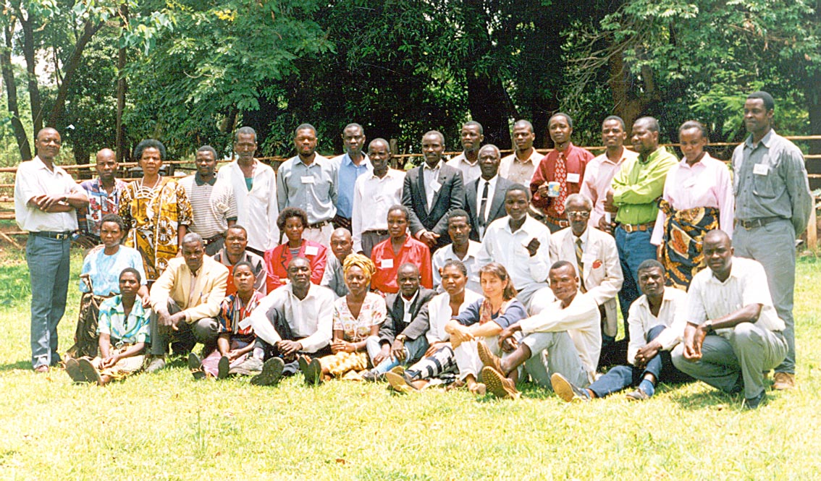Workshops, such as this one held in Chipata in November 2000, are a good way to bring stakeholders together to discuss issues and to plan.

SECTION II. DESCRIPTION OF THE FOREST AND ITS PEOPLE

MANAGEMENT AREA DESCRIPTION
TOPOGRAPHY, VEGETATION, SOILS, CLIMATE
VILLAGE ORGANIZATION, LITERACY, AND ECONOMIC ACTIVITIES
LAND TENURE AND USAGE RIGHTS
BRIEF SETTLEMENT HISTORIES OF VILLAGE REGIONS
GOOD AND BAD FOREST

MANAGEMENT AREA DESCRIPTION

LEGAL STATUS: Chiulukire East and West were gazetted as Local Forests in 1966 on Gazette Number SI.263/66. Chiulukire East Local Forest Number P.158 has 5,403 hectares while Chiulukire West Local Forest Number P.157 has 6, 637 hectares according to the Gazette Number SI.263/66. For purposes of this management plan, the two Chiulukire Local Forests are considered together as “Chiulukire Local Forest”. Chiulukire East and West Local Forests combined contain about 10,800 hectares of mostly miombo woodland according to year 2000 geographic information system calculations; actual locations of boundary markers are to be completed in the first year of the plan. The original proposal stated that the area was a total of “29,850 acres”, or 12,085 hectares.
ACCESSIBILITY: The forest is located 20 kilometers north of Katete (Eastern Province) with two good access roads, one on the west side and one on the west, that connect to the Great East Road. The distance from Chipata to Chiulukire Local Forest is about 70 kilometers. Katete and Chipata are the two large towns that are market centers for many of the forest’s products.
AGRICULTURAL ACTIVITY: Farming is the most widespread activity. The region is good for groundnut and cotton production. Cash cropping of sunflower and paprika of superior quality has been initiated by CLUSA in the surrounding villages. Conservation farming for all these crops has been the object of innovative extension work with CLUSA farmers since 1999.
Pressure on the forest for agricultural land is increasing greatly due to rapid population increase: the 1970 government map showed only about 10 villages in the area immediately surrounding the forest, while now more than 75 villages comprised of over 1,000 households have been recorded. Two neighboring smaller forest reserves to the west have already been more seriously encroached than Chiulukire; it is difficult to find their boundaries on the 1999 satellite photo. However, Chiulukire is relatively “intact” and remains an important source of natural resources to the surrounding population. As of year 1999, about 940 hectares or 9% of the forest is under cultivation. The area was calculated by tracing polygons of fields visible on the satellite image and calculating the cumulative area using the GIS.
ECONOMIC POTENTIAL: The highest-valued resources remaining include a stone-age rock painting area, some small game and a few big cats, a few sawtimber and rare trees, and some year-round water points. There is enormous potential in many nontimber products found there.

USE OF FIRE: A COMMON PROBLEM
One of the principal management problems today, common to all the management areas, is that of fire misuse. Many villages noted that in the past Village Headmen were informed by the Chief of the period during which fires could be started to clear grass and to hunt: usually May/June in some parts of the forest, and October/November in other parts (grazing areas) to allow fresh grass to grow. This system is no longer in place, and fires that are lit during the hottest driest months of August to October (lit mainly by hunters and children hunting mice) cause unnecessary damage to seedlings and harvestable forest products. It is said also that fires drive more wildlife away now than before. Only fires close to villages or fields are controlled or snuffed with tree branches. Fire therefore has cut across the boundaries of many management issues.

TOPOGRAPHY, VEGETATION, SOILS, CLIMATE

The forest sits on the plateau of Eastern Province with altitudes ranging from 900 to 1,200 meters. The landscape is broken by rocky hills, especially in the south, where well-forested moderate slopes lead to the higher summits.
The vegetation of the hilly areas is miombo woodland dominated by Brachystegias and Julbernardias among others. The northern part of the forest contains some mopane woodland dominated by Colophospermum on gentler slopes. Munga woodland is scattered throughout the forest dominated by Acacia, Combretum, Lannea, and other species. Trees larger than 50 centimeters in diameter, and taller than 15 meters, are rare in the forest. Some of the scattered stands of gregarious Brachystegia bussei are the largest and most concentrated areas of wood.
Soils are mainly brown sandy loam with quartz stones and gravel in the topsoil (from original reservation proposal 195_). Some sandy areas are found in low areas and dambos.
Average annual rainfall is between 600 and 1000 millimeters, falling mostly between December and March. Coldest months are June and July (15-18 degrees mean temp.); warmest are September and October (mean temp. 21-26 degrees).

FIELDS IN THE FOREST
About 940 hectares of the forest (8.7%) is under cultivation. (See map in Section IV Fields and Settlements chapter.) Cotton and groundnuts are the main cash crops grown inside the forest; cotton is known as the most destructive in terms of requirements for newly-cleared forest land and use of pesticides harmful to bees and honey production. Maize is mainly grown for home consumption. All sides of the forest are affected with scattered fields and settlements inside forest boundaries. One key to successful management of this forest will be the control of these fields to prevent further destruction of forest land.

VILLAGE ORGANIZATION, LITERACY, AND ECONOMIC ACTIVITIES

1. VILLAGE ORGANIZATION INTO RESOURCE MANAGEMENT AREAS
There are more than 75 villages around the forest. Locations were registered by GPS and satellite imagery on maps produced by Cooperative League of the USA (CLUSA) that accompany this report.
The first table summarizes Village Resource Management Area (VRMA) populations of villages that filled out a questionnaire presented by CLUSA facilitators and village resource assistants in 1999. The populations given by the villagers themselves do include children. “Village” sizes range from 8 persons to over 500 persons.
The population around the forest is more than 5,000 persons as of 1999, when a Village Resource Assessment was completed in the area (see Table 1 which shows populations of villages interviewed). The population of villages and settlements inside the boundary is around 500 persons.
For purposes of being served by CLUSA facilitators and for organization into future resource management areas, each village is assigned to one of five VILLAGE RESOURCE MANAGEMENT AREAS (VRMAs). Their names are:
- CHINKHOMBE (Nthambwa-Musonda, Tontholani, and neighbors southwest of Chiulukire)
- MAGOBO (Kazika and neighbors north of Chiulukire; also KASAMANDA area in northwest corner)
- MATUNGA (Gaveni, Kazembe, and neighbors east of Chiulukire)
- MKAIKA (Agasi, Chipilingu, and neighbors south of Chiulukire)
- ZINAKA (Ndelemani and neighbors northwest of Chiulukire)

2. INFORMATION GATHERED FROM 1999 INTERVIEWS
A participatory village resource assessment (VRA) was carried out in several villages around the forest in 1999. The following information pertains to the summary of findings contained in the report from these interviews. IT IS RECOGNIZED THAT THE ENTIRE POPULATION IN THE AREAS COVERED IS NOT REPRESENTED IN THESE 46 VILLAGES. It has been stated that at least 75 villages are around the forest area, most of them smaller than the 46 interviewed in 1999. However, the interviewed villages provide a good cross-section of the activities and composition of the area.

TABLE 1. POPULATIONS, LITERACY, AND MIGRATION IN VILLAGES INTERVIEWED

MGMT AREA  (No. of villages) | Population represented | Households headed by |  | Number literate |  | Migration per year
MGMT AREA  (No. of villages) | Population represented | Male | Female | Males | Females | Migration per year
Chinkhombe (7) | 1148 | 202 (78%) | 59 (22%) | 165 | 96 | 6 out
Magobo (11) | 434 | 103 (61%) | 67 (39%) | 47 | 24 | 5 in; 1 out
Matunga (11) | 1860 | 163 (74%) | 58 (26%) | 74 | 34 | 5 in
Mkaika (6) | 637 | 102 (79%) | 27 (21%) | 38 | 16 | NONE
Zinaka (11) | 775 | 178 (86%) | 29 (14%) | 105 | 54 | 1 in; 2 out
TOTAL (46 vill) | 4854 | 748 | 240 | 429 | 224 | 11 in; 9 out

MIGRATION: On balance, the migration trends are not changing population much around the forest; however, Chinkhombe is susceptible to emigration and Matunga to immigration. The number of persons seeking seasonal work elsewhere is very low.
LITERACY AND MATRIARCHY: Because the populations are not broken down by age group, it is difficult to estimate the percentage of literacy among school-age and older persons. If the total population of 4854 were divided into family units of 2 parents plus 1 grandparent plus 4 children = 7 persons, of which perhaps 4 are old enough to be literate, then we would expect nearly 3000 to be literate. The actual literate total is 653, which could then indicate a theoretical level of fewer than 25%.
The importance of literacy to management of the forest is principally for bookkeeping and marketing. CLUSA is continuing in its functional literacy program targeting village adults. It is fortunate to have as partners in management the Forest Department personnel; they are there to help bridge the gap in literacy for necessary translations and trainings.
In each area there are close to twice as many males as females qualifying as literate, even in Magobo (Kazika village area) where 39% of the households are headed by women.

VILLAGE OCCUPATIONS: The next table describes various occupations of villagers according to the 1999 survey. All the households represented are engaged in farming as one occupation, so farming is not mentioned on the list. The information is also portrayed on accompanying maps.

TABLE 2. ECONOMIC ACTIVITIES OF VILLAGES AROUND CHIULUKIRE

 | NUMBER OF HOUSEHOLDS WITH THIS OCCUPATION
 | CHINKHOMBE  (1148 = population in 7 villages) | ZINAKA  (775 = pop. in 11 villages) | MAGOBO  822* = population | MATUNGA  (1860 = pop. in 11 villages) | MKAIKA  (637 = pop. in 6 villages) | TOTAL  (5242 pop. in 46 vgs)
OCCUPATION
Sawyer | 15 | 37 | 11 | 13 | 7 | 83
Carpenter | 2 | 13 | 8 | 6 | 9 | 38
Beekeeper | 36 | 54 | 71 | 44 | 25 | 230
Broomtrader | 2 | 20 | 17 | 32 | 5 | 76
Basketweavr | 43 | 36 | 15 | 19 | 10 | 123
Herbalist | 1 | 5 | 0 | 13 | 2 | 24
(Distance to forest bound.) | 2 to 7  kilometers | 0 to 6 kilometers | 0 to 2.8 kilometers | 1.5 to 3  kilometers | 3 to 7  kilometers
Blacksmith | 12 | 38 | 9 | 7 | 7 | 66
Brewer | 16 | 11 | 10 | 38 | 24 | 99
Bricklayer | 5 | 3 | 3 | 27 | 1 | 9
Gardener | 0 | 0 | 9 | 28 | 34 | 71
Grocer | 7 | 3 | 0 | 9 | 2 | 21
Handicraft | 19 | 24 | 0 | 10 | 26 | 79
Potter | 1 | 11 | 4 | 16 | 9 | 41
Other | Radio repair 3  Bike repair 1  Health worker 1 |  | Radio rep. 1  Bike repair 2  Health wrkr 4 | Radio repair 3  Bike repair 16 | Community worker 1
Magobo registry of yeara 1999 has recorded 822 people in the Magobo area covering the part under authority of Chief Mbang’ombe. The 1999 Village Resource Assessment covered interviews with villages representing 434 people in 11 villages. Magobo was the only region to update published results of the VRA report.
If one focuses on those activities that depend on Chiulukire forest cover (shaded portion of table 2), beekeeping is a big occupation on all sides of the forest but particularly in the west and north (Chinkhombe and Magobo). Sawing, carpentry, and basketweaving are also important in those areas.

GRAZING: he following table describes the abundance of primary livestock recorded on village survey sheets.
TABLE 2. LIVESTOCK CLAIMED BY VILLAGES AROUND CHIULUKIRE FOREST
Head of: | CHINKHOMBE  (7 villages) | MAGOBO  (11 villages) | MATUNGA  (11 villages) | MKAIKA  (6 villages) | ZINAKA  (11 villages) | TOTALS  (46 villages)
Goats | 2345 | 539 | 220 | 461 | 1655 | 5220
Cattle | 198 | 133 | 156 | 154 | 120 | 761
Pigs | 162 | 56 | 146 | 143 | 69 | 576

LAND TENURE AND USAGE RIGHTS

1. HISTORY OF STATE LAND
During the colonial era land was divided into Trust land, Reserved land and Crown land. These are now called Traditional and State land, respectively. The recognition by the traditional chief that control of some forests was being ceded to the State happened around 1955 to 1958 (depending on the village describing the process). However, in some cases the bordering villages did not learn of the Forest Department taking over responsibility for the forest until the 1960s (see VRA report, 2000).

2. TRADITIONAL LAND AND CONFLICT RESOLUTION
According to the original reservation proposal E.93, the Chiulukire is “in Chief Mbang’ombe’s area partly in Native Trust Land XXIV and partly in Zumwanda Native Reserve IV and comes under the Chewa Native Authority.”
Traditional land, which covers 96% of the land in Eastern Province, may be occupied according to customary law without a formal right assigned to the land. The traditional chief, in this case Chief Mbang’ombe, whose palace is not far from Katete, controls such land. (The Paramount Chief of the Chewa tribe, Gawa Undi, has a village just to the south of the forest. Chief Mbang’ombe is just below Undi in rank, a senior chief.)
Individuals can apply for land title deed to the Commissioner of lands with written consent from the Chief. The Chief has a traditional council, which advises on governance and other issues affecting the chiefdom.
The Senior Chief’s Village Headmen are his representatives who are authorized to allocate land locally, resolve disputes, and preside over traditional ceremonies. They also have power to grant permission to cut a tree around the village, where normally this act is forbidden and even punishable because such trees are supposed to control wind and water erosion. It is taboo to cut trees and collect mushrooms and fruits from a graveyard.
When local villagers are involved in a dispute, they begin at the most local level, the Village Headman, to attempt to resolve it. If this fails, they take it to a local traditional court called Khonde. Again if it fails they go to the Senior Chief’s Palace, and ultimately to the Paramount Chief for ruling. Beyond this, the conflict goes to the government court of law.

3. LEGAL STATUS OF STATE LAND IN ZAMBIA’S PROVINCES
Chiulukire Local Forest falls under the jurisdiction of state lands of Zambia. Land management and control of state land is vested in the President of Zambia on behalf of Zambia’s citizens. In Eastern Province, it comprises about 280,000 hectares or 4% of the total land area. The President through his government can make grants and arrange leases of 14-99 years through the Commissioner of Lands.

BRIEF SETTLEMENT HISTORY OF THE FIVE VILLAGE RESOURCE MANAGEMENT AREAS

1. HISTORY OF CHINKHOMBE
These people originally came from Sandwe village in Petauke to Sasare area in Katete District in the 1930s. Due to conflicts there they migrated to the present-day Ndelemani in 1939. In 1943 they settled near the Mponda River, and at the present site in 1970.
The village of Tontholani is relatively new; they came in 1998 from Chiwanga village. The ethnic groups are a mixture of Nsenga and Chewa. They are matrilineal.
Chinkhombe settlers that are inside the gazetted forest boundary came from Cholowa village. They came in 1996 after hearing rumours that the forest was going to be degazetted, according to Nthambwa and Tontholani residents.
The distance they state that they walk to collect firewood varies from 500 meters (Cholowa) to 5 kilometers (Chiwanga).

2. HISTORY OF MAGOBO
The first to settle here were in Kazika in 1958. After 15 years, Kazika moved to Matunga area to be closer to school and clinic. In 1989 they came back to the original site. The next year, 1990, Mlangali village settled inside the forest in Magobo to seek fertile land to alleviate a hunger problem.
Declines in honey are blamed on the opening up of agricultural fields (it is not clear whether it is only that “bee trees” were overcut, or if cotton pesticides added to the decline). Availability of fruits also has declined, and this is blamed on bad harvesting methods, which means cutting the tree down for the fruit. Caterpillars are also reported to be in decline. Again, interesting to note that insect-related forest products are all in decline, perhaps related to cotton chemicals.
This is the only area to have mentioned snails among their nontimber forest products. Regeneration and wildlife availability are perceived as poor due to fire management practices, and a decrease in number of tree species (biodiversity) is noted.
Interviewees stated that the Agriculture Department has functioned in both pre- and post-colonial times up to now. Lintco Cotton came in 1990, Clark Cotton came in 1994, then Sable in 1995, then Cotmark in 1996, then Lonrho in 1997, and now CLUSA in 1999. There have been some less formal institutions such as briefcase dealers and women’s clubs organized by the ruling party.
The distance they state that they walk to collect firewood varies from 10 meters (villages inside forest) to 800 meters (Kazika).

3. HISTORY OF MATUNGA
Sunkhu, Gomani, Mbang’ombe, and Ng’ombayela came to this area first in 1929. Later came Katimbila, Ntambwa, Chikumba, Tambala, Kazembe, and many others making the present-day Matunga.
The name “Matunga” originates from the place where special loincloths were sewn in the original villages. A woman there fabricated (kutunga = to sew) these cloths, called “ngumbi”, and sold them to neighboring villagers (input by Moses Staff Phiri, age 72).
Agricultural and other activities were started by the colonial District Agricultural Officer Mr. Fraser in 1942. They continued take place within forest boundaries even after the forest was gazetted in 1958 because villagers did not hear about the new administrative arrangement with the Forest Department until 1967. At that time they abandoned their fields and other activities inside the boundaries.
This trend was reversed starting in 1990 when people slowly started opening fields inside the forest again. The reason given for this is population pressures for more farmland, coupled with poor soil fertility on existing fields due to poor farming practices.
The distance that they state they walk to collect firewood varies from 500 meters (Kazembe) to 2 kilometers (Mkokeza).

4. HISTORY OF MKAIKA
This area covers a stretch about 7 kilometers long between Agasi and Chipilingo with Kalima, Geleta, Kawaza, and Kanyatula in-between. The first to be built was Geleta, with settlers from Munyamadzi looking for more agricultural land in the 1940s. Settlers who broke away from Sumbwi came to Agasi around 1946. Chipilingu was founded in 1957 and Kawaza in 1959 with settlers from Nzamani (Chipata District), and Chimtanga (Chadiza District) called by Chief Mbang’ombe. Kanyatula and Kalima splintered from Kawaza and Agasi in 1983 and 1994, respectively.
The villagers state that they do not need to go as far as the protected forest (4-5 kilometers away) for cultivation, poles and so on because of locally fertile soils and availability of trees.

5. HISTORY OF ZINAKA
Ndelemani first started in 1930. It was followed by the establishment of Chikukula and Mutopa in the 1950s, then Zinaka, Sekani, Kasankha, and Makusi. At the beginning there was a lot of game, which was driven out as the number of villages, started increasing noticeably in the 1980s. Settlers inside the forest came in 1997 looking for water plus arable land.
Most forest products are collected for subsistence only. It was noticed that in the 1980s the population of caterpillars dropped as a large part of the forest was sprayed by tsetse fly eradication projects. As for mushrooms, no changes in availability have been noticed so far. The collection of honey and bamboo for baskets has shifted from subsistence to commercial use. At the same time, a decrease in bamboo availability is noted.
The other resource in decline is “choyo” or broom grass, supposedly due to unsustainable harvesting.
The distance that they state they walk to collect firewood varies from 50 meters (Kamkukute, inside the forest) to 2 kilometers (Makusi).

ORIGINAL REASONS FOR RESERVATION AND OBJECTS OF MANAGEMENT
The following text copied from the reservation proposal describes the original intentions of the Forest Department in the late 1950s:
The area forms part of the series of indigenous pole production forests from which purely local demands for poles will be met. It is intended that the proposal be handed over, under Section 10 of the Forest Ordinance, to the Chewa Native Authority to manage on a simple early-burning – cum coppice system.

GOOD AND BAD FOREST
One of the questions posed during the village resource assessment of 1999 was the villagers’ perception of what a good forest would be like. Following is the summary of their responses. They show that many respondents were viewing the forest mostly as a fertile soil resource and not necessarily as a long-term provider of forest products.

What is a good forest?

- One which has diverse trees, good soils, and streams with running water, and which is suitable for habitation (Zinaka)
- One with various types of animals, with bamboos which indicate fertile soil, with big grass and a lot of trees, with good crop yields, and with various species of trees and vegetation (Magobo)
- One with good availability of trees and tall grass which shows the soil is fertile; a good variety of both tree and animal species, giving a wider choice and several options as to what use it can have; soil which is not rocky as it can’t support vegetation favourably; soils that are well-drained; and terrain which is not too steep (Matunga)
- Forests maintain soil fertility, protect flow of rivers, and provide animal habitat. They provide durable trees that are used to build houses. Undisturbed forests can indicate culturally important burial grounds. Forests are used in the economic sense for hunting, grazing, collection of wood, collection of food, handicraft materials such as for mats and mortars, and utility items such as tool handles and brooms (Mkaika)

What is a bad forest?

- One in which the grass does not grow, where soils are clayey, where a lot of phingo and mphalankaya grow, and where there are few trees (Magobo)
- One without a good number of trees and vegetation cover, without availability of wildlife, grass, and fodder, without a good range of fruit trees, but having a lot of thorn trees and shrubs, and poor soil that cannot support a good cover of vegetation (Matunga)

SECTION III. OBJECTIVES AND STRATEGY

The following objectives were elaborated during a workshop with villagers representing all sides of the forest in November, 2000.

DEVELOPMENT OBJECTIVE

To Link Sustainable Forestry to Community well being by combining Conservation with Economic Development and Cultural values to benefit present and future generations of the local people.

GENERAL OBJECTIVES

- To control destructive wild fires and late fires in the forest reserve.
- To reverse the trend of illegal settlements and cultivation in the forest reserve.
- To protect water catchment areas and conserve watercourses.
- To rehabilitate degraded sites in the forest reserve.
- To promote natural regeneration both inside and outside the forest reserve.
- To protect the heritage sites in the forest reserve.
- To develop forestry related and other small businesses in the communities.
- To increase the forest-based incomes for villages surrounding the forest reserve.
- To optimize economic utilization of timber and non-timber forest products in Chiulukire.
- To protect and conserve reserved areas for ecological, cultural and social benefits to the local community.
- To promote alternative farming techniques outside the forest reserve, such as conservation farming, agroforestry and soil and water conservation, in order to increase crop yields and reduce pressure on the forest.

GENERAL STRATEGY

1. USE OF WORKSHOPS AND COLLECTED INFORMATION TO WRITE THE PLAN

1.1. VILLAGE RESOURCE ASSESSMENTS, MAP UPDATES, AND WORKSHOPS
Planning for resource management requires familiarity with the resources available in the forest. In 1999, the village resource assessment (VRA) was used to help identify important and rare resources and potential ways to quantify them. “Resource informants” gave insight as to the chapters that should be addressed in this plan.
Concurrently, Global Positioning System was used with satellite imagery and village sketch maps to update map locations of villages and roads that have changed since the most recent topographic maps date from the 1970s.
Third, workshops with village, Forest Department, Chief, and District Development Council representatives were held in November 2000 and May 2001 to summarize and refine inputs to the plan contents.

1.2. USE OF THE TECHNICAL INVENTORY TO AID IN CALCULATING SUSTAINABLE HARVESTS
In year 2000, a technical inventory was carried out to get an idea of how many potential forest products per hectare are available for economic and household use.
The inventory information is incorporated into the following chapters on different activities. Maps were produced from the data showing the density of trees and other products that are interesting to different user groups. For some activities, tables of the amount of product present in year 2000 are used as a basis to calculate an annual allowable harvest for the products. This was accomplished by superposing the stand map (and accompanying density tables) onto the Village Resource Management Area (VRMA) map, and then calculating the total resources available to each VRMA. The stand map, which is the template for inventory information on product density, is shown on the next page.
The current standing inventory must satisfy the local users of the resource for a set number of years until younger trees grow again to meet the needs of the future beyond this 10-year plan. Thus the calculations of the annual harvests for all destructive tree uses are based not only on the currently standing trees, but also on the number of forest-dependent workers that must be sustained by them over 10 years.

2. ESTABLISHMENT OF VILLAGE ENTITIES THAT WILL IMPLEMENT THE PLAN
Each Village Resource Management Area will select its own Village Resource Management Area Committee (VRMAC) and pay its own Village Resource Guards to assist in implementing activities described in this plan. The organisational chart of this VRMAC and the procedures for implementation are described in Section Five of this plan.

3. ESTABLISHMENT OF A REVENUE-GENERATING SYSTEM TO SUSTAIN FOREST DEPARTMENT, DISTRICT COUNCIL, CHIEF, AND VRMAC OPERATIONS
The revenue system has one free-harvest policy and two components for guiding the spending of harvest permit incomes.
One of the permit components is for sharing revenue between villages and government, and the other brings 100% of permit-selling revenues back to the village level. The revenues are distributed according to which product is being harvested. Market incomes from selling forest produce go back to those who have bought the permit and have harvested it.

3.1. SHARED-REVENUE PRODUCTS
Products whose permit revenues will be shared by government, traditional authority, and villages are:
- Bamboos sold commercially with or without value-added component | - Barkhive trees
- Felled trees whose carvings are to be sold | - Poles to be sold
- Charcoal trees | - Sawtimber trees
Government shares of permit revenues are to be used for costs of monitoring and implementing this plan. Village shares are to be used for community betterment. Chief shares are to be used for advisory and judiciary functions performed by him or his representatives. Guidelines for revenue uses are found in Sections V and VI.

3.2. VILLAGE REVENUE-ONLY PRODUCTS
Products whose sold permit revenues come back 100% to the villages by way of the VRMAC trust are:
- Fines levied by Village Resource Guards or others on those who violate conditions of forest use, described in activity chapters
- Barkrope sold commercially or used to tie charcoal sacks
- Brooms and sunde bushes with or without value-adding
- Caterpillars sold commercially on a large scale
- Field rents, if implemented
- Fish if sold commercially
- Fruit if processed commercially
- Grazing cattle (annual fee per head), if implemented
- Medicinal plant parts sold on a large scale
- Mushrooms sold at a commercial scale, with or without value added
- Thatch sold in quantity in Katete or other large markets
- Wildlife hunting (small scale only, after moratorium is lifted)

4. ESTABLISHMENT OF ANNUAL VRMA REGISTERS FOR PRODUCTS REQUIRING NO PAID PERMITS
Certain forest products may be harvested free of charge, but will require that users undergo training and/or informational sessions on legal and ecological aspects of harvesting their products. Once sensitized and agreeing to abide by the legal and ecological conditions for harvest, users may be placed on an annual register kept by the VRMAC. Only registered users may collect the products listed. These products include the following as long as they are used domestically:

PRODUCTS REQUIRING SENSITIZATION BEFORE USERS ARE PLACED ON REGISTER:

- bamboos | - grazing (fodder) trees
- caterpillars | - medicinal plants
- barkrope | - mushrooms
- firewood and charcoal | - poles with a specific domestic use and in a specific maximum number
- fish, respecting years of moratorium on fishing | - thatch destined for domestic use
- fruits | - wildlife

STAND MAP:
APPROXIMATE STAND SIZES and descriptions:

1 – 100 hectares (small sawtimber, charcoal (mopane and kamphoni), and broom species)
2 – 260 hectares (quality poles, bamboo, hives, young sawtimber, phingo, fodder)
3 – 770 hectares (bamboos, phingo, barkhives, charcoal species)
4 – 2770 hectares (kamphoni in many size classes, charcoal species, secondary sawtimber (B. bussei))
5 – 6290 hectares (few mukwa, many Brachysteg and kamphoni all size classes, Acacia and mchenja)
6 – 200 hectares (to be sampled in 2002)
7 – 410 hectares (kamphoni and Brachystegias, esp. B. bussei
TOTAL = 10,600 hectares (approximate)

Although the new Forest Act has not been activated as of June 2002, the current act was amended through Statutory Instrument 52, providing the necessary legal framework for Joint Forest Management to move forward until the new Forest Act is activated.

