SUNDE BROOMS (Vellozia equisetoides)
INTRODUCTION:
Sunde grow mainly on rocky shallow soils. Their fiber is used to produce handheld brooms mostly marketed in Katete, Chipata, and Lusaka.
A study on broom economic activity in Chiulukire villages in year 2000 found the following:
- A typical average harvest of brooms in 5 months of rainy season, when fibers are easy to extract, is a total of 135 to 335 plants per man.
- A typical average harvest of brooms in 7 months of dry season, when fiber extraction is difficult, is a total of 55 to 85 plants per man.
- This leads to an average harvest of 190 to 420 brooms per man over 12 months.
- The 1999 Village Resource Assessment of Chiulukire villages found about 80 resident broommakers.
- Thus an average annual harvest of broom plants for commercial sales in the area is about (80 men) x (190 to 420 brooms) = 16 200 to 33 600 brooms per year.
- At a price of about ZK 300 to the producer (ZK 1000 to the buyer), this product is currently infusing 5 to 10 million kwacha per year into the local economy.
- If a greater share of the broom market price could be retained, this infusion could double.

1. SPECIFIC OBJECTIVES
- To verify and maintain a sustainable supply of brooms of good form in the forest.
- To support equitable access and income from broom sales.
- To search for a more direct marketing approach so as to keep a larger share of retail revenues in the local economy.
- To promote a market for smaller-sized broom products.

2. STRATEGY FOR VERIFYING ALLOWABLE HARVEST

- The number of brooms sold by permit will be as described under “Ecological prescription”.
- Each year, the number of broom permits sold will be documented and the actual quantity of brooms leaving the forest will be reported.
- At least two depots for commercially-bound brooms will be established to reconcile permits sold and brooms marketed.
- Each year, regeneration and mortality in selected patches will be noted by users.
- Shortages and increasing distances to commercial-quality brooms will be reported by user groups to VRMAs.
- Changes to be made in current levels of harvest shall be recommended after annual monitoring and evaluation.
- CLUSA will facilitate value-adding and marketing for sunde products.
- Carry out research in biology and ecology of sunde to better understand its regeneration and sustainable harvest.
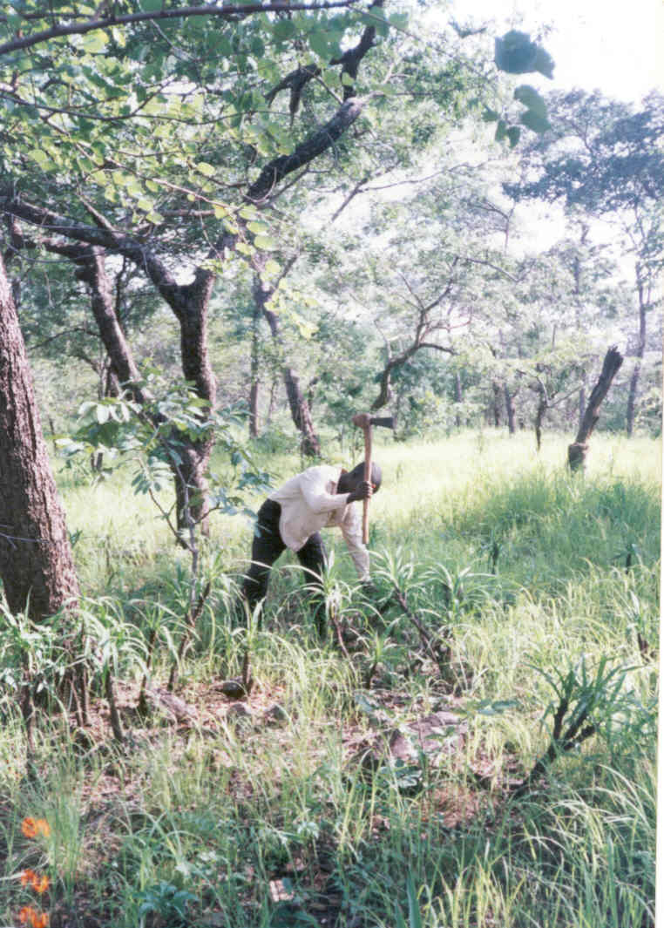

3. LEGAL ASPECTS
- Sunde shall be collected by permit obtained from the VRMAC at an appropriate cost to be determined.
- Brooms for domestic use shall be collected with a free permit. The maximum number of brooms per household allowed free is 3 (three) per year.
- Any person who burns or collects brooms without a permit commits an offence and shall be fined ZK10,000 and the brooms will be confiscated by the VRMAC.

4. ECOLOGICAL INFORMATION AND PRESCRIPTION
- DENSITY: Based on year 2000 inventory data, ¾ of the clustered plots in the northern half of the forest supported sunde, while only about half the clustered plots in the southern half did so.
- EXPLOITATION LEVELS: The greatest pressure on the sunde population comes from Matunga area where the greatest number of broom makers and traders reside, where the average numbers of plants collected per person is two to three times as high as in other parts of the forest. Density of sunde per hectare in the Matunga-Chinkhombe belt is less than half that of the Zinaka-Magobo belt. The number of broommakers in the 5 VRMAs is estimated at 80 from the 1999 Village Resource Assessment, with the heaviest commercialization in Matunga.
- GENETICS: Threats to the broom industry include overexploitation of the best-formed individuals. It is unknown if the genetic makeup of regeneration is being affected by exaggerated removal of long, straight plants. It is proposed to attempt some cropping of side-buds to encourage central shoot lengthening in some limited experimental areas to be established by VRMAC and the user group.
- FIRES: Since the other principal threat to sunde regeneration is late hot fire, harvesters are required to clear debris to a distance of 1 meter around live plants and roots. The early burning regime must also be respected. Lastly, burning of live sunde for smoking beehives is prohibited; only dead sunde may be used for this purpose. Dead sunde have no leaves growing out of the bud end.
- VEGETATIVE REGENERATION AND ROTATION AGE: One mode of regeneration is vegetative propagation by the oldest (multiple-budded) plants drooping to touch the ground and sending out shoots where they become rooted in the soil. Therefore it will be prohibited to cut sunde in this drooping state. It is estimated by some villagers that it may take 20 years for sunde to reach this level of maturity.

- PROPOSED RATE OF HARVEST BASED ON INVENTORY, NUMBER OF BROOMMAKERS, HECTARES, AND CURRENT LEVEL OF EXPLOITATION:
SUNDE CURRENTLY IN THE FOREST: Based on year 2000 inventory, the numbers of brooms currently in the forest described by age (bud) class are as follows:

STAND | AREA NOT RSRVD (HA) | NO. OF PLOTS | 1 – 3 BUDS |  | 4 – 7 BUDS |  | 8+ BUDS |  | DEAD  PER HA
STAND | AREA NOT RSRVD (HA) | NO. OF PLOTS | PER HA | TOTAL  (thous.) | PER HA | TOTAL  (thous.) | PER HA | TOTAL  (thous.) | DEAD  PER HA
1 | 100 | 8 | 1637 | 163.7 | 752 | 75.2 | 221 | 22.1 | 1681
2 | 260 | 8 | 973 | 253.0 | 221 | 57.4 | 133 | 34.6 | 2522
3 | 300 | 8 | 0 | 0.0 | 0 | 0 | 0 | 0.0 | 0
4 | 2570 | 56 | 543 | 1395.5 | 316 | 812.1 | 133 | 341.8 | 1314
5 | 5890 | 52 | 221 | 1301.7 | 88 | 518.3 | 27 | 159.0 | 549
6 | 200 | (NO PLOT) | - | - | - | - | - | - | -
7 | 415 | 8 | 0 | 0 | 0 | 0 | 0 | 0 | 0
TOTALS |  | 132 | 3113.9 thousand |  | 1463.0 thousand |  | 557.5 thousand

If we divide the current stock TOTALS by the estimated rotation length of 20 years to maturity, we get the following annually available stems:

TOTALS DIVIDED BY 20 YEARS | 1 – 3 BUDS | 4 – 7 BUDS | 8+ BUDS
TOTALS DIVIDED BY 20 YEARS | 155,700 | 73,150 | 27,875

It may be assumed that plants with 1-3 buds are usually too short to exploit, and that a good percentage of plants with 8 or more buds may be in the vegetative propagation stage and thus off limits to harvest. This leaves the bulk of the crop to be harvested in the 4-to-7 bud group.

- SUNDE NEEDED TO SUPPORT CURRENT BROOMMAKERS:
To arrive at a reasonable allowable harvest, it is proposed to make an objective “to sustain at least 80 broommakers from sunde in the forest and buffer zone”. The average annual need per single broommaker, according to the year 2000 survey, is about 100 to 400 plants per year, summing for 5 months of rainy-season production plus 7 months of dry-season production. The annual need to be sourced is thus

(80 harvesters) x (200 to 400 plants per harvester) = 16,000 to 32,000 plants per year

According to the inventory, these sunde do exist currently inside the forest and buffer zone (though it is not certain what percentage of the plants are of proper form for exploitation).
It is therefore recommended that the VRMACs be provided with sufficient permits for each of the first two years for A MAXIMUM 400 PLANTS PER PERSON x 80 PERSONS = 32,000 PLANTS, to be divided proportionately among the number of BROOMS (NOT number of broommakers) in each VRMA thus:

VRMAC | NUMBER OF SUNDE WITH  4-7 BUDS  INSIDE FOREST | NUMBER OF PERMITS/YEAR | MAX NUMBER BROOMS/YEAR
CHINKHOMBE | 92,800 | 4.76 OR 5 | 2,000
MAGOBO | 763,700 | 39.13 OR 39 | 15,600
MATUNGA | 172,100 | 8.82 OR 9 | 3,600
MKAIKA | 98,100 | 5.03 OR 5 | 2,000
ZINAKA | 434,500 | 22.26 OR 22 | 8,800
TOTALS | 1,561,197 | 80 | 32,000

The reason for proportioning the number of permits by VRMA density of brooms, and not by number of broommakers, is to avoid overexploiting the brooms in VRMAs that are already in short supply. Thus broommakers are still assured of meeting their needs, while doing so in the best-supplied VRMAs.
- After each of the first years, observations will be made by the user group and the VRGs on the success of sunde regeneration and early burning. The VRMAC will be required to monitor the number of brooms leaving the forest area to compare with the numbers and amounts sold on their permits.
- In the annual reports, recommendations will be made by the VRMAC and the user group on whether the prescribed number of permits should continue as above, or whether the methods or numbers should change.

5. FINANCIAL ASPECTS
- VRMACs shall be responsible for setting the prices of, and collecting revenue from, commercial broom harvesting permits. The VRMAC shall retain 100% of the revenues collected.
- Broom collectors themselves are to do the processing and value adding before marketing the brooms (unfinished plants are not to be sold to outsiders).
Money raised from the sale of brooms shall belong to individual members of the user groups.

6. INDICATORS FOR MONITORING
- The VRMACs shall be responsible for quantifying commercial exploitation activities for the JFM Steering Committee for annual reporting. This includes summarizing information on permits by month, area, and year, and counting broomloads/bundles going out of the forest on the way to market.
- Regeneration and mortality of sunde in selected patches will be monitored by Village Resource Guards and user group members. Excessive reports of late burns, uncleared areas around live sunde in work areas, harvest of older plants already in the drooping stage, or harvesting beyond what is permitted by the VRMAC will result in changing the quantities allowed for annual harvest, or will result in expulsion of habitual offenders from the user group.
- At least two broom depots (one in Magobo and one in Tambala) will be established to monitor sunde exploitation.
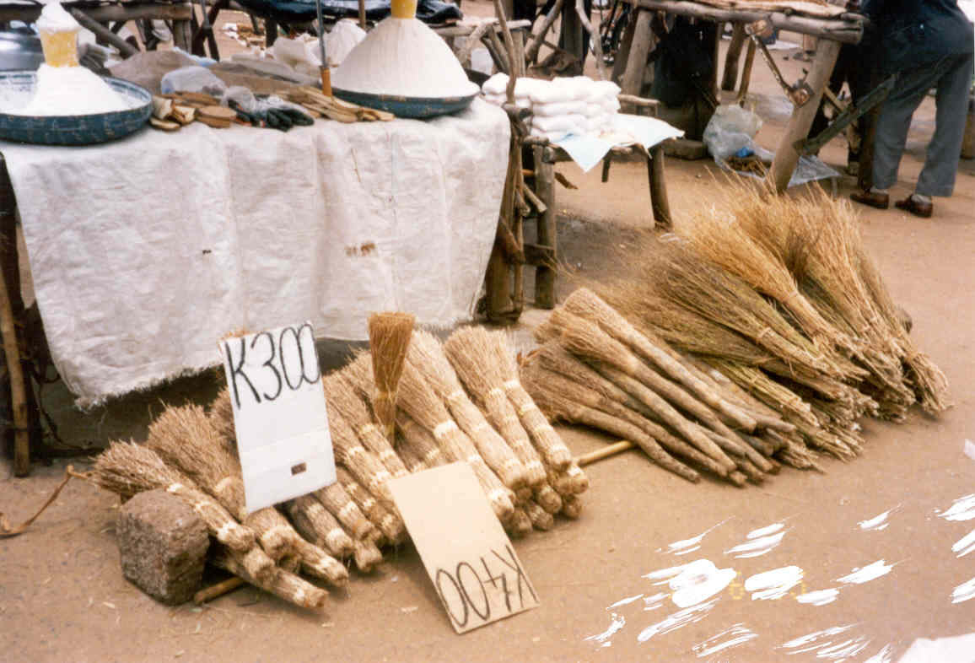
Brooms made from sunde bushes in Chiulukire Forest form a lucrative business.
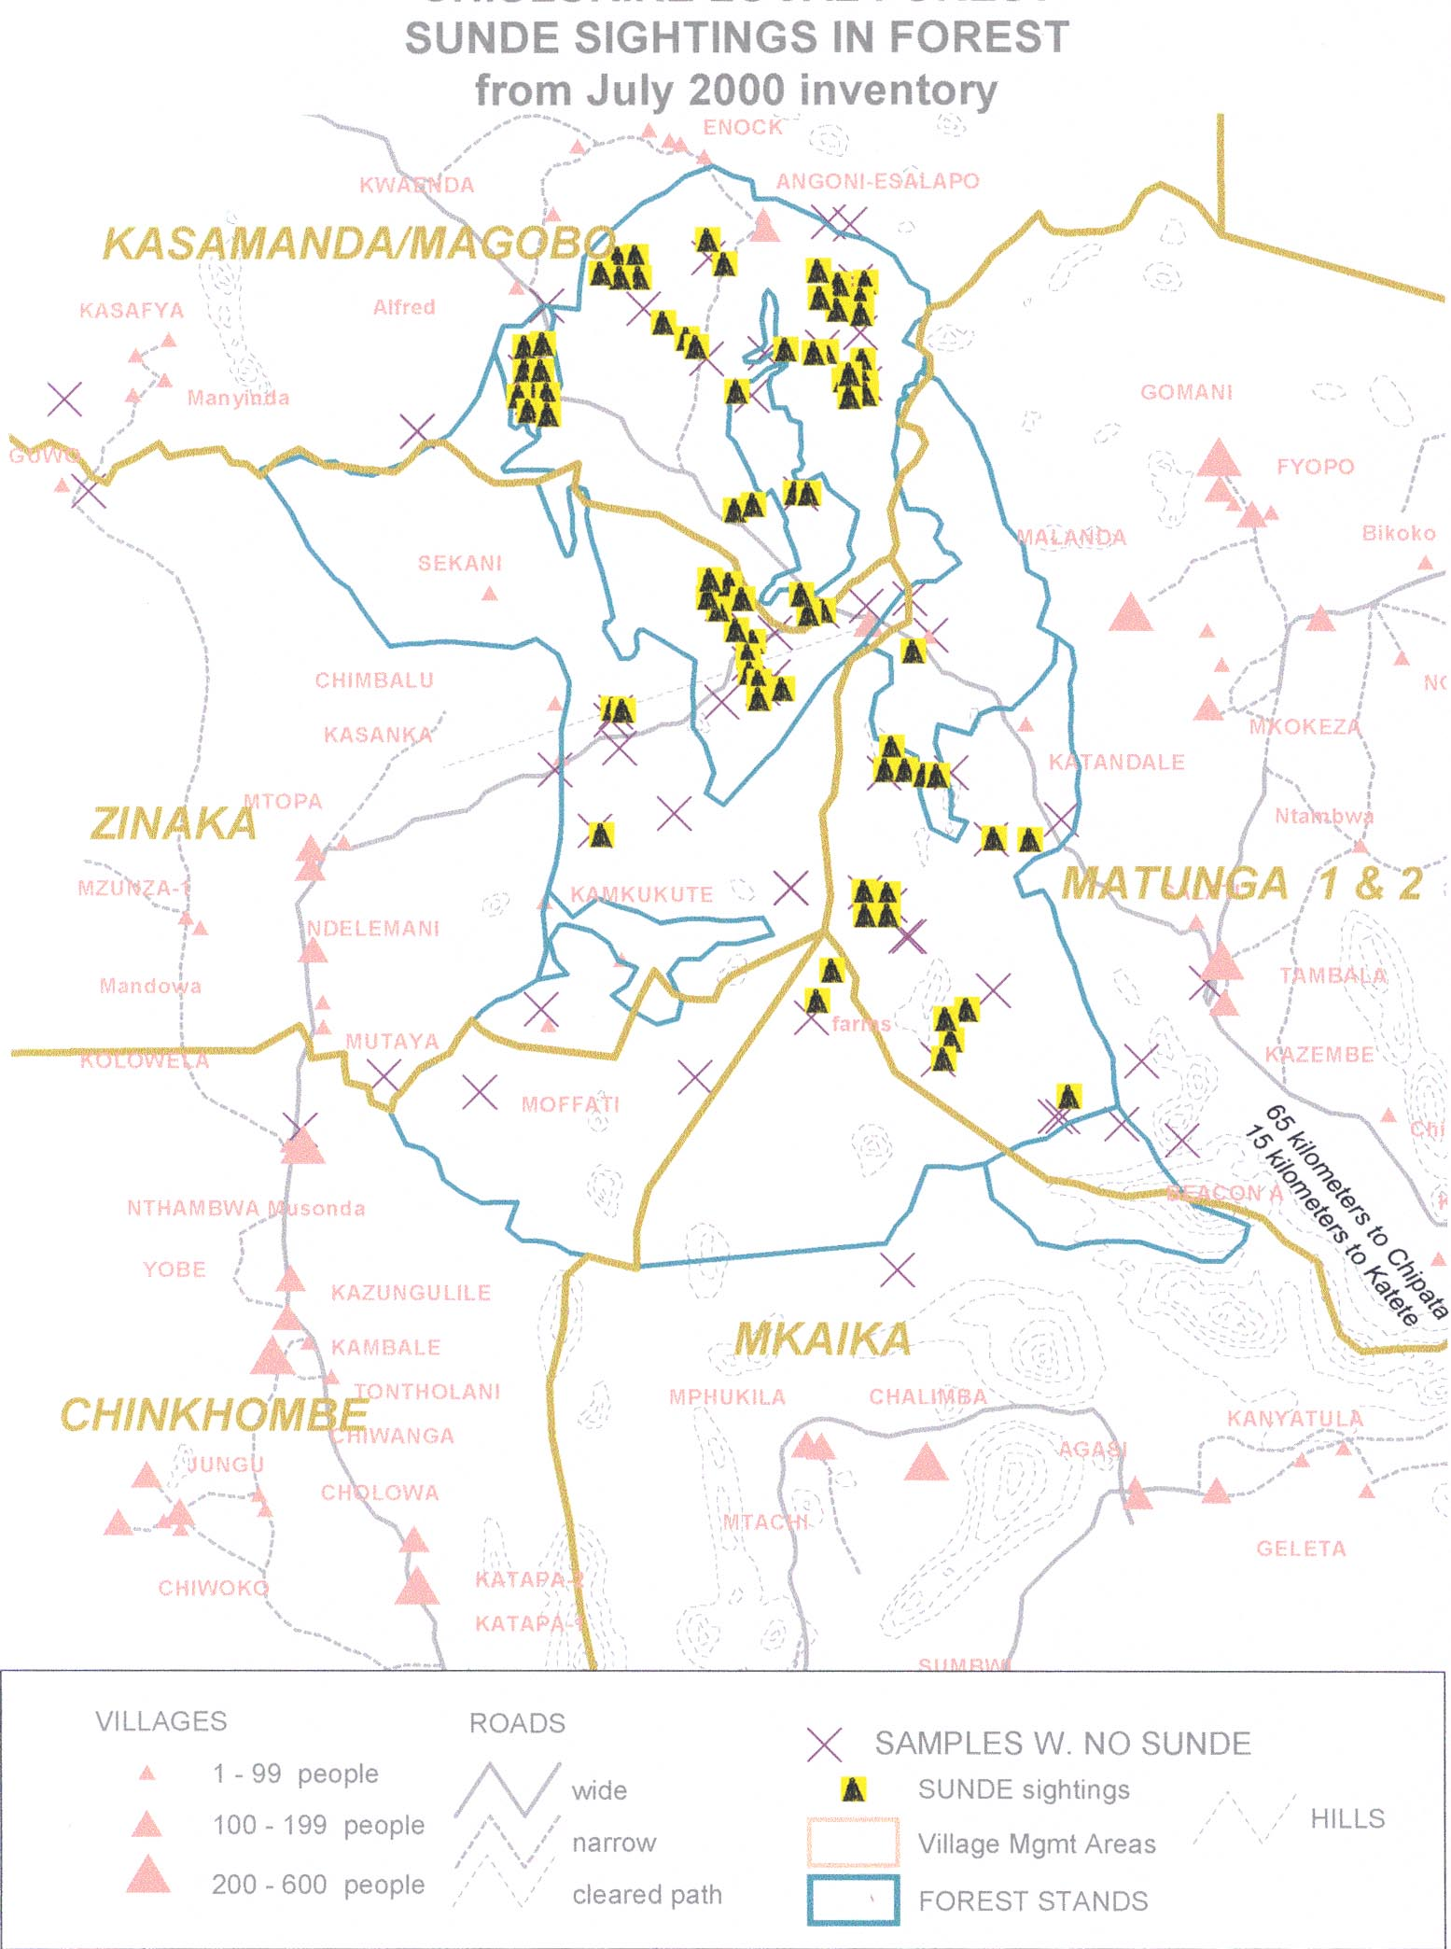
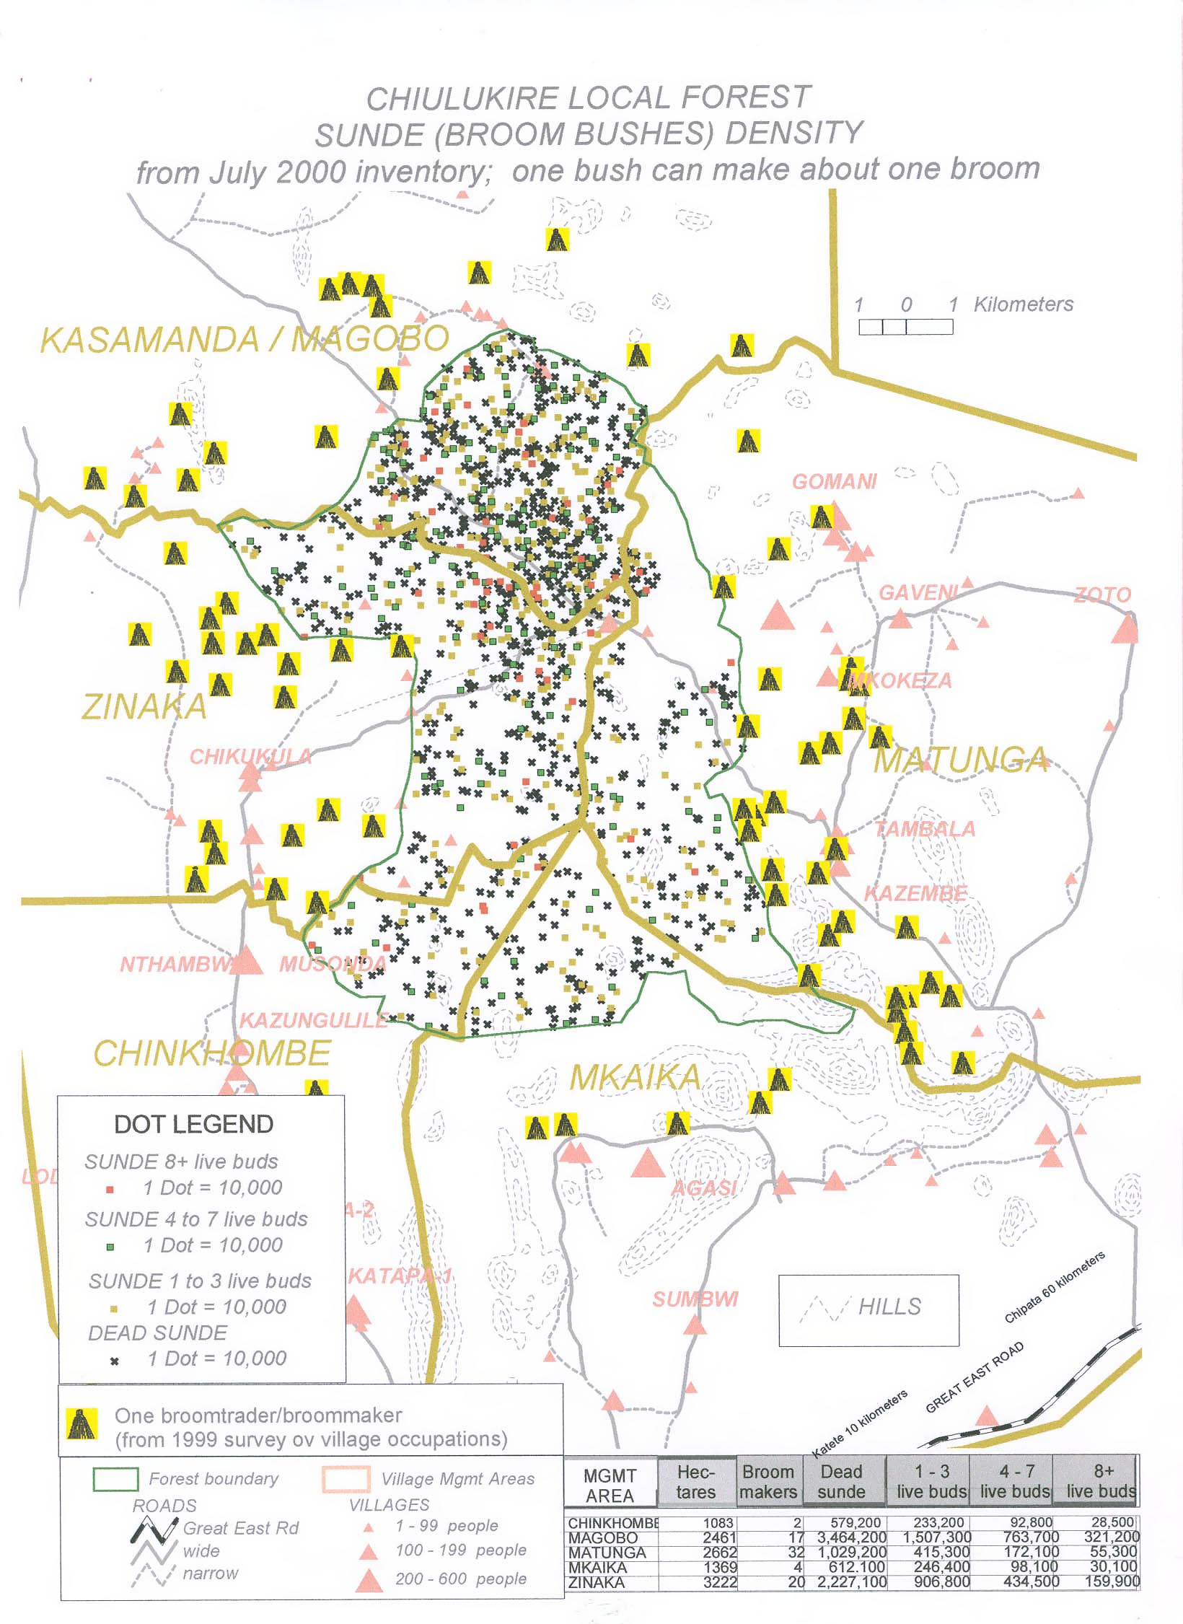
- After each of the first years, observations will be made by the user group and the VRGs on the success of sunde regeneration and early burning. The VRMAC will be required to monitor the number of brooms leaving the forest area to compare with the numbers and amounts sold on their permits.
- In the annual reports, recommendations will be made by the VRMAC and the user group on whether the prescribed number of permits should continue as above, or whether the methods or numbers should change.

5. FINANCIAL ASPECTS
- VRMACs shall be responsible for setting the prices of, and collecting revenue from, commercial broom harvesting permits. The VRMAC shall retain 100% of the revenues collected.
- Broom collectors themselves are to do the processing and value adding before marketing the brooms (unfinished plants are not to be sold to outsiders).
Money raised from the sale of brooms shall belong to individual members of the user groups.

6. INDICATORS FOR MONITORING
- The VRMACs shall be responsible for quantifying commercial exploitation activities for the JFM Steering Committee for annual reporting. This includes summarizing information on permits by month, area, and year, and counting broomloads/bundles going out of the forest on the way to market.
- Regeneration and mortality of sunde in selected patches will be monitored by Village Resource Guards and user group members. Excessive reports of late burns, uncleared areas around live sunde in work areas, harvest of older plants already in the drooping stage, or harvesting beyond what is permitted by the VRMAC will result in changing the quantities allowed for annual harvest, or will result in expulsion of habitual offenders from the user group.
- At least two broom depots (one in Magobo and one in Tambala) will be in established to monitor sunde exploitation.

THATCHING GRASS

1. SPECIFIC OBJECTIVES
- To sustain accessibility of thatching grass
- To promote regeneration of thatching grass in the forest and buffer zone by use of early burning
- For any surplus grasses, to promote commercialization of the resource to Katete, Chipata, and other markets

2. LEGAL ASPECTS
- Thatching grass for domestic use shall be collected free. However, commercial collectors shall pay for thatching grass at a fee to be set by the VRMAC.
- Late fires shall not be allowed in grass collection or any other area of the forest, and early burning should be preceded by thatch collection.

3. ECOLOGICAL PRESCRIPTION
- Hyparrhenia (nyumbu) and tsekela grass species found in Chiulukire are used for thatching houses. These grass species are found in open areas of the forest and buffer zone near dambos and stream banks. Regeneration is not affected by early burning between May and June; however, repeated late burning can be detrimental.
- Collectors are to harvest grass before the onset of early burning as announced by the traditional authorities or the Forest Department.

4. FINANCIAL ASPECTS
- Thatching grass is used extensively as roofing material and has some economic potential outside the forest, according to a study made in 2001. If a commercial operation should commence, the VRMAC will decide on the price of a permit to do so and the revenue shall be retained 100% by the VRMA.
- Priority must remain with domestic needs for thatch; therefore, if shortages of roofing materials are reported to the VRMAC by the villages, commercial activity must be curtailed.

5. INDICATORS FOR MONITORING
Village Resource Management Area Committees will hear reports of thatch shortages through village representatives and through the Village Resource Guards on a seasonal basis. The following indicators for monitoring activities may also be used:
- Continued availability of thatching material as reported by local roofers
- Amount of revenue raised from any commercial operations
- Incidences of late fires reported by VR Guards

