SAWTIMBER

1. SPECIFIC OBJECTIVES
- To sustain the sawyer populations found near the forest reserve
- To sustain and regenerate the sawtimber trees remaining in the forest and buffer
- To work with pitsawyers on conservation, regeneration, and enhancement of remaining stocks of sawtimber
- To provide training in observing regeneration and reducing waste
- Promote early burning on the part of pitsawyers and other forest users
- To promote the use of second-choice sawtimber species, especially Terminalia sericea (gonondo) and Brachystegia bussei (msale), so that pressure on Pterocarpus (mukwa) and Pericopsis (muwanga) is reduced

2. STRATEGY
IN THE FIRST YEAR OF THE MANAGEMENT PLAN:
- Identify and describe sawing workforce composition, work habits, and rates of domestic versus commercial cutting.
- Inventory remaining stands and pockets identified by VRMAs to be special cutting areas.
- Identify areas to be cut in each of the 5 VRMAs. These are termed “OPERATIONAL AREAS”. Operational areas exclude protected galleries and reserved areas. Clearfelling on steep slopes (>30%) is prohibited.
- Set up coupes or some cutting-area scheme for the 10-year rotation, most likely in combination with the charcoal-cutting plan.
- Inform all recognized area sawyers of
- Reserved areas off limits for cutting
- Minimum diameter to cut, and any new legislation they should know
- Policies for cutting diseased and malformed trees
- Policy for leaving seed trees evenly distributed in forest (proposed 1 tree of seed-producing age for each 10 hectares): including marking these trees
- Fines that will be imposed by VRMAC or FD for mis-using or wasting trees
- Provide training and information on
- proper cutting methods (proposed site visits to Petauke; some good sawyers have also been identified in Zinaka and Magobo)
- utilization and marketing of alternative timber species (especially Terminalia sericea and Brachyst bussei)
- Identify existing and potential markets
- Set up monitoring plots or other scheme to ensure regeneration protection (post-cut inspections once per quarter by VRMAC, sawyer leader, or FD; also VR Guard patrols)
- Review current cutting plan, policy, and allowable cut calculations to modify where necessary.

IN THE REMAINING YEARS OF ROTATION:
- Quarterly or yearly monitoring of regeneration from seed (on the assumption that stump sprouts produce an inferior sawtimber tree)
- Continued marketing and promotion of alternative timber species
- Monitoring of the number of pitsawyers in the 5 VRMACs; establishment of criteria for allowing outsiders to harvest
- Annual evaluations of appropriateness of cutting policy and adjustments as necessary by consensus of sawyers, Forest Department, and VRMA.

3. CALCULATION OF ANNUAL ALLOWABLE CUT

3.1. ANNUAL CUT CALCULATION FOR TIMBER PRODUCTION IN PURE STANDS SUCH AS MSALE (BRACHYSTEGIA BUSSEI):
The following formula for number of trees to cut annually may be applied; an illustration is found in the tables following.
(sum of trees in all pure stands in a geographic area, using an estimate of total trees
currently >30cm in each stand)
divided by
(number of years the trees have to last until next size class moves up = 15 to 30 YEARS)
minus
(“seed trees” to be left standing)

- Seed trees of sawtimber species with GOOD FORM (straight) are to be left standing at the rate of 1 per hundred meters perimeter around clear-cuts of pure stands plus 1 per hectare on the interior.
- Regeneration will have to be monitored and protected more carefully in these areas for successful stand replacement.

3.2. ANNUAL SAWTIMBER CUT CALCULATION FOR SELECTIVE HARVEST:
The following formula for number of trees to cut annually may be applied, and are illustrated in the following tables.

(number of existing, quality, exploitable trees³ in each operating area, based on  year 2000 inventory averages per hectare) X (number of hectares)  minus  “seed trees”²  to be left standing at the rate of 10% of sawtimber trees >30cm in diameter | → | minus  (any deficiency in the diameter class of next-rotation’s sawtrees)  divided by  (NUMBER OF YEARS the trees have to last) ¹

3.3. THEORETICAL TABLES OF MAXIMUM ALLOWABLE ANNUAL CUTS INSIDE CHIULUKIRE FOREST

PRIMARY SAW SPECIES (MUKWA AND MUWANGA):

(1) | (2) | (3) | (4) | (5) | (6) | (7) | (8)
VRMA  OPERABLE HECTARES / TOTAL HECTARES  (allowing for galleries and reserved areas = 5% of hectares removed) | TOTAL mukwa and muwanga >30cm diam  =  (from inventory, less 5%) | POOR QUALITY TREES allowing for half, as per inventory  =  ½ X (2) | STANDING GOOD QUALTY SAWTREES THIS YEAR  =  (2) – (3) | SEED TREES =  (10%) of  (4) | DEFICIENCY IN NEXT LOWER SIZE CLASS A  =  1/2 x (4) | TOTAL EXPLOIT-ABLE TREES STANDING THIS YEAR  =  (4) – (5) – (6) | TOTAL PRIMARY SAWTREES EXPLOITABLE EVERY YEAR FOR THE NEXT 15 YEARS  = (7)  divided by  15 years
CHINKHOMBE  1030/1083 ha | 902 | 451 | 451 | 45 | 226 | 180 | 12
MAGOBO  2340/2461 ha | 162 | 81 | 81 | 8 | 40 | 33 | 2
MATUNGA  2530/2662 ha | 4257 | 2128 | 2128 | 213 | 1064 | 851 | 57
MKAIKA  1300/1369 ha | 2450 | 1225 | 1225 | 122 | 612 | 491 | 33
ZINAKA  3060/3222 ha | 2009 | 1004 | 1004 | 100 | 502 | 402 | 27

NOTES:
1.These numbers are based on year 2000 inventory averages per hectare in each stand of the forest, then taking into account the proportion of each stand inside each of the 5 VRMAs. They represent maximum cuts that are allowable and not required cuts.

2. They apply strictly to trees growing inside the forest boundary; trees in the open area should have their own separate “allowable cut” based on local needs and monitored by traditional authorities and the Forest Department.

3. See the map on the following page.
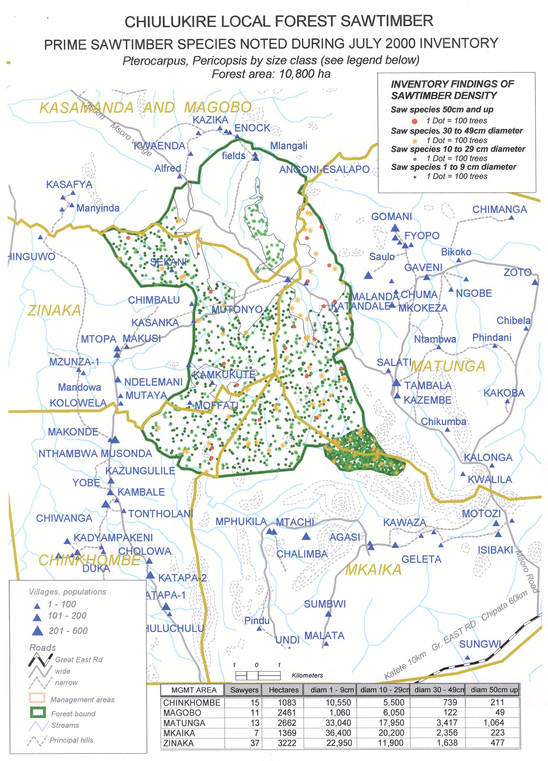
SECONDARY SAWTIMBER (Brachystegia bussei, Burkea africana, Kirkia spp., Terminalia sericea):

(1) | (2) | (3) | (4) | (5) | (6) | (7) | (8)
VRMA  OPERABLE HECTARES / TOTAL HECTARES  (allowing for galleries and reserved areas = 5% of hectares removed) | TOTAL second-ary >30cm diam  =  (from inventory, less 5%) | POOR QUALITY TREES allowing for half, as per inventory  =  ½ X (2) | STANDING GOOD QUALTY SECOND-ARY SAWTREES THIS YEAR  =  (2) – (3) | SEED TREES =  (10%) of  (4) | DEFICIENCY IN NEXT LOWER SIZE CLASS A  =  1/2 x (4) | TOTAL EXPLOIT-ABLE SECOND-ARY TREES STANDING THIS YEAR  =  (4) – (5) – (6) | TOTAL SECONDARY SAWTREES EXPLOITABLE EVERY YEAR FOR THE NEXT 15 YEARS  = (7)  divided by  15 years
CHINKHOMBE  1030/1083 ha | 3,909 | 1,954 | 1,955 | 196 | 978 | 781 | 52
MAGOBO  2340/2461 ha | 3,666 | 1,833 | 1,833 | 183 | 916 | 734 | 49
MATUNGA  2530/2662 ha | 18,124 | 9,062 | 9,062 | 906 | 4,531 | 3,625 | 242
MKAIKA  1300/1369 ha | 5,724 | 2,862 | 2,862 | 286 | 1,431 | 1,145 | 76
ZINAKA  3060/3222 ha | 9,609 | 4,804 | 4,805 | 480 | 2,402 | 1,923 | 128

NOTES:
1. See footnotes on previous table for primary sawtimber (mukwa, muwanga).
2. These numbers are based on year 2000 inventory averages per hectare in each stand of the forest, then taking into account the proportion of each stand inside each of the 5 VRMAs. They represent maximum cuts allowable and not required cuts.
They apply strictly to trees growing inside the forest boundary; trees in the open area should have their own separate “allowable cut” based on local needs and monitored by traditional authorities and the Forest Department.

3. See the map on the following page.

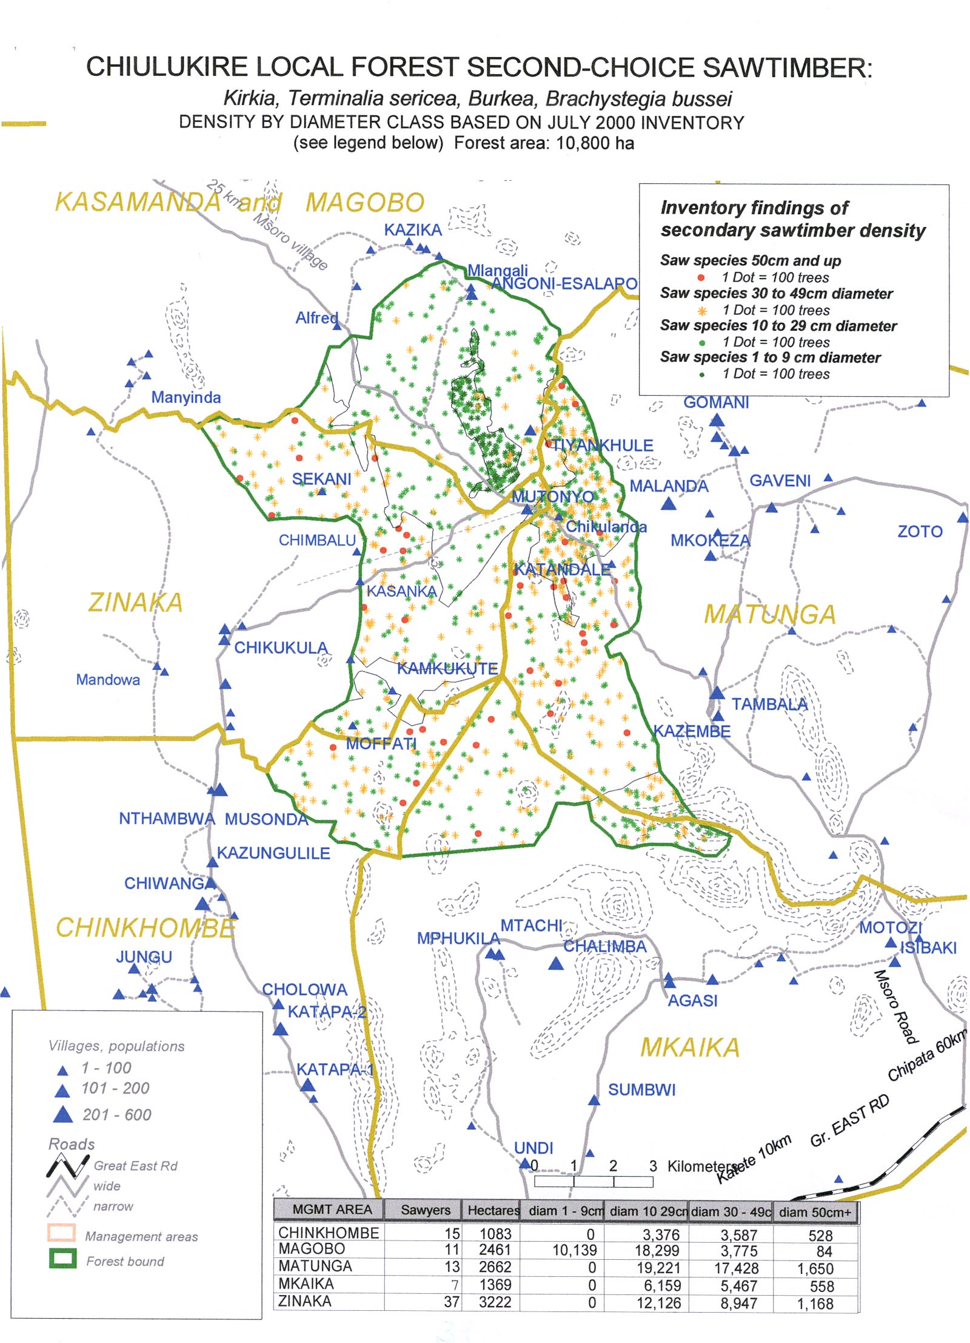

4. LEGAL ASPECTS
- A moratorium on all cutting of Khaya, Swartzia, Afzelia and Dalbergia is imposed.
- Sawing with chainsaws or sawmills inside the forest is prohibited at this time.
- “Commercial sawing” in the sense of pitsawyer association licences (requiring a 5000 hectare minimum) will not be allowed in the forest.
- “Commercial sawing” in jointly-managed Chiulukire Local Forest will be carried out on the same basis as “artisinal sawing” in the sense that only a domestic-use licence will be issued for each tree proposed for cutting in a year. Accordingly, each tree will require a separate permit to be purchased at the rate set by the Forest Department. The VRMACs will be in charge of selling the permits and partitioning revenue as provided in the section on Financial Aspects below.
- Only sawyers who are residents of Chiulukire villages and who are recognized as such by the VRMACs have the right to saw trees inside the forest. If the maximum allowable cut is not met year after year, the VRMAC with the sawyer groups may consider selling permits to sawyers outside the area PROVIDED THAT THEY UNDERGO SENSITIZATION ONTHE LEGAL AND ECOLOGICAL ASPECTS OF THIS PLAN.
- The sawyer has the right to sell his product either in the villages or in other markets. However, any wood destined to a commercial market will be subject to the Forest Department conveyance fee. Also, if shortages of wood for village use become apparent (as reported by householders to the VRMAC or village headmen), the policy on commercial selling rights will be reviewed.
- The number of permits issued to the VRMAC for selling trees each year will be based on an “allowable cut”, based on 3 items: year 2000 inventory data on trees per hectare by stand and VRMA; known number of sawyers in the areas; and the yearly requirement to sustain this known number. The maximum cut is described in the tables above.
- Permits that go unsold at the end of the year may not be transferred to the following year (this is to avoid a backlog of potentially destructive mass cutting taking place all at once).
- The requirements and provisions of these cutting rules must be reviewed after 3 years to make any necessary changes.
- Trees that are uprooted by nature may be recuperated by sawyers who obtain a paid permit from the VRMAC at the standard price.

5. ECOLOGICAL PRESCRIPTION
- No cutting is allowed in the reserved areas, including within 30 meters of streambeds. Rules described in the CUTTING METHODS chapter apply to pitsawing.
- The northern tier contains the lowest density of sawtimber sizes and species in the forest. Here, regeneration needs the greatest protection if important sawtimber species are to grow to merchantable size even to support the relatively few sawyers in Magobo. It is therefore proposed to double fines for late fires in the northern tier, including Magobo and Zinaka VRMAs.
- In the southern 2/3 of the forest (stands 5 and 7), there is fairly good regeneration of Pterocarpus and Terminalia sericea and of Pericopsis. In larger sizes, Pterocarpus and Brachystegia bussei are more common. For now, there seem to be enough trees to go around for the existing sawyers for 10 years of exploitation in stand 5. However, existing regeneration should be protected and allowed to reach sawtimber size.
- Because of their relative abundance and good regeneration, Brachystegia bussei and Terminalia sericea should be promoted as acceptable alternatives to Pterocarpus and Pericopsis. This implies that information and training on marketing of and value adding to these alternative sawtimber species should be provided to sawyer groups.
- Pitsawyers must work with other user groups to ensure future sawtimber tree availability. This includes sharing information about tree allocation for straight-stemmed mukwa and mubanga that can be the object of competition between pole cutters, charcoal producers, and sawyers.
- There should be adequate seed trees left at a proposed average rate of one per 10 hectares. Species left must be among the following: Terminalia sericea, Pterocarpus rotundifolia or angolensis, Pericopsis angolensis, Afzelia quanzensis, Khaya spp., Swarzia spp., and Dalbergia melanoxylon.
- Sawyers will need to work with grazing animal owners to ensure that regeneration of sawtimber species is not eliminated.
- Sawyers will need to work with charcoal producers so that both groups know that the priority use of a straight young mukwa or mubanga is for a future sawtimber tree. Sawyers should be present at coupe sites to claim this priority.

6. FINANCIAL ASPECTS

6.1. POSSIBILITIES FOR PAYMENT OF CUTTING PERMIT
- The sawyers in their groups could acquire forward contracts for their products so that the VRMAC could waive the cost of cutting permits until the product is sold. This would require meticulous record-keeping on the part of the VRMAC and on the part of the sawyers if they want to assure their due.
- Alternatively, the first permit for a cutting season’s supply of trees could be attained by securing a loan from CMS or at some other level, then paying it back once the products are sold. A percentage of the first year’s profits should then be set aside in a bank account or other savings to assure that the next season’s permit can be afforded.

6.2. COST OF A TREE AND REVENUE SHARING
- The cost of a permit to fell a tree is set by the Forest Department of Zambia at the current rate. For example, in year 2001, this rate is
- ZK 18,000 for one Pterocarpus angolensis
- ZK 10,800 for one Pericopsis angolensis
- The revenues from tree-cutting permits, which are sold through the VRMACs, will be shared according to the percentages described in Section Five of this plan.
- Tree-cutting permits are apart from the usual CONVEYANCE FEE which must be paid by sawyers. This fee is set by the Forest Department at the rate of ZK 2,700 per cubic meter of sawn wood of any species. The Forest Department will determine the appropriate procedure to collect the conveyance fee.

7. INDICATORS FOR MONITORING
- Annual number of sawtimber tree permits sold and remaining unsold by each VRMAC
- Number of infractions noted by VR Guards and Forest Department inspections
- Reports by user group and VR guards on regeneration success in cut areas and around seed trees
- Revenues raised for Forest Dept. and VRMACs each year
- Species and sawproducts brought to market each year
Number of conflicts between user groups recorded and resolved by VRMAC and the JFM Committee, such as sawyers and grazers, polecutters, and hunters.

15 years is the estimated number of years that trees will take to move from one diameter class to the next. To be more accurate, more research should be carried out by the Forest Research Department on tree growth, by establishing permanent plots. Inventory showed an absence of trees in the size class below 30 cm for stand 5 (6000 hectares); therefore, current trees must last 30 years.
Seed trees are trees of good form relatively straight and tall with the best potential for producing seedlings of good form. If all (100%) of the best trees are taken away before having a chance to regenerate, then there would be no future work for pitsawyers.
“EXPLOITABLE TREES” are those with actual sawtimber content in them. During the inventory, roughly half of the potential sawtimber trees contained saw products in them.
Regeneration can be estimated by using year 2000 inventory average estimate x hectares in operational area.
A STAND 5 (6000 hectares) had an average 0.9 mukwa + muwanga per hectare >30 cm diameter, and an average of ZERO mukwa + mubanga in the class 20 to 29 cm diameter. Therefore, in stand 5, the trees >30cm diameter have to last 30 years. Overall, mortality rates between youngest to middle size class was 41%; between middle to small saw class, mortality was 87%; and between the small saw class and large saw class was 75%. Since normal uneven-aged forests tend to have constant rates of mortality and loss between age classes, the estimated shortage of the middle to small saw class is probably at least a half. That is, there are not enough younger trees to replace all the older trees presently in the forest. Threfore, the current trees have to last longer to satisfy local needs “sustainably”.
A The deficiencies for secondary sawtimber species are extremely severe in the lowest size class, 1 to 9 centimeters in diameter, where only in Magobo VRMA were individuals recorded in this size class during inventory. However, regeneration plots revealed healthy young secondary sawtrees in most stands. Therefore the deficiency rate is still kept at one-half the available sawtrees, in order to plan for the two rotations beyond the current one.

