HONEY AND BARKHIVE PRODUCTION
Maps presented at the end of this chapter show the abundance of bee forage and hivemaking trees currently inside Chiulukire Local Forest.

1. SPECIFIC OBJECTIVES
- To promote marketing of honey, propolis, and wax
- To sustain a strong level of honey production in Chiulukire Local Forest
- To maintain bee forage regeneration
- To maximize use of the trees consumed for barkhives

2. STRATEGY
- Train people in good beekeeping methods and marketing.
- To combine hivemaking with charcoal, medicine, sawtimber, carving, and construction pole exploitation
- To organize beekeepers into user groups by VRMA or geographical location so that the numbers and names of beekeepers can be used for sustainable planning
- To explore possibilities of using other materials for beehives

3. LEGAL ASPECTS
- A permit shall be required to hang hives and crop honey inside Chiulukire Local Forest. For home use a maximum number of 6 hives per household per year may be maintained after obtaining a free permit.
- For commercial use, a fee will be required by way of killing or felling trees to make barkhives (see Ecological Prescription).
- The number of commercial hives allowed per registered beekeeper will start in the first two years at 10. Monitoring of regeneration of forage and hive trees, fire control, and level of adherence to rules (maximum hives and cropping months respected) will determine whether the number of 10 hives will be sustained beyond the first 2 years. Beyond 10 hives, they must be located outside the forest boundary.
- Honey hunting (cutting or burning a tree to get at wild hives) shall not be permitted inside the forest and shall carry a fine of ZK10,000.
- Fire and chemicals shall not be permitted when cropping honey.

4. ECOLOGICAL PRESCRIPTION
- In order to allow proper regeneration of bees and pollination of flowers, honey shall only be harvested from April to June and October to December.
- Cotton pesticides are known to be destructive to bees and beekeeping. Therefore, poisons used in cotton production must be kept at a distance of 200 meters from hives hung in trees.
- The preferred trees for bee forage in honey production are shown in the following table, and their regeneration is of interest to the beekeeper user groups.

PREFERRED BEEKEEPING FORAGE SPECIES

Acacia erioloba (mkunkhu) | Diplorhynchus condylocarpon (mtowa)
Adansonia digitata (mlambe) | Julbernardia globiflora (kamphoni)
Adenia senensis (mwanya) | Lannea discolor (shaumbu)
Afzelia quanzensis (mpapa) | Pseudolachnostylis maprouneifolia (msolo)
Brachystegia longifolia (bovu) | Pterocarpus rotundifolius (mbangozi)
Combretum molle (kalama) | Sterculia africana (mlele)
Dalbergiella nyasae (mkanganjovu) | Terminalia sericea (gonondo)

- These species are currently well distributed in all the five Village Resource Management Areas; monitoring will therefore include an element of noting exaggerated mortality of these species and causes of the mortality.
- Julbernardia globiflora and paniculata and Brachystegia boehmii and spiciformis are preferred for barkhive construction because they don’t warp. However, they are also used for charcoal, firewood, and medicine. It is therefore proposed that hivemakers (who are required to kill trees to make their hives) join with charcoal producers to make their hives and assist in paying for Julbernardia and Brachystegia trees felled for charcoal.
- Bees help in pollinating trees and crops. To maintain harmony in the colony and avoid absconding and migration of bees, the Queen Bee should be protected by assuring her food supply and physical cover: some honey and comb should be left in the hive when cropping, and the months of prohibited harvest should be respected (July-September and January-March).
- The number of free barkhives allowed per household is tentatively set at SIX per year.
- For commercial beekeepers (required to be “registered” and in “groups” for purposes of training and communications), a maximum average of 10 hives per year beekeeper (each hive replaceable every 4 years) is allowed. The table below shows the number of Beekeepers and the MAXIMUM NUMBER OF HIVES in each Village Resource Management Area:

NAME OF VRMA | NO. OF BEEKEEPERS | MAX. NO. OF BARKHIVES
MAGOBO | 71 | 710
ZINAKA | 54 | 540
MATUNGA | 44 | 440
CHINKHOMBE | 36 | 360
MKAIKA | 25 | 250
TOTAL | 230 | 2300

Assuming a rate of 1 hive per tree and hive replacement of once per 4 years, this indicates a necessity of felling (2300/4 =) 575 trees every year. It was found that these trees do exist in the forest currently, but their regeneration will have to be monitored closely by the hivemakers and by the charcoal producers alike. It is also assumed that some of the hive trees will be felled outside the forest boundaries.
- If the above-mentioned 575 trees are cut every year, and an average number of sacks of charcoal contained in hive-sized trees is 1.5, then it is conceivable that
(575 x 1.5 =) more than 800 sacks of charcoal
are contained in the yearly allotment of hive trees. These trees shall be felled by permit only with the VRMAC for commercial exploitation.
- Beekeepers with more than 10 hives currently inside the forest are obligated to move the surplus hives outside the forest boundary.
- See the charcoal chapter for links to other users of hive trees.

5. FINANCIAL ASPECTS
- The Village Resource Management Area Committees shall be responsible for issuing permits for hanging hives (both the household-use free permits and the commercial felled-tree paid permits). The paid permits are a percentage of the cost of the tree used to make charcoal: the charcoal-maker pays 75%, and the hive-maker pays 25%.
- Honey that is processed and graded is of higher value than crude honey. Comb honey, pollen honey, water pollen honey and granulated honey all fetch different prices. User group training on processing and grading will be sought on demand.
- Training on wax and propolis processed into medicines, polishes, and candles will be promoted on demand.
- Revenue collected from honey and by- product sales shall belong to members of the beekeeping user groups.

6. INDICATORS FOR MONITORING
The Village Resource Management Area Committees and the beekeeping user groups shall be responsible for monitoring the beekeeping activities using the following indicators.

- Numbers of beekeeping user groups and people in each group
- Quantity and quality of honey produced by the groups (to be reported annually by groups to VRMAC)
- Revenue raised by commercial beekeeper permits (documented by VRMAC)
- Number of honey hunters caught and fined by the user groups and the VRGs
- Regeneration of bee forage species (reported annually by user group to VRMAC)
- Training in value adding and grading requested and carried out in the user groups; numbers of beekeepers trained.
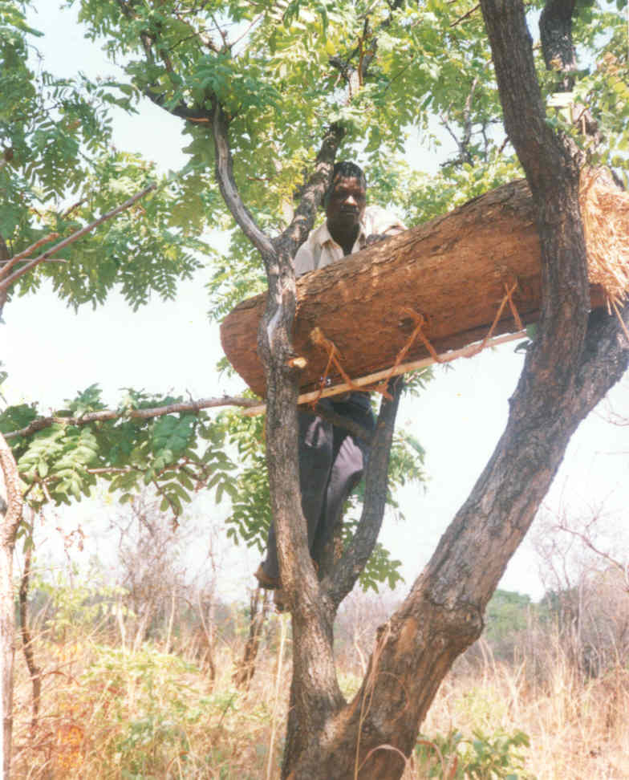
- Beekeepers with more than 10 hives currently inside the forest are obligated to move the surplus hives outside the forest boundary.
Beekeeping is already a common source of household income in Chiulukire Forest.

- See the charcoal chapter for links to other users of hive trees.

ONE SYMBOL REPRESENTS
100 BARKHIVES POTENTIALLY MADE FROM STANDING TREES
VRMA | BEEKEEPERS | HECTARES | HIVES

MEDICINAL PLANT PARTS

1. SPECIFIC OBJECTIVES
- To assure the long term supply of authentic medicinal plants found in Chiulukire local forest

2. STRATEGY
- Regulate the use of certain rare important medicinal species, particularly mlunguchulu (Zanthoxylem chalybeum)
- Provide educational campaigns in the villages on proper and legal harvesting methods of medicinal plants
- Provide educational campaigns to user groups (for example charcoal producers) on conservation of medicinal trees

3. LEGAL ASPECTS
The following regulations shall apply when collecting medicinal plants:
- Medicinal plants for domestic use shall be collected by registered, sensitized users only.
- Ring barking plants when collecting medicine is prohibited.
- Medicinal plants shall be protected against late fires.
- Felling or killing trees for medicinal content is prohibited.

4. ECOLOGICAL PRESCRIPTION
- Chiulukire local forest is endowed with a rich supply of plants whose roots, bark, and leaves are used for medicinal purposes. Improper harvesting of bark and roots can destroy plants.
- The most important commonly used medicinal plants are in the following table:

LOCAL NAME | SCIENTIFIC NAME | LOCAL NAME | SCIENTIFIC NAME
changaluche | Zanha africana | mpalankhanga | Albizia harveyii
chipembele | Xeromphis obovata | msekese | Piliostigma thonningii
kankhande | Ziziphus abyssinica | mtondo | Julbernardia paniculata
mbwabwa | Cussonia arborea | mtukumphako | Pavetta schumanniana
mkanganjovu | Dalbergiella nyasae | mtunda | Turraea nilotica
mleza | Cassia abbreviata | nthudza | Flacourtia indica
mlombe, mukwa | Pterocarpus angolensis | shaumbu | Lannea discolor
mlunguchulu | Zanthoxylem chalybeum
These species regenerate readily from seed, root suckers and stumps.
- Herbalists should visit planned coupe and other cutting areas before trees are felled to extract products important to their trade.
- The use of specific trees that are becoming rare due to overuse shall be regulated. In the immediate, this includes the following species:
  - Mlunguchulu (Zanthoxylem chalybeum)
  - Use of these species will require a special permit.
  - An informational campaign on these rare species shall be carried out by herbalists.

5. FINANCIAL ASPECTS
- Medicinal plants shall be collected free from the forest as long as they are not sold outside Chiulukire area for profit. Professional herbalists must register as such with the VRMAC and receive instruction on ecological aspects before being added to the register annually.
- In the event that any medicine sales grow to the point of becoming highly commercial, the VRMAC will decide on permit costs and procedures.

6. INDICATORS FOR MONITORING
- The herbalist user group must monitor for any shortages of needed plants and keep the VRMAC informed.
- If the Village Resource Guard can assist in observing proper use of medicine trees, the user group must make an arrangement with him to do so.

MUSHROOMS

1. SPECIFIC OBJECTIVES
- To increase the availability of mushrooms in the forest reserve and buffer zone
- To conserve trees which are associated with mushroom growth
- To promote increased revenue from sale of mushrooms by adding value (drying, salting, spicing)

2. STRATEGY
- Mushroom collectors should notify VRMACs of special areas for seasonal collection so that other harvesting operations do not destroy collectors’ areas.
- The user group can request training in value adding, with preference given to trainers within VRMAs.

3. LEGAL ASPECTS
- Authority shall be sought from the Village Resource Management Area Committees for collecting mushrooms from the forest. FIRST PRIORITY FOR THIS ACTIVITY WILL BE GIVEN TO WOMEN AND CHILDREN RESIDING IN THE VRMAs.
- The following activities shall not be allowed in mushroom collection areas:
- Cultivation of fields
- Late burning
- Grazing of livestock
- Production of charcoal
- Cutting, felling, burning, or injuring trees associated with mushrooms

4. ECOLOGICAL PRESCRIPTION
- Mushrooms are commonly found on sandy loam soils with associated vegetation. The mushrooms may require leaf litter, bark, or other organic matter associated with specific vegetation (especially trees), and thus the longevity of a mushroom crop being found in an area will depend on the continued presence of certain trees and their leaf fall.
- In Chiulukire, most of the mushrooms are found in the Eastern and Southern parts of the forest and in buffer zone dambos. They grow through asexual reproduction: spores from the fruiting body are important for genetic diversity of mushrooms. Mushroom harvesting has little impact on the environment.
- Late fires threaten leaf-cover required for some mushrooms to grow. Again, the importance of early burning instead of destructive late burning will play a role.
- The table below shows the type of mushrooms found in Chiulukire local forest area and some known associated tree species. Since many of the associated trees correspond to charcoal trees, charcoal producers are required to inform mushroom collectors of their zone of work each year.

5. FINANCIAL ASPECTS
The mushroom collectors shall retain 100% of the revenue they generate from sales.

6. INDICATORS FOR MONITORING
Mushroom collectors shall be responsible for monitoring collection activities and reporting problems to the VRMAC. The Village Resource Guard shall also assist in monitoring.
The indicators for monitoring shall be as follows:

- Availability of different edible mushroom varieties | - Number of mushroom collection areas
- Regeneration of species associated with mushrooms | - Incidences of late fires

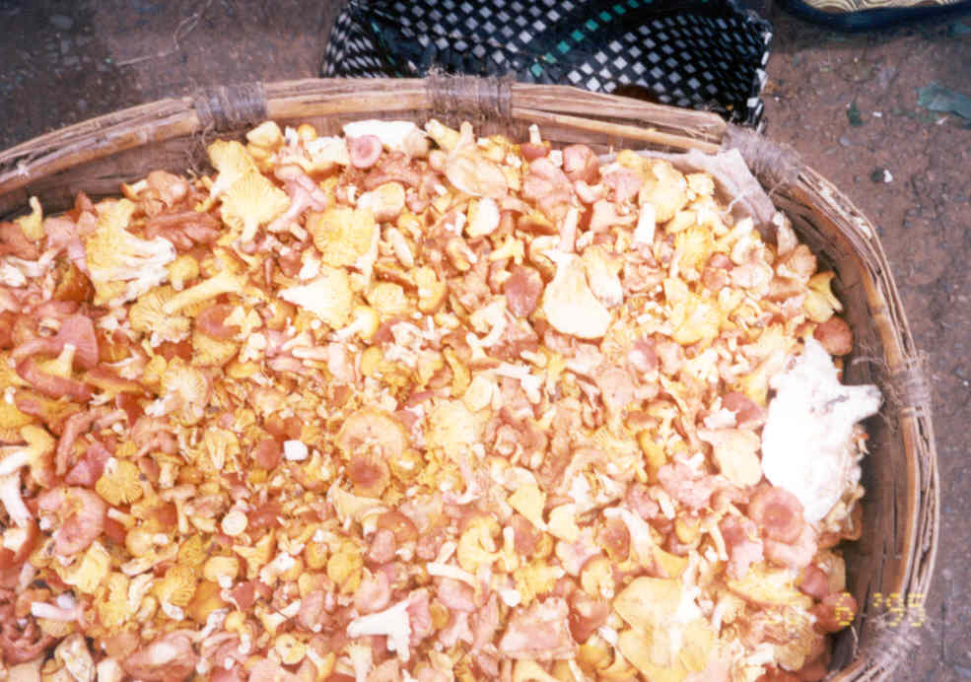

Mushrooms add to the diet and the household income.

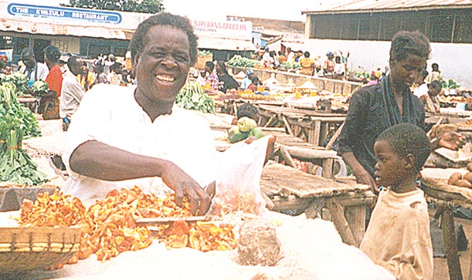

SOME TREE SPECIES ASSOCIATED WITH MUSHROOM PRODUCTION

LOCAL MUSHROOM NAME | SCIENTIFIC/ ENGLISH NAME | LOCAL NAME OF TREE SPECIES | SCIENTIFIC NAME OF TREE SPECIES
Chipindi | Russula spp | Kamphoni  Mkuti  Gonondo  Mgalilondo  Msolo  Msuku | Julbernardia globiflora  Brachystegia utilis  Terminalia sericea  Afzelia quanzensis  Pseudolachynostylis maprouneifolia  Uapaca kirkiana
Manyame | Cantharellus miniatescens | Kamponi  Mkuti  Gonondo  Mgalilondo  Msuku | Julbernardia globiflora  Brachystegia utilis  Terminalia sericea  Afzelia quanzensis  Uapaca kirkiana
Ndelemya | Amanita zambiana | Msuku,  Mgalilondo  Msale | Uapaca kirkiana  Afzelia quanzensis  Brachystegia bussei
Kambakumbaku |  | Gonondo | Terminalia sericea
Kalawelawe |  | Mkanganjovu  Chimphakasa  Msuku  Kasokolowe  Mtombozi  Mtondo | Dalbergiella nyasae  Lonchocarpus capassa  Uapaca kirkiana  Uapaca nitida  Diplorhynchus condylocarpon  Julbernardia paniculata
Maso ang’ombe |  | Gonondo  Kamponi  Mgalilondo  Bovu | Terminalia sericea  Julbernardia globiflora  Afzelia quanzensis  Brachystegia longifolia
Bowafisi | Termitomyces (letestui?) | Gonondo  Kamponi  Mgalilondo  Bovu | Terminalia sericea  Julbernardia globiflora  Afzelia quanzensis  Brachystegia longifolia
Ndevuzababa |  | Gonondo  Kamphoni  Mgalilondo  Bovu | Terminalia sericea  Julbernardia globiflora  Afzelia quanzensis  Brachystegia longifolia
Nyonzwe | Termitomyces clypeatus | Gonondo  Kamphoni  Mgalilondo  Bovu  Mthethe | Terminalia sericea  Julbernardia globiflora  Afzelia quanzensis  Brachystegia longifolia
Kachipande |  | Mtondo  Kasokolowe  Kansima  Mzai  Kamphoni  Msale | Julbernardia globiflora  Uapaca sansibarica  Strychnos cocculoides  Julbernardia globiflora  Brachysstegia bussei
Lilime lang’ombe |  | Kamponi  Bovu  Mfendaluzi  Mtondo | Julbernardia globiflora  Brachystegia longifolia  Brachystegia boehmi  Julbernardia paniculata
Kanyendela |  | Mtondo  Kasokolowe  Mfendaluzi | Julbernardia paniculata  Uapaca nitida  Brachystegia boehmi
Bowakombo | Termitomyces(letestui?) | Mkanganjovu  Gonondo  Kasokolowe | Dalbergiella nyasae  Terminalia mollis  Uapaca nitida

POLES FOR CONSTRUCTION

1. SPECIFIC OBJECTIVES
- To set aside certain tree species of specific sizes and form for use as construction poles (taking into consideration other suitable uses).
- To utilize and sustain the supply of construction poles in Chiulukire local forest.
- To promote alternative species.

2. STRATEGY
FIRST YEAR:
- Study the number of poles needed for home use in Chiulukire villages and try to reserve this number.
- Magobo and Zinaka will decide on a method to allocate, conserve, and regenerate their mopane (Colophespermum mopane) trees.
ALL YEARS:
- Encourage use of live fences for gardens, for example chatata (Cesalpina) or sisal or cactus.
- Use of exotic species such as Eucalyptus planted in woodlots at specific sites should be considered.
- Use of alternative construction materials such as bricks and moulded soil should be encouraged to reduce pressure on the poles.

3. LEGAL ASPECTS
- Only trees of prescribed diameter range and species shall be cut for use as poles. Taking into consideration their suitability for other more valuable uses, priority shall be given to future sawtimber trees.
- Collection of construction poles for domestic use shall be done with by registering after sensitization with the VRMAC. Each household shall be allowed to collect 20 to 40 poles free per refurbished house.
- Swartzia madagascariensis would be more valuable if cut for carving purposes. Therefore, it would be illegal to cut it for use as a construction pole. Likewise, the three top timber species Pterocarpus angolensis, Khaya nyasica, and Pericopsis angolensis must be left for timber purposes.
- Fruit trees shall not be cut for poles. Temporary moratorium on phingo (Dalbergia spp) and mchelekete (Swartzia madagascariensis) until regeneration level is established.
- A permit shall be purchased for collection of poles on a commercial level.
- For public (community) building projects, the VRMAC will be consulted for obtaining free poles.

4. ECOLOGICAL PRESCRIPTION
- Harvesting of construction poles can be done in conjunction with charcoal coupes.
- Regeneration of poles can be achieved from seed and coppice.
- Zinaka and Magobo will pay particular attention to regeneration of mopane for pole and charcoal exploitation to avoid overuse of this species.

5. FINANCIAL ASPECTS
This is a table of pole prices as charged by the Forest Department.  Note: These prices are irrespective of species, as long as they are not from an exotic plantation. | Diameter class | Number of Fee units | Price per fee unit | Price per pole
 | 7 -- 14 cm | 1 | K180 | K180
 | 15 – 19 cm | 2 | K180 | K360
 | 20 – 24 cm | 3 | K180 | K540

The Village Resource Management Area Committee shall be responsible for collection of revenue. The revenue collected shall be shared with the Forestry Department according to agreed ratios.

6. INDICATORS FOR MONITORING
The following indicators as recorded by VRMAC accounting shall be used to monitor the harvesting of poles:
- Number of Poles of various sizes and species harvested in a particular period of time.
- Number of infractions recorded (e.g. cutting primary sawtimber species for construction poles).
- The amount of revenue raised from sales of poles.

RESERVED AREAS

1. LOCATIONS AND OBJECTIVES OF RESERVED AREAS
On recommendation of the JFM Plan task force of village representatives, the following areas shall be created as reserves in Chiulukire Local Forest:
- CHILIMA in south-central Chiulukire between Kamwala hill and Mwala olemba: an area of 100 hectares shall be reserved for breeding of animals and birds.
- CHAMALENJE, situated in the northwestern section of the forest: an area of 50 hectares shall be reserved for breeding of animals and birds.
- MWALA OLEMBA, or prehistoric rock paintings, located in the center of the forest between Mthiko and Kamalaza streams: a buffer zone of at least 200 meters radius shall be established around the paintings, in which no human intervention will be permitted (see legal aspects). The paintings are to be preserved for religious use and as a National Heritage site to be gazetted.
- Corridors 200 meters wide linking the wildlife areas are to be drawn on the map. In these corridors, human activity is prohibited.
- Waterpoints used by wildlife in the corridors and along less-protected streams will be identified by GPS, mapped, and again placed off-limits to human and livestock use.
- A fishing reserve along the Mponda stream named Njeyrwa is a prime fish breeding area and should remain unfished.

2. STRATEGY
FIRST TWO YEARS:
- The hunter groups will walk with foresters and interested VRMAC members to proposed sites to identify more precisely the limits of the reserved areas and the corridors between them.
- The areas will be mapped and marked on photography of the forest.
- The reserve locations and objectives will be presented to all the VRMA villages to ensure the needed collaboration.
- An animal monitoring scheme as described in the wildlife chapter will be established.
- National Heritage will be contacted regarding gazetting of the rock paintings.

3. LEGAL ASPECTS
- The following activities are forbidden in the reserve areas:
- cultivation of fields and growing of crops
- felling, cutting, fashioning, burning, taking, collecting or removing forest produce
- grazing of domestic animals
- squatting, camping, residing or excavating
- setting fire without express authority issued by the VRMAC or the Forest Dept.
- hunting and setting of traps
- fishing
- using poisons for hunting or fishing
- collection of bees, comb, honey, beeswax, or hanging of hives
- The VRMAC or the Forest Dept shall not issue any licence for the forest produce in reserved areas.
- All animals and birds in the reserved areas shall be protected: NO HUNTING of animals and birds shall be permitted for a period of three (3) years.
- The Rock paintings shall be preserved for National heritage in accordance with the National Heritage Conservation Commission Act. No fashioning, defacing, engraving, burning, painting, or removal of any piece of rock shall be permitted.

4. FINANCIAL ASPECTS
- The reserved areas shall be used for generating hunting revenue in the long-term. The VRMACs in which the areas are located shall be responsible for collecting revenues for hunting; however, if it is found to be an intolerably inequitable situation, the revenues may be shared among the several VRMACs.
- If additional guards become necessary for purposes of monitoring wildlife off-take, hunting permit revenues will be used to engage necessary local scouts.

5. INDICATORS FOR MONITORING
- Village Resource Guards, the hunters’ groups, and the VRMACs will play important roles in monitoring success of the reserved areas. The JFM Steering Committee and Traditional Authorities will play important roles in informational campaigns and settling disputes.
- The VR Guards need to visit the areas at least once weekly in the beginning months of the management plan until all parties are well-informed of the policies. Infractions reported should diminish with time. Each year, the number of infractions reported to the VRMAC and subsequently to the JFM Committee will indicate the level of success.
- Special indicators can be set up by National Heritage and Matunga VRMAC where the Rock Paintings are located for monitoring of this resource.
- Wildlife-related areas can be monitored using indicators described in the wildlife chapter.

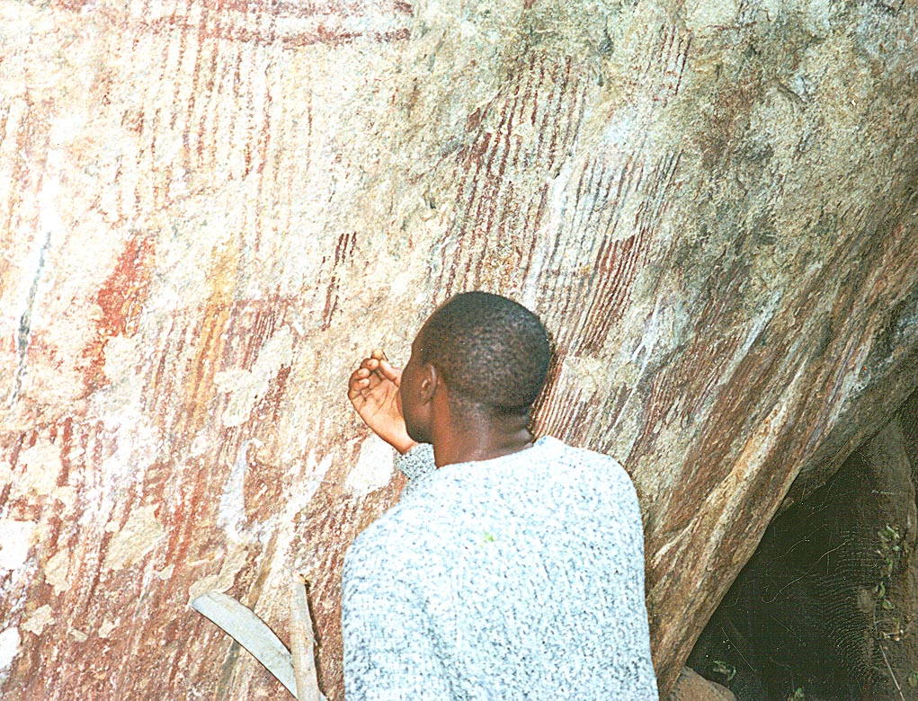
The rock paintings inside Chiulukire Forest form one of the reserved areas.

