FIELDS AND SETTLEMENTS IN THE FOREST
It has been noted that there are almost 1000 hectares being cultivated in Chiulukire Forest currently, almost 9% of the land. The map at the end of this chapter shows the field locations. Several settlements also exist inside the forest. Most persons have alternative land to cultivate outside the forest, although some claim not to.

1. SPECIFIC OBJECTIVES
a. To resettle people who are currently inside the forest
b. To control further settlement and cultivation in the forest
c. To rehabilitate degraded areas

2. STRATEGY
- Physical inspection and registration of fields, gardens, and settlements inside the forest is to be done by the Village Resource Guards with village headmen and VRMAC representatives, and verified by Forest Department every September, starting in year 2002.
- Establish a realistic time-frame for squatter, settlement, and farmers’ withdrawal from forest.
- Explain the resettlement program carefully to villagers and dispel rumours quickly.
- Educate farmers on the inside and outside of the forest in methods of conservation farming for their existing fields to remain productive.
- Forest Department will assist Chief Mbang’ombe with maps showing potential relocation sites outside forest.
- Allow abandoned fields to reforest naturally.
- Depending on the situation, CLUSA may assist farmers with conservation farming methods to reduce forest destruction even if they are inside the forest. During the transition period, neither CLUSA nor any other organization will provide fertilizers for fields inside the forest. A memorandum will be circulated to all concerned organizations.
- The preferred mode of reforestation is by natural regeneration of surrounding tree species. Where areas are too degraded from settlements and cultivation, a more intensive tact can be taken. Site recovery plans can be prepared jointly by the Forest Department, Joint Forest Management Committee, and the Village Resource Management Area Committee. The recovery plan will include methods of promoting regeneration of forest species.
- Prohibit the cultivation of cotton inside forest boundaries in all cases.

3. LEGAL ASPECTS
- The people who are settled in the forest reserve shall be resettled in Chief Mbang’ombe’s area as alternative land is found for them.
- No villages, fields, or gardens inside forest boundaries as of July 2001 shall be extended. The clearing of new fields inside the forest (either by persons residing inside or outside the forest) is strictly prohibited. Any person violating this regulation shall be prosecuted in the court of law in accordance with the Forest Act.
- The deadline for resettling the people currently inside the forest is June 30, 2003. This means that no more replanting will occur from the 2003-2004 season.
- Those remaining in the forest after the 2002-2003 season will be required to pay the legally-allowed fees as prescribed in the Forest Act of 1999 and the fee schedules in effect at the time (Forest Department Regulations First Schedule Part III): that is, ZK72,000 per hectare.
- No resistance shall be expected on any settlement in the forest when alternative land is found by Forest Department or the Chief.
- AFTER SIX MONTHS OF IMPLEMENTATION, the field issues and policies shall be reviewed again by the Chief and the Forest Department and a suitable strategy will be determined.

4. ECOLOGICAL PRESCRIPTION
Degraded areas shall be rehabilitated by natural regeneration and early burning. Rehabilitated areas may be used as demonstration areas for future reference.

5. INDICATORS FOR MONITORING
- Annual progress on land allocations outside the forest, as reported by the Chief or representatives to the JFM Steering Committee
- Number of new fields observed by VRGs each year; number of fallow fields going to tree cover
- Number of fines and prosecutions pursued

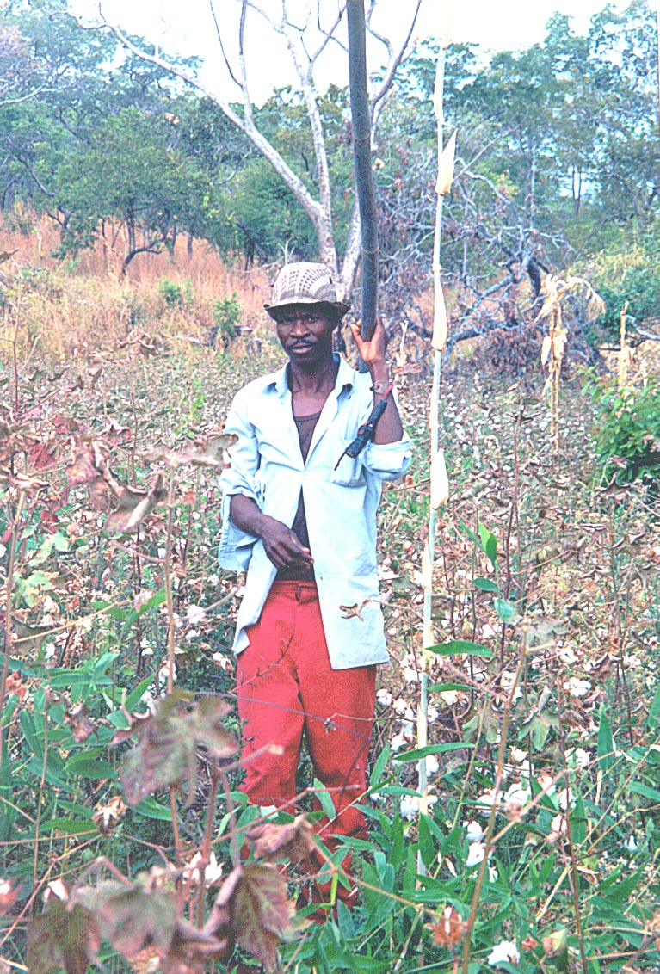

Cotton fields inside the forest are the most destructive of forestland.

FIRE MANAGEMENT

1. SPECIFIC OBJECTIVES
a. Through adherence to the early burning program each year, to ensure:
- survival of all forest vegetation regeneration, and most importantly that of the commercially important species: sunde, sawtimber, thatch, fruit, mushrooms.
- an improved quantity of game for future hunting
- preservation of important soil organisms
- control of plant and animal pests
- avoiding over accumulation of fuels on the forest floor
b. To control incidences of late fires

2. STRATEGY
- Revitalize Forest Department and traditional authority involvement in executing early burning program
- Early burning will commence anytime from the 15th of May every year. However, determination of actual date will be done after an assessment by the Forest Department and the Village Resource Management Area Committees.
- The Village Resource Management Area Committees will inform the local communities about the early burning commencement date and procedures
- Use VR Guards to patrol observation routes during fire danger season August to November. In case of fire, the VRG is authorized to mobilize whoever is in the vicinity to assist in extinguishing these late fires.

3. LEGAL ASPECTS
- No late fires (after 15th August to November) shall be permitted in Chiulukire Local Forest.
- No person shall carry out any of the following in Chiulukire Local Forest without authorization from the Village Resource Management Area Committee or the Forest Department:
- set fire to any tree, undergrowth, grass, or forest produce
- allow any fire lit by any person or the employees or agents of that person to spread into the local forest
- Any person 18 years of age and above in the vicinity (within 5 kilometers of the boundary) shall be bound to assist in extinguishing the late season fire in Chiulukire Local forest.
- During early burning period, farmers with fields inside the forest must be prepared to extinguish fires that enter their fields and settlements.
- Any person caught breaking the above regulations will be fined ZK20,000 AND ALSO
- if the offender is a hunter, he will lose his licence for one year as well;
- if the offender is a herder, he will lose a year’s grazing permit as well.

4. ECOLOGICAL PRESCRIPTION
- Early burning assists in breaking seed dormancy and encourages regeneration of vegetation. Seeds of Combretum, Terminalia and Pterocarpus spp are protected from the direct effects of fires by their indehiscent friuits (Chidumayo.E.N, 1997).
- Early fires also prevent the buildup of pests such as ticks, tsetse flies, and grasshoppers, by destroying their reproduction cycle.
- Late fires can destroy plant and animal diversity by killing seeds, regeneration, and soil organisms. Late fires also kill useful insects like bees and caterpillars. They should be extinguished as soon as they are spotted in the forest.
- Fires easily destroy fire-sensitive species such as Albizia and Uapaca and the young of Burkea africana (kawidzi), Julbernardia globiflora (Kamphoni) and Pseudolachnostylis maprouneifolia (msolo).
The following table shows some of the trees that can be damaged most easily:

FIRE - INTOLERANT or  SEMI-TOLERANT SPECIES (more likely to die) |  | FIRE-TOLERANT SPECIES  (less likely to die in hot fires)
SCIENTIFIC NAME | LOCAL NAME | SCIENTIFIC NAME | LOCAL NAME
Brachystegia longifolia | Bovu | Anisophyllea boehmii | Mfungo/ Mkondamadoda
Bridelia cathatica | Mkuzyandola | Diplorhynchus condylocarpon | Mtowa, Mtombozi
Bridelia duvigneaudii | Mwanjane | Erythrophleum africanum | Kawidzi
Brysocarpus orientalis | Kapululambuzi | Dombeya rotundifolia | Matowo, Mchiu
Garcinia huillensis | Matatane, Msongwe | Hymenocardia acida | Kabale
Hexalobus monopetalus | Mkhandanchem-bele | Parinari curatellifolia | Mpundu
Julbernardia paniculata | Mtondo | Pterocarpus angolensis | Mlombe
Lannea discolor | Shaumbu | Strychnos cocculoides | Mthemya
Pseudolachnostylis maprouneifolia | Msolo | Strychnos innocua | Mtulutulu, Kabulukulu, Mtheme
Uapaca kirkiana | Msuku | Strychnos spinosa | Mzimbili
 |  | Swartzia madagascariensis | Mchelekete
 |  | Syzygium owariense | Katope
Based on Trapnell (1959) |  | Uapaca nitida | Kasokolowe
 |  | Vitex madiensis | Fika, Mdyafungu

5. INDICATORS FOR MONITORING
The VRMAC and the Forest Dept shall be responsible for monitoring the early burning program. Reports of serious fires shall be submitted to the Joint Forest Management Committee for annual reporting. Indicators:
- Number of late fires reported by the Village Resource Guard to the VRMAC
- Pest and disease incidences in crops and livestock around the forest
- Long-term regeneration survival as reflected in reports of shortages by user groups
- Community trainings and participation in extinguishing fires

FIREWOOD
The following species have been named by villagers as preferred for firewood: Brachystegia boehmii (mfendaluzi), Brachystegia longifolia (bovu), Combretum molle (kalama), Julbernardia globiflora (kamphoni), and Brachystegia bussei (msale).

1. SPECIFIC OBJECTIVES
- To utilize and sustain the supply of firewood in Chiulukire Local Forest
- To ensure the availability of firewood to local women and households
- To raise revenue from sale of surplus firewood

2. STRATEGY
- Firewood collectors will be encouraged to work closely with hivemakers and pitsawyers to utilize all parts of the trees preferred by many user groups. The potential for firewood sales from offcuts of barkhive trees and charcoal production will be presented to villages.
- Women, who normally collect household firewood, will report shortages and lengthening distances for firewood collection to their VRMAC so that competition for this vital resource can be reduced. Women will be awarded priority rights to firewood in any conflict arising. They should be placed on VRMA registers.
- Promote use of improved stoves.

3. LEGAL ASPECTS
- Firewood for domestic use shall be collected without paying. Priority shall be given first to local women for firewood collection; then to local village members. Collectors are obligated to receive information on legal and ecological aspects before being allowed to register annually with the VRMAC.
- A permit shall be required for collecting firewood to be sold commercially. Permits shall be purchased from the VRMAC in whose area the wood is to be collected, at the price set by the VRMAC or at the prevailing Forest Department (FD) price per cord or per cubic meter. Also a conveyance fee shall be paid to the FD.
- Only dead wood shall be collected for firewood.
- No live tree shall be cut for firewood.
- A special regeneration scheme for mopane found only in the north of the forest shall be explored.

4. ECOLOGICAL PRESCRIPTION
- Firewood species can be regenerated from seed and by coppicing. However, it is only within the context of charcoal production that branches of firewood trees shall be collected green and then dried.

5. FINANCIAL ASPECTS
- Permits are to be bought by commercial collectors of firewood. The Village Resource Management Area Committee shall be responsible for collection of permit revenue. The revenue collected shall be shared with Forest Department according to the agreed ratio (chapter 5).
- The District Forest Officer shall collect a conveyance fee for commercial firewood (currently ZK1800 per cubic meter) to be paid by collectors to the Forest Department.

6. INDICATORS FOR MONITORING
- Distances walked to collect firewood as reported by local village women to the VRMAC
- Presence of firewood collectors at sites of barkhive and charcoal production
- Number of people fined for felling fresh wood (monitored by the Village Resource Guards in each VRMA)
- Amount of revenue collected from firewood permits and conveyance fees

FISHING

1. SPECIFIC OBJECTIVES
- To improve water quality for fish
- To encourage fish farming
- To increase fish population in all the streams which are found in Chiulukire
- To raise revenue from fishing permits

2. STRATEGY
- Increase control over fishing activity.
- Enforcing legal fishing ban between 1 December and 31 March.
- Initiate a study to determine the importance and abundance of fishing in Chiulukire.
- Create fishing reserves that are off-limits to fishing at all times.
- Study the potential for constructing fish ponds around the forest.

3. LEGAL ASPECTS
The following regulations shall apply:
- Fishing shall not be allowed anywhere in the forest during the first year so that fish stocks can be replenished.
- When fishing resumes, using the following methods is prohibited:
- poison
- mosquito nets
- explosives
- oil
- fish traps called moono (with the same effects as mosquito nets)
- No fishing shall be carried out during the breeding period from 1st December to 31st March every year.
- No fishing is allowed in the Reserved Areas described in chapter on Reserved Areas.
- Fines shall be applied for breaking these regulations, and money from the fines will be under the charge of the VRMACs (see FINANCIAL ASPECTS).

4. ECOLOGICAL PRESCRIPTION
- Stream bank erosion caused by cultivation along watercourses contributes to silting of the streams of Chiulukire. This tends to lower the volume of water in the streams. The low volume of water during the dry season affects the breeding cycle of fish, which only survive in isolated pools of water. Mtetezi river, Kamiza, Chavuzi, Mkangazi, Zinaka, Mponda, and Mthiko streams are all affected by silting. This is the main reason for prohibiting agriculture along streambeds (see chapter on Watercourses).
- Fishing within the Reserved Areas (see Reserved Areas chapter) is prohibited.
- Fishing with mosquito nets or other fine nets is prohibited.

5. FINANCIAL ASPECTS
- Once fish stocks are replenished, fishing shall be restricted to Chiulukire villagers who have followed a sensitization program and been placed on the annual VRMAC fishing register. Their fish must not be sold.
- However, if any person is caught fishing during the breeding months (December, January, February, March) or during the proposed moratorium of one year, or if any person is caught fishing in the reserved areas, fines shall be levied according to Zambian law and the money shall come back to the VRMAC at 100%.

6. INDICATORS FOR MONITORING
The Village Resource Management Area Committees through the Village Resource Guards shall monitor fishing activities. The following monitoring indicators shall be used:
- Availability of fish in the seven principal streams of Chiulukire, as reported by fishing groups
- Number of cultivators chased from streambeds
- Volume and clarity of water in streams, as reported by fishing groups
- Number of cases of illegal fishing methods reported and fined by VRGs

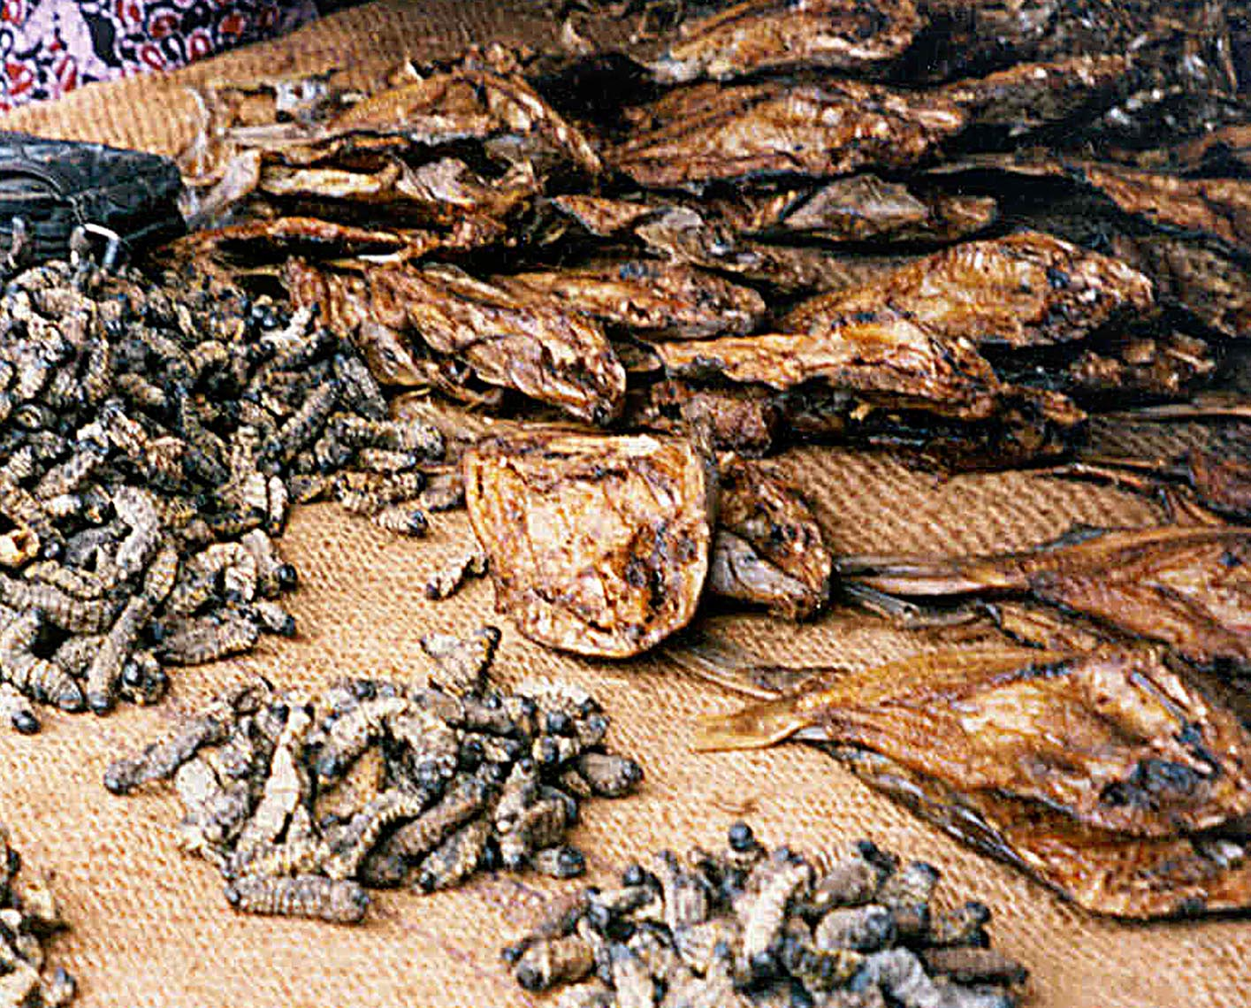

Fish, an important source of protein, do survive in some isolated pools of
Chiulukire streams when they are not over-silted.

FRUIT TREES

1. SPECIFIC OBJECTIVES
- To preserve a minimum of fruit trees in each VRMA to satisfy the dietary needs of households by
- allowing a certain number of fruit seeds to ripen and regenerate
- monitoring regeneration of fruit trees as the years pass
- not allowing entire trees to be cut down for the sake of collecting fruit
- To minimize waste of collected fruits by
- only collecting what is needed for home consumption
- only collecting fruit for sale for known markets
- developing drying methods for longer storage times
- To minimize conflicts with other users of fruit trees, notably:
- medicine practitioners -- especially Lannea (shaumbu), Flacourtia (nthudza), Ziziphus (mshabankhunzi), Diospyros (mchenja)
- charcoal producers – especially Diospyros; and that fires do not destroy fruit trees

2. LEGAL ASPECTS
- There is no permit required to collect fruits from the forest; however, collectors must follow the sensitization program for fruit collection before being placed on the VRMAC annual register of collectors.
- Commercial activity is too minimal to levy a fee on fruit collection at the present time. However, fines shall be imposed by the VRMAC on fruit tree abusers, such as those who cut entire trees only to get the fruit.
- In addition, any other forest user group who wants to harvest fruit tree products OR wood from the above-named species, which are traditionally used by fruit collectors, will be required to consult first with the women’s collector group.
- If the collectors in the northernmost village management areas (parts of Matunga, and Magobo) find that their supplies are short, they must
  - make arrangements with their southern neighbors for collection rights in more abundant areas;
  - collect from areas outside the forest; or,
  - arrange to barter for fruit from other parts of the forest in exchange for other goods.

3. ECOLOGICAL PRESCRIPTION
- Most fruit trees are found in the southern 2/3 of the forest, and most in the area of Mkaika. Species there that are highly ranked are Adansonia (baobab), Bridelia (mkumbya), Diospyros (mchenja), Flacourtia (nthudza), Garcinia (matatane), Hexalobus (nkhandachembere), Lannea (shaumbu and mbyulu), Parinari (mpundu), Strychnos (ntemya), Uapaca (msuku), and Ximenia (nthengele).

- In the northern area, Annona (mpovya), Diospyros, Flacourtia, Lannea, and Ximenia are the main fruits noted.

- INVENTORY DATA (see map at the end of this chapter):
- In all areas of the forest, the number of fruit trees greater than 30 centimeters in diameter is very small; none were noted greater than 50 centimeters.
- Regeneration in the 5-centimeter class is only fair in Zinaka, Chinkhombe, and Mkaika; Matunga and Magobo have a noticeable lack of small trees as well as large trees. However, there are some even younger fruit trees coming up in all parts of the forest. Therefore, one can suspect that late fires are playing a role in eliminating the next generation of fruit trees.
- If the management plan fire regime is carried out, then the fruit user’s group should be noticing an increase in regeneration of young trees.

4. FINANCIAL ASPECTS
- For the time being, there will be no fees paid for collecting fruit. (Collectors must be registered with the VRMACs.) However, fines may be imposed for wasting fruit on a grand scale and for cutting trees simply to collect fruit. The fines will be levied by the VRMAC.
- Any revenues from fines may be used to educate user groups on ways to avoid waste and increase storage time.

5. INDICATORS FOR MONITORING
- It will be up to the women’s fruit collection group to monitor
- regeneration survival,
- tree misuse and cutting for the wrong reasons,
- over-harvesting of fruit so that no regeneration is allowed to germinate from seed,
- young trees destroyed by fire.
- The proposed method is to practice looking right and left off the trails to the fruit trees to notice regeneration. Also young trees near the base of the seed trees should be noticed and followed over the years.
- All fruit collectors and the Village Resource Guards are to report misused and damaged fruit trees noticed during the season of collection.
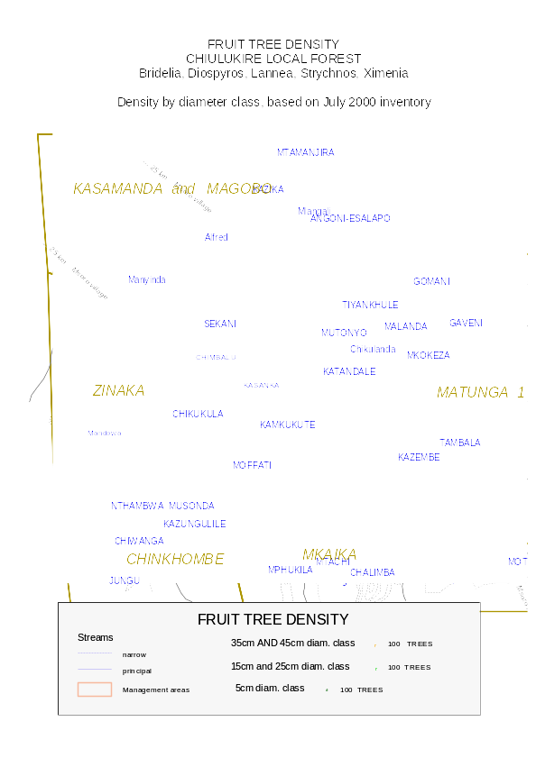
Fruit map

GRAZING
The map at the end of this chapter shows livestock density outside, and fodder tree density inside, the forest.

1. SPECIFIC OBJECTIVES
- To increase the availability and regeneration of fodder species, especially outside the forest in a “buffer zone”
- To control grazing inside forest so that other uses of fodder trees are not compromised.

2. STRATEGY
- Designated grazing areas will be agreed upon and set up during the first year. The areas must not conflict with charcoal, honey, mushroom, or sawtimber production, and they must not be located near the reserved areas.
- Cattle owners must go through a sensitization program before being allowed to graze inside the forest.
- Designated months when grazing is not allowed will be established by the VRMACs in order to favor tree regeneration.
- Some areas may allow concentrated grazing as a form of firebreak.
- Fodder banks and water points are to be set up outside the forest reserve at village level to reduce the need for forest pasture and water in the dry season.
- Maximum herd sizes and penalties for exceeding them, if deemed appropriate, will be set by each VRMAC to limit negative impacts on regeneration and wildlife.

3. LEGAL ASPECTS
The Village Resource Management Area Committee through the Village Resource Guards and the grazing user groups shall be responsible for enforcing regulations in the forest:
- Cattle only (no sheep or goats) shall be allowed to graze in designated areas and designated months inside the forest reserve with a permit, on a trial basis (first two years). The VRMAC will document cattle owners and the size of their herds once sensitization has been completed.
- No livestock shall be allowed to graze in the reserved areas and at reserved waterpoints at any time (refer to map of reserved areas).
- Cattle from villages not participating in the Joint Forest Management Plan are not allowed in the forest.
- No late burning to produce pasture shall be allowed.
- Any undocumented livestock that trespasses through the forest shall be impounded and the owner will be fined a fee set by the VRMAC.
- Animals belonging to interior villages waiting for relocation to outside the forest must be kept in kraals at night.
- Monitoring shall be done by the Village Resource Guards and by interested user groups to ensure that no area is overgrazed and that tree regeneration is not unduly affected.
- If this experimental grazing policy appears to cause too much damage to other forest resources, grazing will be discontinued and an alternative to finding browse will be established in the buffer zone.

4. ECOLOGICAL PRESCRIPTION
Chiulukire local forest has good stocking and distribution of fodder species (see map). Most of these species have the potential to regenerate from stumps and root suckers. The following table shows the Chiulukire fodder species that are preferred for livestock:

ECOLOGICAL PRESCRIPTION – PREFERRED FODDER TREES:

SCIENTIFIC NAME | LOCAL NAME | ATTRIBUTES
Acacia albida | Msangu | Palatable, high crude protein, sprouts readily, but rare
Albizia harveyi | Mpalankhanga | Palatable
Bauhinia petersiana | Mpondo | Palatable, sprouts readily
Dicrostachys cinerea | Kalumphangala | High crude protein, palatable, but somewhat rare
Diplorynchus condylocarpon | Mtombozi, Mtowa | Palatable, sprouts readily, very common
Parinari curatellifolia | Mpundu | Palatable
Piliostigma thonningi | Msekese | Palatable, sprouts readily,
Pseudolachnostylis maprouneifolia | Msolo | High crude protein, palatable, sprouts readily
Strychnos spinosa | Mzimbili | crude protein, palatable, sprouts readily
Swartzia madagascariensis | Mchelekete | Palatable, sprouts readily, but rare
Ziziphus abyssinica | Kankhande | palatable
- Early burning shall be carried out to encourage regeneration of the fodder species and grasses.
- It is prohibited to graze rare plant species.
- The livestock population is very high on the western side of the forest with Chinkhombe Village Resource Management Area having the highest concentration, especially of goats. This has resulted in increasing pressure on grazing areas and the forest reserve. Since goats are non selective browsers and cause more damage than cattle and pigs, goats are prohibited from entering the forest reserve.

5. FINANCIAL ASPECTS
The Village Resource Management Area Committees shall be responsible for collecting and managing any fines levied. Fines when imposed will be retained 100% by the Village Resource Management Area Committees.

6. INDICATORS FOR MONITORING
The Village Resource Management Area Committees through the Village Resource Guards, and designated herders, shall be responsible for monitoring grazing impacts, using the following indicators:
- Noted impacts of overgrazing: shortage of regeneration, eroded soil, damaged trees
- Number of infractions cited annually: late fires set by herders and livestock impounded
- Number of fodder in banks outside the forest reserve
- Availability of fodder in banks outside the forest reserve
- Number of livestock impounded
- Amount of money raised from fines.

The penalty carries a jail term not exceeding six months, a fine not exceeding K5.4 million, or both.

