SECTION IV. ACTIVITIES CONTROLLED BY THE VILLAGE RESOURCE MANAGEMENT AREA COMMITTEES (VRMACs)
IN ALPHABETICAL ORDER

BAMBOOS
BARKROPE
BOUNDARY RECOGNITION
CARVING SPECIES
CATERPILLARS
CHARCOAL
CUTTING METHODS
FIELDS AND SETTLEMENTS INSIDE FOREST
FIRE
FIREWOOD
FISH
FRUIT TREES
GRAZING
HONEY
MEDICINE
MUSHROOMS
POLES
RESERVED AREAS
SAWTIMBER
SUNDE BROOMS
THATCH
WATERCOURSES
WILDLIFE

BAMBOOS

1. SPECIFIC OBJECTIVES
- To maintain or increase availability of bamboos in all five VRMAs through regeneration and proper cutting techniques
- To manage and utilize bamboos sustainably
- To promote value adding as requested by user groups

2. STRATEGY
- In order to increase bamboo availability, each VRMA will set aside an area for planting and managing bamboos for local and commercial use.
- User groups will be organized in each VRMA for addressing common issues and training needs in processing and marketing.
- CLUSA will facilitate value-adding training for bamboo groups.

3. LEGAL ASPECTS
- All bamboos collected for sale or processed to add value shall be by paid permit whether collected from inside or outside the forest reserve.
- Bamboos collected for domestic use may be collected with a free permit. Domestic use is defined as material for roofing, fencing, basketry, furniture, and other home products used at village level. The VRMAC shall determine the number of bamboos to allow free for domestic use.
- People from villages outside the VRMAs are required to pay for collection of bamboos regardless of their use.

4. ECOLOGICAL PRESCRIPTION
- Bamboos are mainly found in Magobo though some are found in Mkaika, Matunga, Zinaka, and Chinkhombe. Some are found around fields outside the forest. The local bamboo (Oxytenanthera abyssinica) takes about 7 years to mature and flowers only once in its lifetime before dying.
- Selective cutting of bamboos at ground height can be used to stimulate regrowth. Bamboos may be replanted in areas set aside in each VRMA using root suckers or rhizomes.
- Bamboos when rampant can become a source of competition with sawtimber species for sun, water, and soil resources. Therefore, near timber-producing areas, tree cover should interface with bamboo stands and be given preference to avoid over-spreading.
- Bamboo stands thus in competition with other users’ tree species can be eliminated on approval of both sides by cutting at 1 meter height to encourage rot in the rainy season. Offering shoots as cattle browse is another option.

5. FINANCIAL ASPECTS
The VRMACs shall collect permit fees on bamboos. The cost of the permit will be ZK900 per 20 canes to be used commercially. The VRMAC shall share money raised from permit sales in the proportions described in Section 5.
- Revenues raised from sale of value-added bamboo products shall belong to members of that user group.
- Collectors of bamboos for domestic use must follow a sensitization on best cutting and regeneration methods and resolution of conflicting uses of stems of different sizes.

6. INDICATORS FOR MONITORING
The VRMAC and user group shall be responsible for monitoring bamboo stands in their areas, using the following indicators:
- Observations on success of bamboo regeneration reported by users to VRMAC
- Number of hectares of bamboo reserves set aside and mapped in each VRMA
- Quantity and type of bamboo products marketed, according to permits sold
- Incomes from bamboo products.

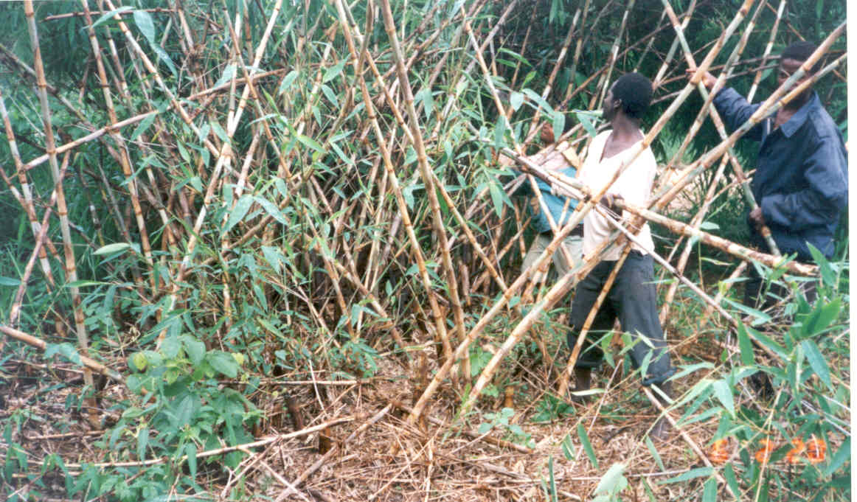

Bamboos grow in clumps, sometimes to the exclusion of allowing trees to regenerate.

BARKROPE

The following species are favoured for barkrope collection in Chiulukire Local Forest: Brachystegia spiciformis (mputi), Brachystegia longifolia (bovu, mfendaluzi), Brachystegia manga or allenii (msumbu).

1. SPECIFIC OBJECTIVES
- To conserve and regenerate species that are suitable for barkrope production for local use;
- To determine a sustainable method of harvesting barkrope taking into consideration other future uses of the barkrope species.

2. STRATEGY
- Collectors of barkrope will be encouraged to harvest it in a manner that does not completely kill off the young trees but that these should be able to coppice or regenerate after removal of part of the bark.
- Collectors will also be required to harvest bark from trees of a particular size and species.
- Other rope-producing plants such as sisal and papyrus (mlaza) will be promoted in the villages to supplement fibre-producing trees and reduce pressure on them.
- The commercial potential for barkrope production will be considered in the future.

3. LEGAL ASPECTS
- Barkrope for domestic use shall be collected with a free permit.
- Large trees will not be cut down for the collection of barkrope from its branches; but branches may be cut from the top of a tree as long as the life of the tree is not endangered.
- Only trees between 7 and 15 centimeters in diameter shall be used in the harvesting of barkrope.
- For now, commercial harvest of barkrope is prohibited. However, if the user group can make a proposal for commercial harvest that is not destructive to the honey-producing and other user groups, and that will leave sufficient regeneration, it can be considered by the VRMAC and an appropriate revenue collection scheme shall be made.

4. ECOLOGICAL PRESCRIPTION
- The most highly-ranked barkrope species from the VRA study (1999) are:

LOCAL NAME | SCIENTIFIC NAME | OTHER USES  (POTENTIAL CONFLICTS)
Mfendaluzi, Bovu | Brachystegia longifolia | - Charcoal production  - Firewood  - Bee forage
Msumbu | Brachystegia manga or allenii | - Charcoal production  - Barkhives
Mputi | Brachystegia spiciformis | - Firewood  - Barkhives

- It is recommended to cut trees coppice-style (clean stump to maximum 30 cm height) to best regenerate the barkrope trees.
- Otherwise, regeneration of barkrope trees can be achieved from seed as well as coppice, especially for bovu. Therefore, a selective cut method within the coupe system would work well for regeneration.
- Collection should not involve complete debarking of a standing tree.
- If branches are harvested from a large tree and then debarked, the debarked branches must be cleared from the tree trunk to avoid hot fires there. The branches should be used for firewood.

5. FINANCIAL ASPECTS
- Domestically-used barkrope shall be collected free by those who have passed a sensitization on the ecological aspects outlined above and then have been placed on the VRMAC annual register.
- Barkrope used to tie up charcoal sacks or other commercial use will be charged per felled tree if taken from outside the demarcated coupe (felling) area. The rate charged will follow that for poles (POLE chapter) and the permit will be purchased from the VRMAC.

6. INDICATORS FOR MONITORING
Monitoring of barkrope harvesting and regeneration shall be done by the VRG and the user groups. Indicators will include:
- Number of households that plant alternative rope-producing plants in their village.
- Documentation of species of trees being harvested for barkrope

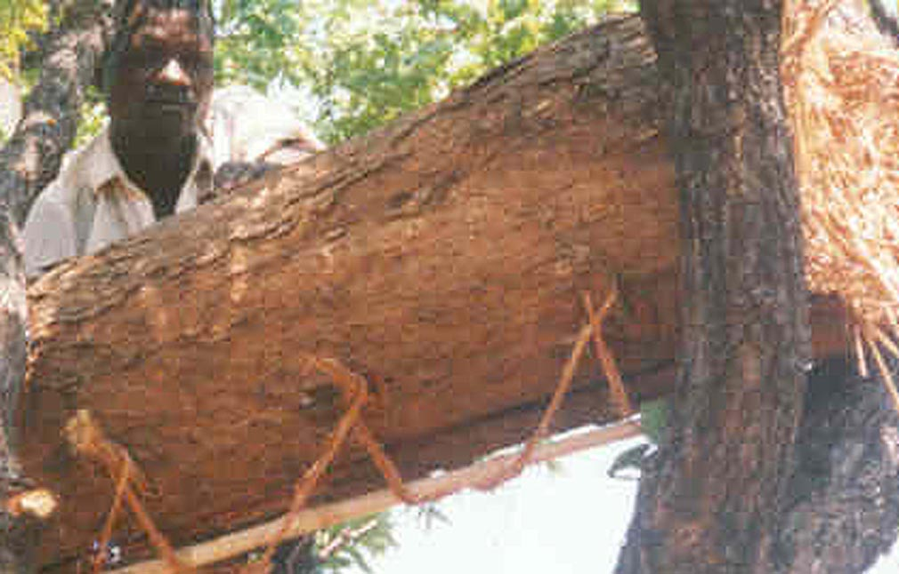
Ropes pulled from young Brachystegia bark are needed for hanging hives,
tying charcoal sacks, and other uses, both domestic and commercial

BOUNDARY RECOGNITION

1. OBJECTIVES
- To ensure recognition of legal forest boundary by village residents, village headmen, chiefs, and Forest Department
- To clarify the regions for which the five VRMAs take responsibility for joint management
- To provide physical evidence of boundaries where they are not made of natural watercourses so that those who are unfamiliar will know when they have reached the joint forest management area

2. STRATEGY
- Inform the Chief of the objectives, strategy, and results of this activity; obtain his support
- Walk to the forest boundary closest to each VRMA with a group composed of village members and Forest Department and with the original boundary description from 1950s
- Find existing beacons on topographic map, and photography (satellite image); record location by GPS
- Agree on named watercourses comprising the legal boundary; make corrections of names and locations where necessary
- When reaching unmarked or indefinite segments of the boundary, mark the two known endpoints of the segment with stone piles (beacons). Then, devise a plan with Forest Department for future recognition of these segments using any of these methods:
  - Define the bearing and distance and plan to clear brush and trees at a width of 6 meters along this line periodically; village labour and Forest Department surveying expertise will be used
  - Plan on explaining/showing the acknowledged forest boundaries to outsiders anytime they are encountered in the area
  - Plant a row of exotic tree species (jacaranda, Cassia, etc.) the length of the unmarked portion, and protect the trees for 5 years from grazing and fire until they are able to survive on their own

3. LEGAL ASPECTS
- Any person or village found to move a beacon shall be prosecuted in the court of law in accordance with the Forest Act No. 7 CAP 199 of 1999, which carries a jail term not exceeding 6 months, a fine not exceeding ZK 5.4 million, or both.
- User groups working inside Chiulukire Local Forest will be considered legally bound to assist in boundary delimiting activities in exchange for the right to use forest products.

4. INDICATORS FOR MONITORING
The following are indicators for monitoring:
- Boundary work will be supervised by the Forest Department..
- Demarcation and other activities should be finished within 3 years of plan signing.
- Progress reports will be submitted annually by the VRMACs and Forest Department to the JFM Committee.

CARVING TREES
The following trees used for artisanal and domestic wood carvings grow in Chiulukire Forest: Crossopteryx febrifuga (mwavi), Dalbergia melanoxylon (phingo), Faurea speciosa (chiyele), Julbernardia globiflora (kamphoni), Lannea discolor (muwale, shaumbu), Pavetta schumanniana (mtukumphako), Pericopsis angolensis (muwanga), Ricinodendron rautanenii (mkusu), and Swartzia madagascariensis (mchelekete).

1. SPECIFIC OBJECTIVES
- To promote a woodcarving industry that could increase local incomes
- To promote organization of wood carvers into user groups for marketing, training, and utilization purposes
- To focus on regeneration on woodcarving species that are becoming rare

2. STRATEGY
To follow the regeneration recommendations set out below in Ecological Prescriptions concerning:
  - Controlling late fires
  - Coppicing
  - Clearing debris from around the stump
  - Devising special plans for protected species

3. LEGAL ASPECTS
- Felling a tree for its carvable content shall be done by permit whether the tree is inside the Forest or outside. The price of the tree is set by the Forest Department. The permit is obtainable through the VRMAC and revenues from permit sales shall be shared according to the proportions noted in chapter 5.
- The same felling conditions used in pitsawing shall be followed when cutting trees for wood carvings.
- Trees that are more valuable for sawtimber must be left as such, based on the species, straightness, size, and health of the bole.
- For the first 3 years of the management plan, no Dalbergia (phingo) nor Swartzia (mchelekete) shall be cut until a plan for regenerating these rare species is put into place.
- For domestic use, small utensils such as cooking sticks will be obtained from branches and offcuts of paid felled trees. Mortars requiring felled trees will be by paid permit. This policy will be reviewed after two years.

4. ECOLOGICAL PRESCRIPTION
- The following species can be regenerated by coppicing: Julbernardia globiflora (kamphoni), Lannea discolor (muwale, shaumbu), Faurea speciosa (chiyele), Crossopteryx febrifuga (mwavi), and Pavetta schumanniana (mtukumphako). However, stumps must be cleared of debris so that regeneration will not be harmed by early burning.
- Methods of regeneration of Swartzia and Dalbergia must be explored and recommended by user groups interested in exploiting these rare species. A proposal for regeneration should be put before the VRMAC within two years of signing of the management plan.
- The stump height is limited to 30cm. Once the tree is cut, the stump shall be trimmed to encourage regeneration by coppice shoots (see chapter on cutting systems).
- Since some species used by wood carvers are also used by other groups, they should participate in charcoal production site prospecting and claim trees that are valuable to them before the trees are cut and burned for fuel or made into barkhives.
- Training in full-tree utilization (or other relevant subjects) is possible at the request of the user group.

5. FINANCIAL ASPECTS
- The Village Resource Management Area Committees shall be responsible for collection of revenue from permits sold to commercial wood carvers.
- Woodcarvers on an annual VRMAC domestic-use (free) register will be required to go through informational sessions on the legal and ecological aspects and agree to abide by them.

6. INDICATORS FOR MONITORING
The following indicators may be used for monitoring:
- Coppicing success of harvested trees (woodcarvers will revisit harvest sites to assess this; Forest Department may lend advice)
- Number of illegally-cut carving trees (and resulting fines) noted by Village Resource Guard
- Number and quality of wood carvings made available for sale in local markets and abroad (assessed by user group marketing component and reported to JFM Committee)
- Number of user groups organized around the forest (reported by VRMACs)
- Revenue raised by the Village Resource Management Area Committee from tree harvest permit

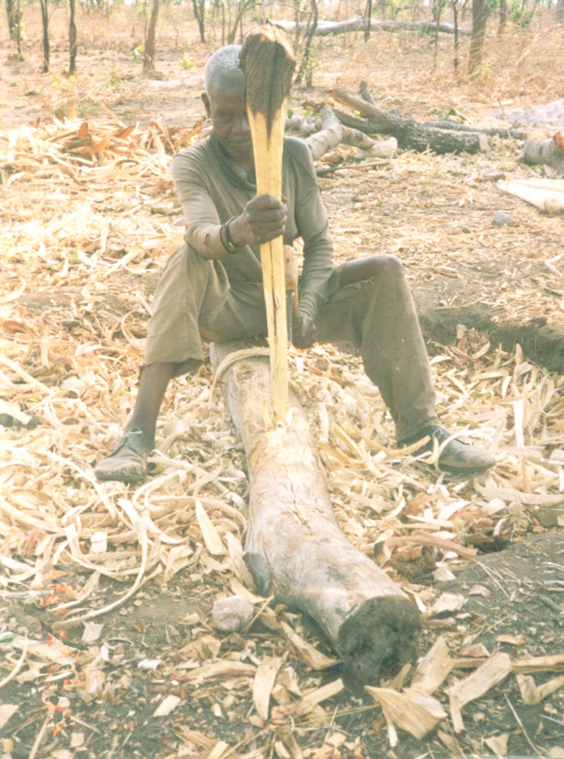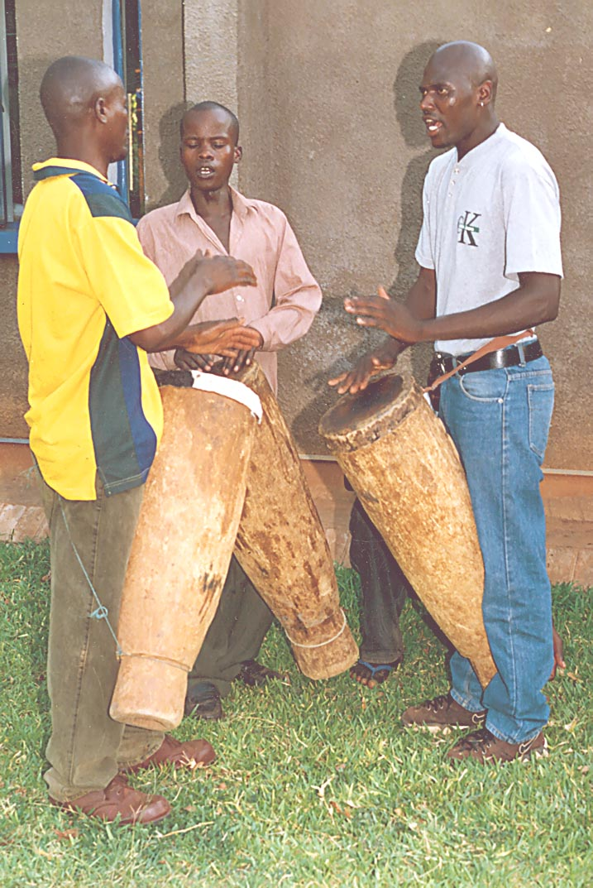
Wood carving encompasses artisanal as well as cultural uses; hoe handles and drums, among others.

CATERPILLARS

There are at least nine species of caterpillars in Chiulukire local forest.

1. SPECIFIC OBJECTIVES
- To conserve and regenerate host tree species for breeding of caterpillars
- To promote value adding by processing caterpillars

2. STRATEGY
The strategy will involve principally raising awareness of
- host tree species and their conservation and regeneration by proper harvesting methods;
- the nutrition content of caterpillars as a diet supplement; and
- the possibilities of ways to add value to increase incomes to women.

3. LEGAL ASPECTS
a. Caterpillars shall be collected freely by persons on an annual VRMAC register (see Financial Aspects).
b. The following regulations shall apply when collecting caterpillars:
- No tree shall be cut when collecting caterpillars
- Caterpillars shall be collected by shaking the tree, climbing the tree and picking from the ground
- Host trees for caterpillars shall be protected against fires

4. ECOLOGICAL PRESCRIPTION
- One species locally known as Mphalabungu is almost extinct due to tsetse fly spraying which has been carried out in 1970s by the Department of Veterinary and tsetse control. The chemicals used to eradicate tsetse flies has an effect on this and other plants and animals.
- The edible caterpillars are produced by butterflies and moths, which lay eggs on trees in September. The eggs hatch in October- November and produce young caterpillars, which feed on young leaves. Caterpillars can consume about 100 kg per hectare of foliage at peak density, but 90 per cent is returned to the soil as faeces (Malaisse 1978). Host trees often produce new leaves within a few months (Campbell 1988).
- Collection should be done between November and March.
- Collection of caterpillars from tall trees must not cause them to be cut down.

The table below shows the Host plant species on which some caterpillars are found.

CATERPILLAR | HOST PLANT SPECIES
CATERPILLAR | SCIENTIFIC NAME / ENGLISH NAME | LOCAL NAME
Nthowa | Diplorhynchus condylocarpon | Mtombozi
Masase | Burkea africana | Kawidzi
Matole | Julbernardia panuiculata | Mtondo
Vilungulungu | Diospyros kirkii, Cussonia kirkii, Piliostigma thoningii, Crossopteryx febrifuga | Mchenja, Mbwabwa, Msekese, Mwave
Mapala | Brachystegia manga, Brachystegia bussei, Julbernardia globiflora, Brachystegia longifolia | Msumbu, Msale, Kamphoni, Mfendaluzi
Mapalampapha | Julbernardia paniculata | Mtondo
Kapale | Lonchocarpus capassa | Chimphakasa, Mpandapanda
Mphalabungu | Grass | Udzu

5. FINANCIAL ASPECTS
- Although permits are free as at signing of this plan, priority for collection shall be given to local women residing in Chiulukire villages. Names of free collectors must be placed on an annual register only after a thorough understanding of the ecological and legal aspects has been gained.
- If caterpillars are processed in order to add value and a large commercial operation results, the free permit aspect will be reviewed, and the VRMAC will decide on a fair price for a commercial annual permit.

6. INDICATORS FOR MONITORING
The following indicators shall be used to monitor the activities:
- Regeneration of the host trees and plants: this must be noted by the collectors.
- Quantity of caterpillars observed for sale, processed and unprocessed.
- Availability of different species of caterpillars: collectors must report shortages and try to identify reasons.

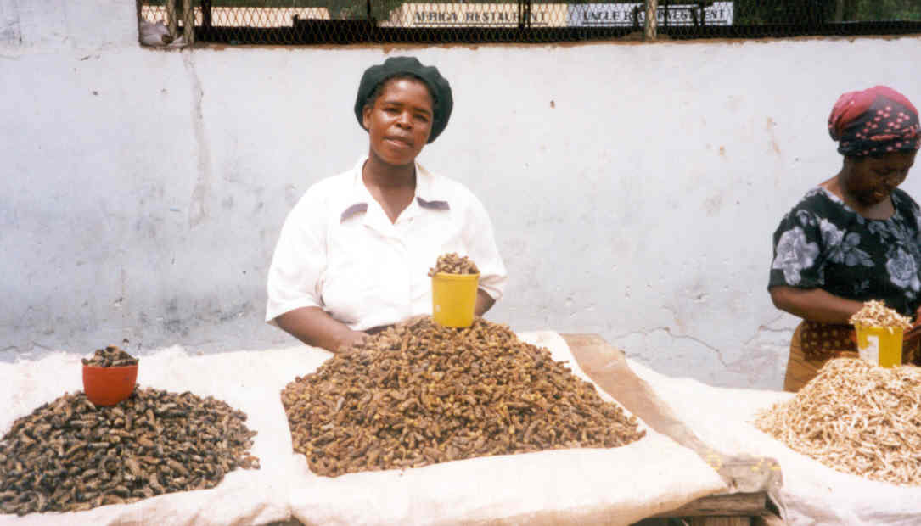
Caterpillars add to the richness of local diets.

CHARCOAL trials

The demand for charcoal is very high in urban areas: about 83% of the households use it as a source of energy. The average daily consumption of charcoal per household is 3.8 kilograms (WORLD BANK / ESMAP 1990). It is fair to assume that a strong market for this product exists both in Katete and Chipata.
The year 2000 inventory illuminated the fact that an abundance of charcoal trees grows in Chiulukire Forest, particularly the Brachystegias and Julbernardias. The plan therefore proposes a modest, well-monitored charcoal-producing operation to raise revenues for VRMAC and Forest Department operations from the beginning. The proposal is to produce on a trial basis until the process is determined to be ecologically stable.

1. SPECIFIC OBJECTIVES
- To try producing charcoal in a sustainable way using a coupe system
- To regenerate trees in clear felled and selectively felled areas
- To organize charcoal producers into user groups for purposes of training and monitoring
- To generate income from charcoal sales

2. STRATEGY
- At least one trial charcoal production coupe of 20 hectares shall be set up in at least one of the five Village Resource Management Areas during the first year. The siting will be based on the stocking rate, species composition and topography of the area. The coupe will be divided into compartments to be felled alternately, thus ensuring that shelterbelts are left between clear felled areas.
- Selective and clear felling methods shall be used in the coupe system depending on the stocking rates and species composition. Selective felling method shall be used where species composition and distribution is diverse with low stocking rates. Clear felling method shall be used where tree species are light demanders and there is high stocking rate in order to regenerate well.
- The rate of regeneration shall be monitored during two seasons and comparison made between clear felled and selectively felled areas.
- COUPE FOR CHARCOAL PRODUCTION:
The area is divided into compartments. Compartments are clearfelled once per rotation of 10 to 15 years. Shelter belts are unfelled compartments left between successively clearfelled compartments to provide seeds and shelter. See the diagram below.
Valuable timber species shall not be felled for charcoal production. At the moment of setting up the coupe, sawyers are required to identify current and future timber crop trees to be reserved.
The actual size, shape and arrangement of the coupes shall vary depending on the terrain.

COUPE:
YEAR
6
YEAR
1
YEAR
2
YEAR
7
YEAR
9
YEAR
4
YEAR
8
YEAR
3
YEAR
10
YEAR
5
3. PROPOSED SCHEME FOR CHARCOAL PRODUCTION

3.1. FIRST YEAR ACTIVITIES/OBJECTIVES
- Brief study / verification of market:
- current charcoal prices (costs and sales)
- determine ideal charcoal pricing structure in order to compete with illegal charcoal producers / traders outside Chiulukire local forest
- identification of potential markets and means of transportation

- Identify operation zones in the forest:
- Katete District Forest Officer visits sites with experienced local charcoal producers
- Estimate size of the operation areas and map them (exclude wildlife reserves and watercourses)
- Pick a specific area of 5 hectares maximum per VRMA for training and trials in the first year

- Identify charcoal producers (workforce):
- Local charcoal producers available within Chiulukire villages
- Hivemakers and firewood producers willing to work with charcoal group
- Resource persons knowledgeable about production techniques
- Time of year when they can be actively involved in charcoal production

- Design a scheme for harvesting in the second year based on the following:
- Number of charcoal producers
- Mapped area of operation
- Marketing Plan (Marketing strategy)
- Formation of a charcoal user group with a spokesperson

3.2. SECOND YEAR ACTIVITIES
- Set up the trial coupe area on the ground
- agree on alignment of the coupe (if rectangular, perpendicular to slopes)
- within the coupe, determine current standing valuable timber trees and mark them for pitsawing
- within the coupe, determine hive trees; notify honey group that they should cut hives off these
- determine which other trees (fruit, young sawtimber, and rare trees) should be left standing
- the remaining trees are cut for charcoal production
- User group works with Facilitators and resource persons on marketing and record keeping
- Evaluation of the entire process at the end of the season:
- delimitation
- tree preservation
- production method and yield
- recommended changes for the third year
- identification of next year’s coupe location(s) and hectares; possibility of expanding to other VRMAs

3.3. THIRD YEAR ACTIVITIES
- Based on recommendations from evaluation of the second year, repeat charcoal production and marketing methods of the second year
- Assess regeneration in first coupe
- Evaluate the process again at the end of the year and make recommendations accordingly
- Set some objectives for numbers of hectares that can be realistically and sustainably cut for charcoal in combination with barkhives, crafts wood, medicine, and sawtimber

3.4. FOURTH YEAR ACTIVITIES
- Continue charcoal production and marketing based on latest recommendation
- Assess regeneration in coupes clear felled in the second and third years
- Evaluate the process at the end of the year and make recommendations

3.5. FIFTH YEAR ACTIVITIES
- Repeat the same activities as those in the fourth year
- Evaluate the activities and decide whether to continue the program or not (Do a financial analysis).

4. LEGAL ASPECTS
- No felling down of trees for charcoal production inside and outside the forest shall be allowed without a permit or licence.
- Charcoal shall be produced in pre-mapped coupes.
- Charcoal producers shall be responsible for fire management in their burn areas.
- Trees for charcoal production shall have a minimum diameter of 10 cm at breast height.
- The cord which has been sold by permit shall be measured by the Village Resource Guard. If the volume of the kiln surpasses 3 cubic meters, the charcoal producer will pay the appropriate price as required per cord.
- THE FOLLOWING PROTECTED TREES MAY NOT BE CUT: timber species Pterocarpus (mukwa), Afzelia (mgalilondo), Khaya (mubwabwa), Terminalia sericea (gonondo –yellow), and Pericopsis (muwanga); and fruit trees Uapaca kirkiana (msuku), Strychnos spinosa (mzimbili), Strychnos cocculoides (nthemya), Diospyros kirkii (mchenja), Annona senegalensis (mpovya), Flacourtia indica (nthudza), Parinari curatelifolia (mpundu) and Garcinia huilensis (matatane).

5. ECOLOGICAL PRESCRIPTION
- Species used for charcoal production, especially Brachystegia boehmii (mfendaluzi), Brachystegia manga (msumbu), Brachystegia longifolia (bovu), Combretum molle (kalama), Julbernardia globiflora (kamphoni), and Julbernardia paniculata (mtondo) can successfully be regenerated by coppicing from stumps, by root suckers, and from seed. Regeneration of these species is currently well distributed throughout Chiulukire Local Forest.
- Barkrope used for tying charcoal sacks shall be taken from branches and stems already cut for the kiln pile, not from trees outside the coupe area.
- Colophospermum mopane is mainly found in the northern part of Chiulukire Local Forest. This species is very good for charcoal because of its high heat calorific value and durability, and because it produces little ash and smoke. Because its extent is limited, care should be taken not to overcut it and even to encourage its regeneration by early burning and cutting a clean stump for coppicing no higher than 30 centimeters.
- The growth of grass tends to increase from the second year after clear felling the coupes and remains high until tree canopy is re established. In these areas thatch collection should be encouraged and effects of early burning monitored. Early burning shall be carried out between May and June every year to reduce mortality. The charcoal production user groups shall be responsible for early burning in Charcoal coupes.

6. FINANCIAL ASPECTS
- The Village Resource Management Area Committees shall be responsible for sale of charcoal production permits and collection of permit revenues. Charcoal cords will be sold at ZK5,400 (or at the prevailing price) per three cubic meters (3 meters by 1 meter by one meter). Revenue collected from sale of charcoal permits shall be shared with Forest Department according to agreed ratios (Section 5).
- The District Forest Officer shall collect conveyance fees for the user group’s right to sell charcoal. The conveyance fee for a standard grain bag of charcoal shall be ZK360 (or the prevailing fee)

7. INDICATORS FOR MONITORING
The Village Resource Management Area Committee, VRGs, and the Forest Department shall monitor charcoal production activities and burning inside the forest. Outside the forest, traditional authorities need to assist in monitoring.
- Hectares of charcoal coupes established in each Village Resource Management Area (VRMAC and FD responsible)
- Yield in cords and sacks per hectare exploited (Forest Dept and producers)
- Regeneration success judged by user group after 2nd, 3rd, 4th, and 5th years (FD and producers)
- Availability of kamphoni trees as medicine source maintained (as reported by medicine user group)
- Number of hives produced before logs are placed in kilns (Honey producers)
- Number of hivemakers, firewood producers, traditional herbalists, and woodcarvers working with charcoal producers (VRMAC)
- Number of charcoal producers in groups and number trained in proper cutting methods and monitoring of burns and regeneration (VRMAC and FD)
- Number of infractions recorded with respect to cutting of protected trees and kiln fires out of control (VRGs)
- Amount of revenue raised from sale of permits (VRMAC, JFM committee)

CUTTING METHODS: GENERALITIES

Two cutting methods may be used in Chiulukire Local Forest: selective felling and clearfelling.

1. SELECTIVE FELLING
This involves removal of single trees or groups of trees while leaving other high-quality trees for shade and shelter. This system can be used when harvesting timber trees and poles, and also when making charcoal. It promotes regeneration since sunlight is able to reach the young plants through the gaps created. However, because of conflicting uses of some tree species, care must be taken not to remove too many high-quality stems less than 30 centimeters in diameter, measured at breast height (1.3 meters from the ground). Examples include muwanga (timber conflicts with poles) and the Brachystegias (barkhives conflict with charcoal).
In the case of sawtree harvest, trained Village Resource Guards shall first mark timber trees before they are felled. Experienced Forest Department officers will give training in the first year of the plan.
Selectively felled areas may be clear felled for charcoal production later.

2. CLEARFELLING
Clearfelling is a method whereby in a demarcated area all or most forest produce is removed. This method may be used for charcoal production, or for timber production in areas where shade-intolerant timber species need light to regenerate. This method is applicable mainly in msale (Brachystegia bussei) or other stands of trees of homogeneous size.
Before clearfelling, provision for regeneration must be made either through shelterbelts or seed trees.

3. FELLING CONDITIONS
The following felling conditions shall be observed in both selective felling and clear felling:
- Chainsaws and mechanized felling systems are not currently allowed in Chiulukire Local Forest.
- All trees shall be cut 30 centimeters or less from the ground except for those which have a buttress or root swelling. Such trees shall be cut at a point immediately above the buttress or swelling.
- The stumps should be cut at a 45-degree angle to discourage rot.
- The stump of the cut tree shall be trimmed of splinters immediately after felling to encourage good and numerous coppice shoots.
- All branchwood and waste derived from felling the tree or trees shall be lopped to ground level by the permit holder and cleared away from all growing trees and live stumps for a distance of at least two metres.
- Branchwood and waste from appropriate species shall be recuperated for firewood.
- The permit holder shall pay a fine for any non-permitted tree seriously (mortally) damaged in the course of felling or extraction. The permit holder shall also fell the tree and pay for the wood at the market price, and the revenue (collected by the VRMAC) remains with the community for community use.

4. REGENERATION OF PROTECTED AND VALUABLE SPECIES
“Protected trees” means trees that are rare and are not permitted to be cut in the first three years of the management plan. The list of species may be lengthened by VRMACs and includes at minimum:
- Afzelia quanzensis (mpapa),
- Cassia abbreviata (mleza, mkoswe)
- Colophospermum mopane (lupanya),
- Dalbergia melanoxylon (phingo),
- Khaya nyasica (mubwabwa),
- Swartzia madagascariensis (mchelekete)
Once an acceptable regeneration plan for “protected trees” has been proposed by sawyer and other user groups in the VRMAs, the policy of no-cut will be reviewed. The plan may include plantation along watercourses accompanied by complete protection from grazing, cutting, and burning.
Zinaka and Magobo VRMACs will devise their own specific regeneration schemes for mopane since it is restricted to their areas.

5. REVIEW OF CUTTING POLICIES
All the cutting policies contained in this management plan must be reviewed in the first year and every after three years and adjusted as necessary. Justification for modifications include but are not restricted to
- a sustained number of cutting infractions noted by Village Resource Guards and VRMACs
complaints by locally resident sawyers of misallocation of cutting permits to harvesters outside Chiulukire area
- noncompliance with cutting conditions after all trainings are held
- findings of error in estimated sawtimber availability
- noncompliance of any party signing the management plan
- introduction of any mechanized timber production system in the VRMA
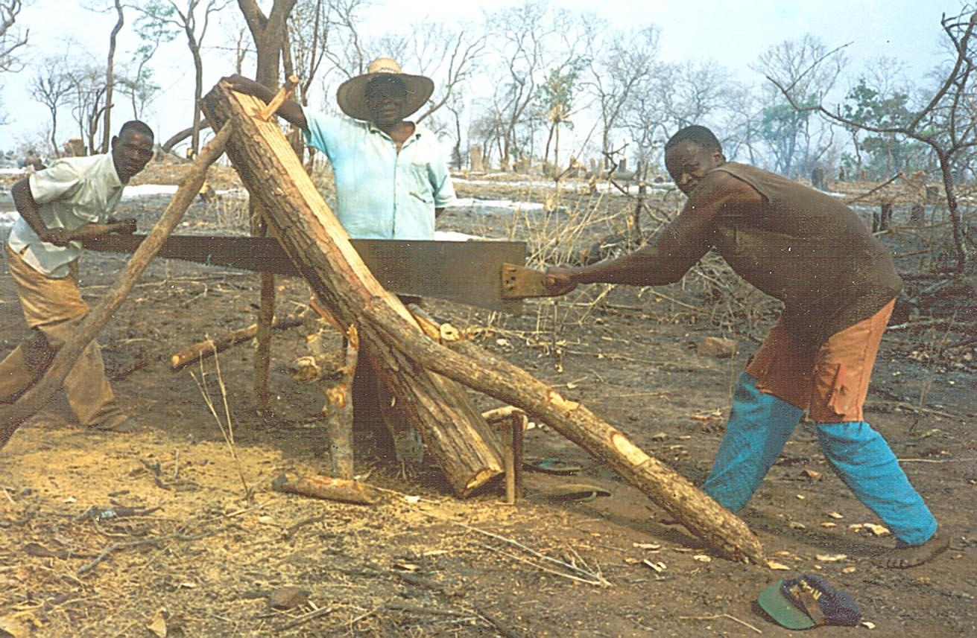
Pitsawing is an ecologically sound way to make planks from trees.

