CHIULUKIRE LOCAL FOREST INVENTORY REPORT

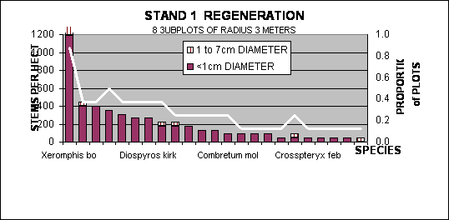

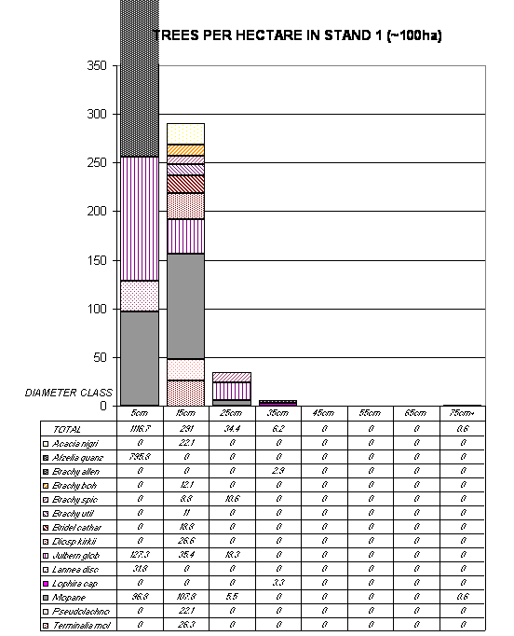

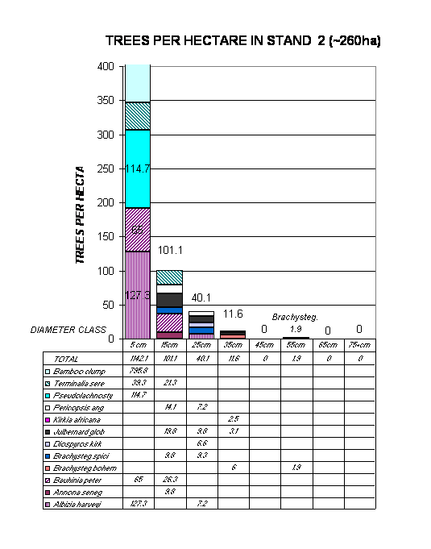
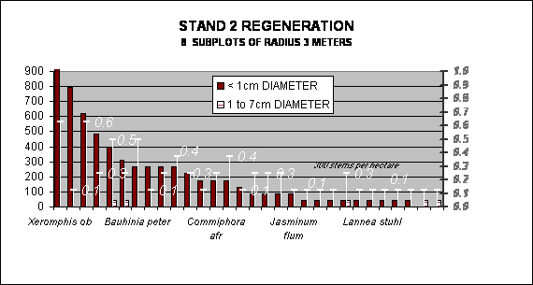

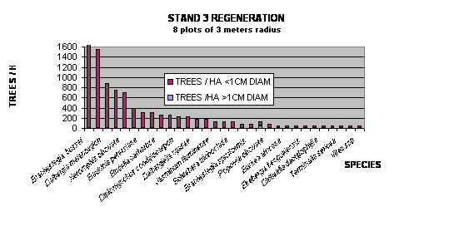

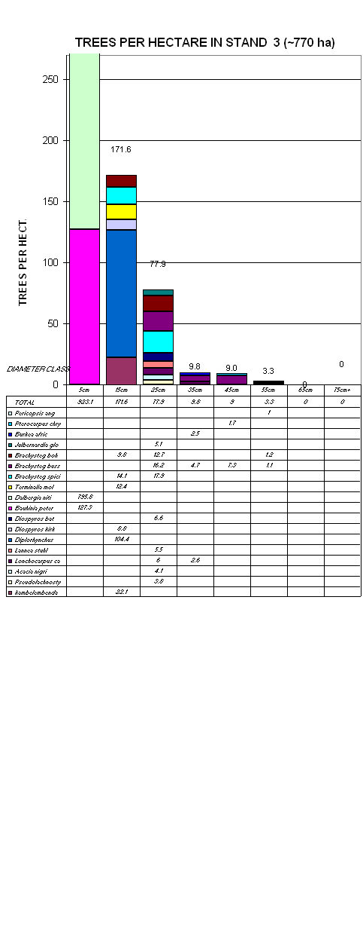

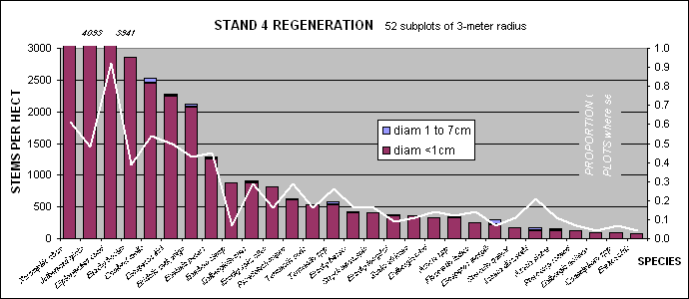

 |  |  |  |  |  | Inventory annex -- page 6
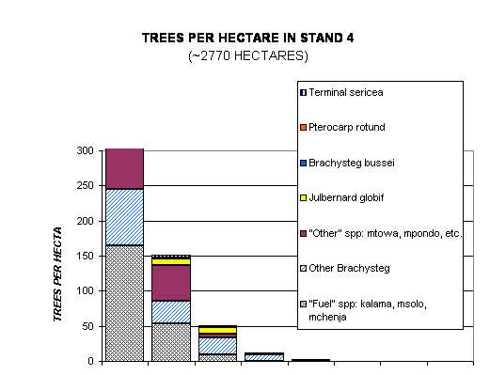
NOTE: reported
figures reflect a
9% reduction in
calculated means
to reflect field
and garden areas
taken out of
forest.
DIAMETER CLASS | 5cm | 15cm | 25cm | 35cm | 45cm | 55cm | 65cm | 75cm+
"Fuel" spp: kalama, msolo, mchenja | 164.7 | 53.2 | 9.9 | 0.0 | 0.0 | 0.0 | 0.0 | 0.0
"Other" spp: mtowa, mpondo, etc. | 363.1 | 50.1 | 4.3 | 0.4 | 0.0 | 0.0 | 0.0 | 0.0
Julbernard globif | 7.0 | 10.0 | 9.9 | 1.3 | 0.3 | 0.0 | 0.0 | 0.0
Other Brachysteg | 80.5 | 32.9 | 24.1 | 9.1 | 1.4 | 0.0 | 0.0 | 0.0
SAWTIMBER SPECIES:
Albizia harveyii | 0.0 | 0.0 | 0.0 | 0.0 | 0.2 | 0.0 | 0.0 | 0.0
Kirkia acuminata | 0.0 | 0.0 | 0.0 | 0.5 | 0.0 | 0.0 | 0.0 | 0.0
Brachysteg bussei | 0.0 | 0.0 | 1.9 | 0.4 | 0.3 | 0.0 | 0.0 | 0.0
Pterocarp rotund | 4.5 | 1.5 | 0.0 | 0.0 | 0.0 | 0.0 | 0.0 | 0.0
Terminal sericea | 0.0 | 3.2 | 0.5 | 0.0 | 0.0 | 0.0 | 0.0 | 0.0
TOTAL SAW | 4.5 | 4.7 | 2.4 | 0.8 | 0.5 | 0.0 | 0.0 | 0.0
GRAND TOTAL | 619.8 | 147.7 | 48.2 | 11.2 | 1.8 | 0.0 | 0.0 | 0.0

 |  |  |  |  |  |  |  |  | Inventory annex -- page 7
STAND 4: TREES PER HECTARE IN DIAMETER CLASS, by USE ( ~2770 ha)
DIAMETER CLASS |  |  |  | 5cm |  | 15cm |  | 25cm |  | 35cm | 45cm | 55cm | 65cm | 75cm+
TOTAL |  |  |  | 681.1 |  | 162.3 |  | 53.0 |  | 12.3 | 2.0 | 0.0 | 0.0 | 0.0
"OTHER" SPECIES:
Xeroderris stuh |  |  |  |  |  | 3.4
Zahna africana |  |  |  |  |  | 1.5 |  | 1.4 |  | 0.4
Acacia nigr |  |  |  | 13.6 |  | 5.4 |  | 0.7
Acacia nilot |  |  |  |  |  | 3.7
Bauhinia peter |  |  |  | 144.5 |  | 9.7
Bridelia cath |  |  |  | 4.9
Bridelia du |  |  |  |  |  |  |  | 0.6
mpindule |  |  |  | 13.6
Commifora af |  |  |  | 19.6
Dalbergiel nyas |  |  |  | 4.9 |  | 6.3
Diplorhynchus |  |  |  | 162.4 |  | 9.8 |  | 0.9
Jasminium fl |  |  |  |  |  | 1.4
Strychnos innocua |  |  |  | 4.9
Vangueriopsis la |  |  |  | 30.6
Lannea disco |  |  |  |  |  | 8.8
Lannea stuhl |  |  |  |  |  | 5.0 |  | 1.1
TOTAL "OTHER" |  |  |  | 399.0 |  | 55.0 |  | 4.7 |  | 0.4 | 0.0 | 0.0 | 0.0 | 0.0
"FUELWOOD" SPECIES:
Diospyros kirkii |  |  |  | 12.5 |  | 18.4 |  | 7.1
Diospyros mesp |  |  |  |  |  | 6.8
Lonchocarp cap |  |  |  |  |  | 1.5 |  | 1.7
Pseudolachnostyl |  |  |  |  |  | 15.2 |  | 0.9
Combretum col |  |  |  |  |  | 1.7
Combretum mol |  |  |  | 160.8 |  | 11.4
Terminalia sten |  |  |  | 7.7 |  |  |  | 0.7
TOTAL "FUEL" |  |  |  | 181.0 |  | 55.0 |  | 10.4 |  | 0.0 | 0.0 | 0.0 | 0.0 | 0.0
BRACHYSTEGIAS (barkrope, hives…):
Brachysteg spici |  |  |  |  |  | 7.6 |  | 5.7 |  | 1.8 | 0.3
Brachysteg util |  |  |  |  |  |  |  | 0.9 |  | 0.5
Brachysteg mang |  |  |  |  |  |  |  |  |  | 0.4
Brachysteg bohe |  |  |  | 12.1 |  | 18.7 |  | 11.6 |  | 5.7 | 0.4
Brachysteg allen |  |  |  |  |  |  |  | 2.7 |  | 1.2
Brachysteg longi |  |  |  | 76.4 |  | 9.8 |  | 3.5 |  |  | 0.5
TOTAL BRACHY |  |  |  | 88.5 |  | 36.1 |  | 26.5 |  | 10.0 | 1.5 | 0.0 | 0.0 | 0.0
SAWTIMBER (second-choice only):
Julbernard glob |  |  |  | 7.7 |  | 11.0 |  | 10.9 |  | 1.4 | 0.3
Albizia harv |  |  |  |  |  |  |  |  |  |  | 0.2
Brachysteg buss |  |  |  |  |  |  |  | 2.1 |  | 0.4 | 0.3
Pterocarpus rot |  |  |  | 4.9 |  | 1.7
Terminalia seri |  |  |  |  |  | 3.5 |  | 0.5
Kirkia acumin |  |  |  |  |  |  |  |  |  | 0.5
TOTAL SAWTIMBER |  |  |  | 4.9 |  | 1.7 |  | 2.1 |  | 0.9 | 0.5 | 0.0 | 0.0 | 0.0

SOME STANDARD ERRORS CALCULATED FROM PLOT DATA
 |  |  | Standard |  | 95% |  |  |  |  | Coefficient
 | POPULATION SAMPLED | Mean | error |  | confidence limits |  |  |  |  | of variation
BASAL AREA |  | 4.2 m2/ha | 0.33 |  | 3.5 to 4.9 m2/ha |  |  |  |  | 57%
MUKWA+MUBANGA 10-29cm diam |  | 1.7 /ha | 1.69 |  | 0 to 5.1 trees/ha |  |  |  |  | 723%
MUKWA+MUBANGA 1-9cm diam |  | 4.9 /ha | 4.90 |  | 0 to 14.7 trees/ha |  |  |  |  | 721%
MSALE (Br.bussei) >=30cm diam |  | 0.6 /ha | 0.62 |  | 0 to 1.8 trees/ha |  |  |  |  | 721%
KAMPHONI >=30 cm diam |  | 1.7 /ha | 0.91 |  | 0 to 3.5 trees/ha |  |  |  |  | 382%
KAMPHONI 10-29cm diam |  | 21.8 /ha | 7.68 |  | 6.4 to 37.2 trees/ha |  |  |  |  | 254%
OTHR BRACHYSTEG >=30cm diam |  | 13.9 /ha | 2.74 |  | 8.4 to 19.4 trees/ha |  |  |  |  | 142%
OTHR BRACHYSTEG 10-29cm diam |  | 53.8 /ha | 10.42 |  | 33.0 to 74.7 trees/ha |  |  |  |  | 140%
OTHR BRACHYSTEG 1- 9cm diam |  | 57.2 /ha | 57.2 |  | 0 to 171.6 trees/ha |  |  |  |  | 721%

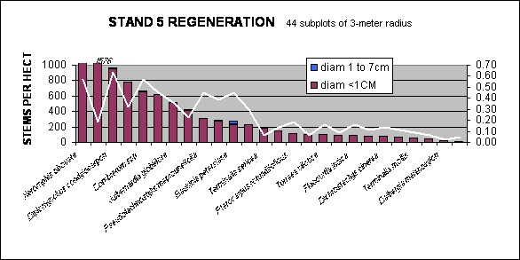 |  |  |  |  |  |  |  |  |  |  |  |  |  |  |  |  |  |  |  |  |  |  |  |  |  |  |  |  |  |  |  |  |  |  |  |  |  | Inventory annex -- page 8
 |  | 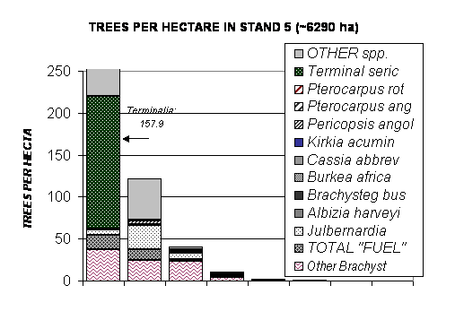
DIAMETER CLASS |  |  |  |  |  |  |  |  | 5cm |  |  |  | 15cm |  |  |  | 25cm |  |  | 35cm |  |  |  | 45cm |  | 55cm |  |  |  | 65cm |  |  | 75cm+
Fuel sp: Acacia, mchenja |  |  |  |  |  |  |  |  | 17.6 |  |  |  | 13.2 |  |  |  | 2.5 |  |  | 0.7 |  |  |  | 0.3
OTHER SP: mpondo, mvungwe, mbwabwa.. |  |  |  |  |  |  |  |  | 172.9 |  |  |  | 49.5 |  |  |  | 3.2 |  |  | 0.4 |  |  |  |  |  |  |  |  |  | 0.1
Julbernard glob |  |  |  |  |  |  |  |  | 6.0 |  |  |  | 28.3 |  |  |  | 7.3 |  |  | 1.7
Other Brachyst |  |  |  |  |  |  |  |  | 37.2 |  |  |  | 24.4 |  |  |  | 23.5 |  |  | 4.5 |  |  |  | 1.0 |  | 0.4
SAWTIMBER SPECIES:
Albizia harv |  |  |  |  |  |  |  |  |  |  |  |  |  |  |  |  | 0.6 |  |  | 0.4 |  |  |  |  |  | 0.2
Brachysteg buss |  |  |  |  |  |  |  |  |  |  |  |  |  |  |  |  | 0.5 |  |  | 2.3 |  |  |  | 0.7 |  | 0.4
Burkea africa |  |  |  |  |  |  |  |  |  |  |  |  |  |  |  |  | 1.0
Cassia abbrev |  |  |  |  |  |  |  |  |  |  |  |  |  |  |  |  | 1.0
Kirkia acumin |  |  |  |  |  |  |  |  |  |  |  |  | 1.7 |  |  |  |  |  |  |  |  |  |  | 0.2 |  |  |  |  |  | 0.1
Pericopsis angol |  |  |  |  |  |  |  |  |  |  |  |  | 3.7
Pterocarpus ang |  |  |  |  |  |  |  |  | 1.0 |  |  |  | 1.5 |  |  |  |  |  |  | 0.4 |  |  |  | 0.3 |  | 0.2
Pterocarpus rot |  |  |  |  |  |  |  |  |  |  |  |  |  |  |  |  | 0.9 |  |  | 0.3
Terminalia sere |  |  |  |  |  |  |  |  | 157.9
TOTAL SAW |  |  |  |  |  |  |  |  | 167.9 |  |  |  | 6.9 |  |  |  | 4.0 |  |  | 3.4 |  |  |  | 1.2 |  | 0.8 |  |  |  | 0.1 |  |  | 0.0
GRAND TOTAL |  |  |  |  |  |  |  |  | 375.0 |  |  |  | 109.1 |  |  |  | 38.0 |  |  | 10.0 |  |  |  | 2.2 |  | 1.2 |  |  |  | 0.2 |  |  | 0
- 71% |  |  |  | - 65% | - 74% |  |  | - 78% |  |  | - 45% |  |  |  |  | - 83% |  |  | -100%
 |  |  |  |  |  |  |  |  |  |  |  |  |  |  |  |  |  |  |  |  |  |  |  |  |  | Inventory annex -- page 9
BEST SAWTIMBER: |  |  |  |  |  |  |  |  | 5cm |  |  |  | 15cm |  |  |  | 25cm |  |  | 35cm |  |  |  | 45cm |  | 55cm |  |  |  | 65cm |  |  | 75+cm
Pericopsis angolensis |  |  |  |  |  |  |  |  |  |  |  |  | 3.7
Pterocarpus angolensis |  |  |  |  |  |  |  |  | 10 |  |  |  | 1.5 |  |  |  |  |  |  | 0.4 |  |  |  | 0.3 |  | 0.2
TOTAL 1 SAW |  |  |  |  |  |  |  |  | 10 |  |  |  | 5.2 |  |  |  | 0 |  |  | 0.4 |  |  |  | 0.3 |  | 0.2
SECOND CHOICE SAWTIMBER:
Albizia harveyii |  |  |  |  |  |  |  |  |  |  |  |  |  |  |  |  | 0.6 |  |  | 0.4 |  |  |  |  |  | 0.2
Brachysteg bussei |  |  |  |  |  |  |  |  |  |  |  |  |  |  |  |  | 0.5 |  |  | 2.3 |  |  |  | 0.7 |  | 0.4
Burkea africana |  |  |  |  |  |  |  |  |  |  |  |  |  |  |  |  | 1.0
Kirkia acuminata |  |  |  |  |  |  |  |  |  |  |  |  | 1.7 |  |  |  |  |  |  |  |  |  |  | 0.2 |  |  |  |  |  | 0.1
Pterocarp rotundifolia |  |  |  |  |  |  |  |  |  |  |  |  |  |  |  |  | 0.9 |  |  | 0.3
TOTAL 2 SAW |  |  |  |  |  |  |  |  | 0.0 |  |  |  | 1.7 |  |  |  | 3.0 |  |  | 3.0 |  |  |  | 0.9 |  | 0.6 |  |  |  | 0.1 |  |  | 0.0
"FUELWOOD" SPECIES:
Brachysteg boehmii |  |  |  |  |  |  |  |  |  |  |  |  | 6.6 |  |  |  | 7.2 |  |  | 0.7 |  |  |  | 0.6
Brachysteg longifolia |  |  |  |  |  |  |  |  |  |  |  |  | 2.9 |  |  |  | 1 |  |  |  |  |  |  |  |  | 0.2
Brachysteg manga |  |  |  |  |  |  |  |  | 27.2
Brachysteg spiciformis |  |  |  |  |  |  |  |  |  |  |  |  | 4.3 |  |  |  | 5.1 |  |  | 1.4 |  |  |  | 0.2 |  | 0.1
Combretum molle |  |  |  |  |  |  |  |  |  |  |  |  | 6.7 |  |  |  |  |  |  | 0.3
TOTAL FUEL |  |  |  |  |  |  |  |  | 27.2 |  |  |  | 20.5 |  |  |  | 13.3 |  |  | 2.4 |  |  |  | 0.8 |  | 0.3 |  |  |  | 0 |  |  | 0
FRUIT:
Dichrostachys kirkii |  |  |  |  |  |  |  |  | 17.6 |  |  |  |  |  |  |  | 1.1 |  |  | 0.4
Lannea discolor |  |  |  |  |  |  |  |  | 7.7 |  |  |  |  |  |  |  | 2.1 |  |  | 0.4
Strychnos innocua |  |  |  |  |  |  |  |  |  |  |  |  | 6.9
Ximenia americana |  |  |  |  |  |  |  |  |  |  |  |  |  |  |  |  | 1.1
TOTAL FRUIT |  |  |  |  |  |  |  |  | 25.3 |  |  |  | 6.9 |  |  |  | 4.3 |  |  | 0.8 |  |  |  | 0 |  | 0 |  |  |  | 0 |  |  | 0
BEE FORAGE SPECIES:
Acacia gerardii |  |  |  |  |  |  |  |  |  |  |  |  |  |  |  |  |  |  |  |  |  |  |  | 0.3
Acacia nigricans |  |  |  |  |  |  |  |  |  |  |  |  | 6.5 |  |  |  | 1.4
Brachysteg longifolia |  |  |  |  |  |  |  |  |  |  |  |  | 2.9 |  |  |  | 1 |  |  |  |  |  |  |  |  | 0.2
Combretum molle |  |  |  |  |  |  |  |  |  |  |  |  | 6.7 |  |  |  |  |  |  | 0.3
Dalbergiella nyasae |  |  |  |  |  |  |  |  |  |  |  |  | 8.8
Lannea discolor |  |  |  |  |  |  |  |  | 7.7 |  |  |  |  |  |  |  | 2.1 |  |  | 0.4
Pseudolachnostylus |  |  |  |  |  |  |  |  | 6 |  |  |  | 12.8
Pterocarpus rotundifolia |  |  |  |  |  |  |  |  |  |  |  |  |  |  |  |  | 0.9 |  |  | 0.3
Sterculia africana |  |  |  |  |  |  |  |  |  |  |  |  |  |  |  |  |  |  |  |  |  |  |  |  |  |  |  |  |  | 0.1
Terminalia sericea |  |  |  |  |  |  |  |  | 157.9
TOTAL BEE FORAGE |  |  |  |  |  |  |  |  | 171.6 |  |  |  | 37.7 |  |  |  | 5.4 |  |  | 1 |  |  |  | 0.3 |  | 0.2 |  |  |  | 0.1 |  |  | 0
FODDER SPECIES:
Bauhinia petersiana |  |  |  |  |  |  |  |  | 49.4 |  |  |  | 7.1
Albizia harveyii |  |  |  |  |  |  |  |  |  |  |  |  |  |  |  |  | 0.6 |  |  | 0.4 |  |  |  |  |  | 0.2
Diplorhynchus condylo |  |  |  |  |  |  |  |  |  |  |  |  | 3.4
Pseudolachnostylus |  |  |  |  |  |  |  |  | 6 |  |  |  | 12.8
TOTAL FODDER |  |  |  |  |  |  |  |  | 55.4 |  |  |  | 23.3 |  |  |  | 0.6 |  |  | 0.4 |  |  |  | 0 |  | 0.2 |  |  |  | 0 |  |  | 0
MEDICINE TREES:
Albizia harveyii |  |  |  |  |  |  |  |  |  |  |  |  |  |  |  |  | 0.6 |  |  | 0.4 |  |  |  |  |  | 0.2
Dalbergiella nyasae |  |  |  |  |  |  |  |  |  |  |  |  | 8.8
Lannea discolor |  |  |  |  |  |  |  |  | 7.7 |  |  |  |  |  |  |  | 2.1 |  |  | 0.4
Pterocarp angolensis |  |  |  |  |  |  |  |  | 10 |  |  |  | 1.5 |  |  |  |  |  |  | 0.4 |  |  |  | 0.3 |  | 0.2
TOTAL MEDICINE |  |  |  |  |  |  |  |  | 17.7 |  |  |  | 10.3 |  |  |  | 2.7 |  |  | 1.2 |  |  |  | 0.3 |  | 0.4
BRACHYSTEGIAS except bussei
Brachysteg allenii |  |  |  |  |  |  |  |  | 10 |  |  |  | 7.7 |  |  |  | 4.8 |  |  | 1.1
Brachysteg boehmii |  |  |  |  |  |  |  |  |  |  |  |  | 6.6 |  |  |  | 7.2 |  |  | 0.7 |  |  |  | 0.6
Brachysteg manga |  |  |  |  |  |  |  |  | 27.2
Brachysteg spiciformis |  |  |  |  |  |  |  |  |  |  |  |  | 4.3 |  |  |  | 5.1 |  |  | 1.4 |  |  |  | 0.2 |  | 0.1
Brachysteg utilis |  |  |  |  |  |  |  |  |  |  |  |  | 2.9 |  |  |  | 5.4 |  |  | 1.3 |  |  |  | 0.2 |  | 0.1
TOTAL BRACHYS |  |  |  |  |  |  |  |  | 37.2 |  |  |  | 21.5 |  |  |  | 22.5 |  |  | 4.5 |  |  |  | 1 |  | 0.2 |  |  |  | 0 |  |  | 0
 |  |  |  |  |  |  |  |  |  |  |  |  |  |  |  |  |  |  |  |  |  |  |  |  |  | Inventory annex -- page 10
STAND 5: SOME STANDARD ERRORS CALCULATED FROM PLOT DATA
 |  |  |  |  |  |  |  |  |  |  |  |  |  |  |  |  | Standard |  |  |  |  |  |  | 95% |  |  |  |  |  |  |  |  | Coefficient
 |  |  |  |  |  |  |  |  |  |  |  |  | Mean |  |  |  | error |  |  |  |  |  |  | confidence limits |  |  |  |  |  |  |  |  | of variation
 |  |  | 7.3 m6/ha |  |  | 0.60 |  |  |  |  |  | 6.1 to 8.5 m2/ha |  |  |  |  |  |  |  |  |  | 57%
1.3 /ha |  |  |  | 0.64 |  |  |  | 0 to 2.6 trees/ha |  |  |  |  |  |  |  |  |  |  |  |  |  |  | 346%
6.6 /ha |  |  |  | 3.35 |  |  |  | 0 to 13.3 trees/ha |  |  |  |  |  |  |  |  |  |  |  |  |  |  | 350%
10.8 /ha |  |  |  | 10.80 |  |  |  | 0 to 32.4 trees/ha |  |  |  |  |  |  |  |  |  |  |  |  |  |  | 693%
4.6 /ha |  |  |  | 1.68 |  |  |  | 1.3 to 7.9 trees/ha |  |  |  |  |  |  |  |  |  |  |  |  |  |  | 252%
10.6 /ha |  |  |  | 5.88 |  |  |  | 0 to 22.4 trees/ha |  |  |  |  |  |  |  |  |  |  |  |  |  |  | 385%
 |  |  |  | ----------- none -------------
1.8 /ha |  |  |  | 1.08 |  |  |  | 0 to 4.0 trees/ha |  |  |  |  |  |  |  |  |  |  |  |  |  |  | 408%
38.6 /ha |  |  |  | 15.42 |  |  |  | 7.8 to 61.4 trees/ha |  |  |  |  |  |  |  |  |  |  |  |  |  |  | 277%
6.6 /ha |  |  |  | 6.55 |  |  |  | 0 to 19.7 trees/ha |  |  |  |  |  |  |  |  |  |  |  |  |  |  | 693%
6.4 /ha |  |  |  | 1.95 |  |  |  | 2.4 to 10.4 trees/ha |  |  |  |  |  |  |  |  |  |  |  |  |  |  | 210%
51.7 /ha |  |  |  | 11.98 |  |  |  | 27.7 to 75.7 trees/ha |  |  |  |  |  |  |  |  |  |  |  |  |  |  | 160%
40.3 /ha |  |  |  | 31.22 |  |  |  | 0 to 102.7 trees/ha |  |  |  |  |  |  |  |  |  |  |  |  |  |  | 536%
NOTES:
1. Variability of a population is reflected in the width of the confidence interval and
the size of the coefficient of variation:
-- The wider the confidence interval, the more patchy is the coverage of the population;
-- The higher the Coefficient of Variation, the more variable is the population; that is, the more
unpredictable will be the chances of seeing a member of the population at a given site.
-- The coefficient of variation can be used to compare one population with another.
-- It can be seen that the smallest diameter trees produce a variability much higher
 |  |  |  |  |  |  |  |  | than other populations.
2. Basal area is the least variable of the populations sampled. The coefficient of variation,
potential annual harvest of specific products; therefore we use the diameter distribution.
3. Higher coefficients of variation, or wider confidence intervals, imply that one should be
It is better to use conservative estimates.

