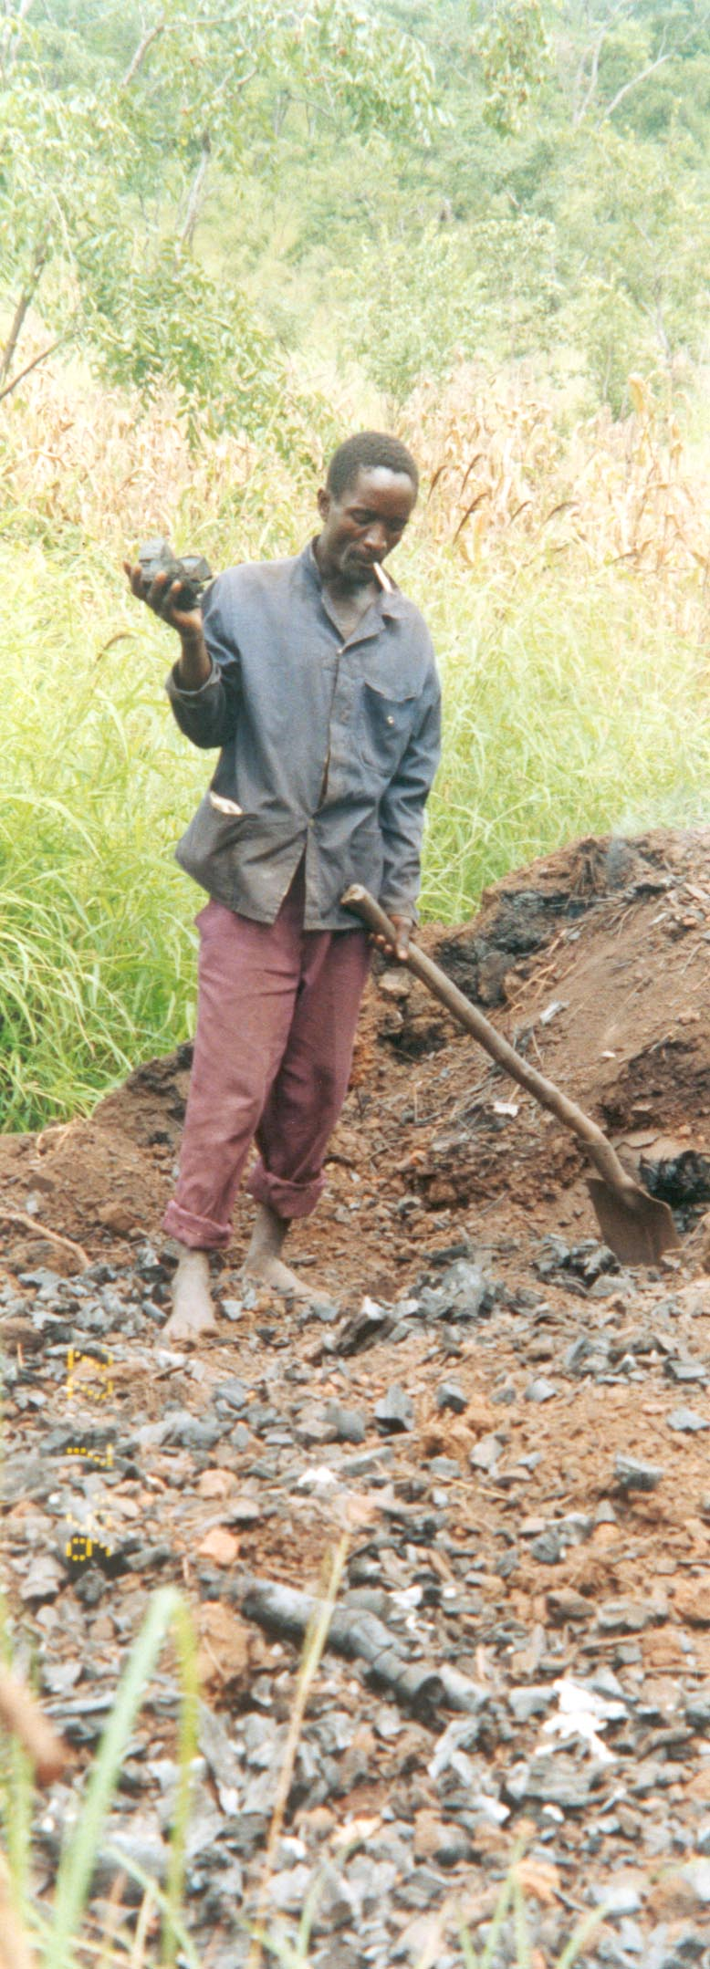
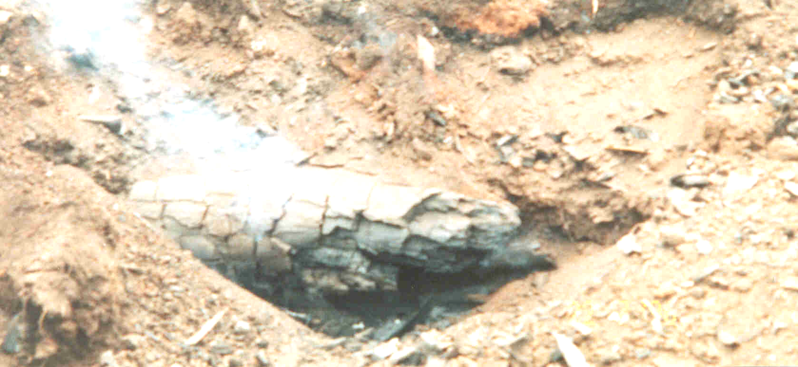
AMAPSYA MCIFUWA
They get burnt in their chest
NDIPONSO THUPI LIKUDA
and their bodies turn into dark skin
AMADWALA CIFUWA
They suffer from sneeze and cough
AMACITA ZIKANG’A MMANJA CIFUKWA COSOWA ZOTETEZELA
They develop cracks in their hands because of lack of protections
CHIWILI CIKADOOKA, UTSI WAKE UMABWELETSA MATENDA
When the burned heaped trees let out their smoke, it is smoke that brings diseases
NDIPONSO CAKUMODZI
One develops the side pain
KUFUWILA MASO
Eye turns into red
MOTO UMAFOKETSA THUPI LA CIMUNA
Fire makes a man’s body to be weak and not working.

- Information thanks to Chiulukire Villagers year 2000
THE HAZARDS OF
PRODUCING CHARCOAL

